Chakyra (Kdnae) Richard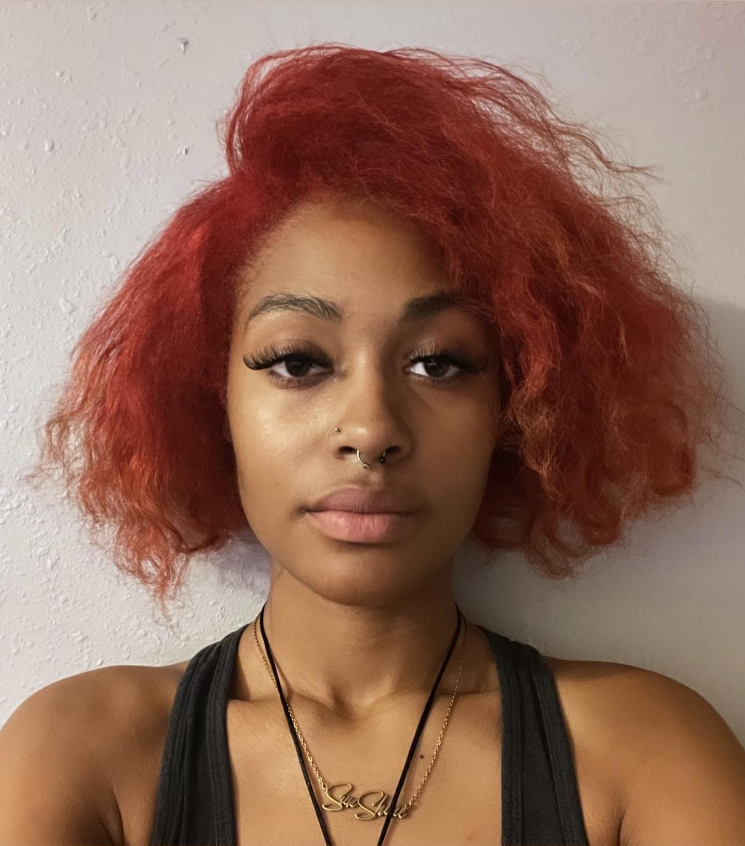

Actress • Model • Creative Artist • YouTuber

Email: [kdnaesline@yahoo.com](mailto:kdnaesline@yahoo.com)

Mobile: +1 (281) 409-2273

Houston, Texas



Theater_________________________________________

Rags: Someday(2019) "Irma" KIPP Sunnyside HS Theatre, Dir.Chakyra Richard & Krista Saulter

Carmen: If Looks Could Kill(2019) ”Carmen" KIPP Sunnyside HS Theatre, Dir.Lamorial Evans & Isaiah Taylor

Chicago: Cell Block Tango(2019) “Lipschitz" KIPP Sunnyside HS Theatre, Dir. Orlandriah Horton

The Gift of Magi(2019) ”Della" KIPP Sunnyside HS Theatre, Dir. Amy Aviles

Fronteras: I Am Here(2018) “Chakyra/Speaker KIPP Sunnyside HS Theatre, Dir. Shalayla Simmons

El Fuego Está en la Sangre(2019) Presenter KIPP Sunnyside HS Theatre, Dir. L. Llanas, Y. Santos, A. Aviles, T. Gonzalez, J. Santos, C. Richard, & S. Simmons

Soul Heaven(2019) Narrator 1 KIPP Sunnyside HS Theatre, Dir. Shalayla Simmons

Film___________________________________________

Amygdala(2022) "Amber" Volleyball Player 2 Dir:Courtney Glaude

The Masquerade(2022) Extra Dir:Justin Williams

Black Market(2022) Lead Dir: Romeo Myles

The Elevator Ritual(2021) "Ashley" Lead Dir: Jhazmin Carter

The Simulation: Break the Rules(2021) Extra Dir: Wazeer the Great & Javeon Butler

Dream High USA A cappella Performance(2013) Guest Star Konexion Tv. MundoFox

Toy & Gift Drive(2013) Collaborate Local KHOU News

Habituation(2023) "Nurse Johansson" Lead Dir: Richard Goffner

**Commercial_______________________________________** “Stop Simpin” Movement (2022) Local

Trip Terror Inc Fanta Commercial (2014) Local

**Print _______________________________________**

Dream High USA(2013)

Maxi Black Magazine(2022)

Bold Journey Magazine(2024)

Other ___________________________________________

FYE FYE Music Video(2021) Tobe Nwigwe Carmen Jones

Passing Through Music Video(2022) Tobe Nwigwe Carmen Jones, Tobe Nwigwe

The Simulation Music Video(2021) Wazeer the Great Javeon Butler

One Mo Music Video(2021)Rhya Rhya

Catch a Vibe Music Video(2024)L¡ya 2cozyshots

**Promotional/BrandAmbassador___________________________**

Kala’s Hair Bar(2021)Kalashairbar

Stop Simpin Movement(2022)1125clothingco

The Mint Collection(2022) Mint by Chukwu

Beauty Beginnings Hairstylist(2023) Beautybeginnings_

**FashionShows_____________________________________**

Houston International Community Fashion Show Week(2014) Model Enakeme Ofukeme /Enakeme Ofukeme

TraeNia’s Closet Fashion Show(2013) Model Trae’NiaCloset/ Evonia Wilmore

The Stark Show Fashion Show(2023) Model ILYSM Ali/Khalil Ali, Univerge, Exchange to Change/Jayling Rose

The Ghostly Gala Fashion Show(2023) Model Zariah’s Chic Apparel/Zariah, Pretty Customz/Clarise, The Signature BLVD/Chelsea Madison, Shisty Clothing/Kenneth

The New Eden Fashion Show(2023) Front of House Assistant Niming.bycc/Cam Choi

ILYSM Fashion Show(2023) Model ILYSM Ali/Khalil Ali

Unfinished “An Unpopular Experience” Fashion Show(2024) Bartender Menace Apparel

50 Shades of Love Fashion Show(2024) Model Zariah’s Chic Apparel/Zariah, The Signature BLVD/Chelsea Madison, ILYSM Ali/Khalil Ali

Fashion Night Out 4: Taking Care of Home(2024) Front of House Staff

Fashion Night Out 5: LuxurioUS(2025) Front of House Staff, Project Assistant, Floater

**Skills___________________________________________**

Seamstress Youtuber Rolling skating Spanish Sign Language Music Production Team collaboration Adaptable/innovative poses Product/Brand Promotion Digital native in social media Accents/Dialects: London accent/Southern BeerTender (TABC Certified) Writing/Creative Director Waitress Entrepreneur Content Management Website Building/Promotion/Administration/Monetization/ Updating Online Promotion Video Editing/Post-Production/Production Product Launch/Marketing Business Analysis/Development/Process Improvement Leadership Project Management Event Planning/Management Analytical Skills Problem Solving Graphic Design Brand Development Public Relations Sales Modeling (Print/Runway) Theater Performance Driver’s License Improvisation Impalement Art Throwing Knife Flexibility Child Care Services

**Training_________________________________________**

StarModel Runway Class(2013)

KIPP Sunnyside HS Theater Arts(2018-19)

Creators Avenue Modeling Workshop(2023)

**Education________________________________________**

2017-20, High School Diploma

KIPP Sunnyside High School, Texas

* Pursued my passion for education, directing, and acting
* Won the cover of Dream High USA’s Magazine in Dream High USA’s Magazine cover launch Competition
* Starred in seven high school theater productions