Neve Lacey  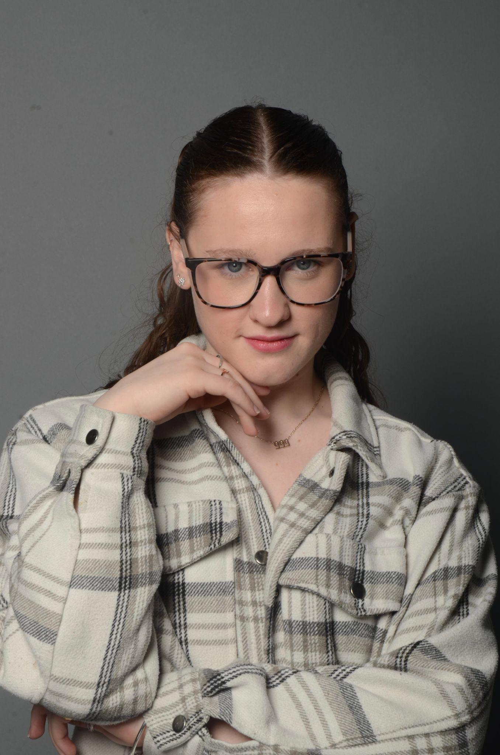  Hight: 1.65m  Weight: 65.1kg  Hair: dark blond  Eyes: blue  D.O.B: 12/08/2006  Experience  Broadway dance centre new york 2025  I spent two weeks in new york with my college to study  At Broadway dance centre. I was able to take part  In all dance styles they offered for example,  Tap, ballet, jazz, musical theater ect  Scarefest Puxton park 2023-2024  During my time at college we were given  the opportunity to be a scare actor for  Puxton park in their scare mazes.  Chicago 2023  In a college production of Chicago where I  played the character of Anne (a cell block tango girl)  Everybody's talking about Jamie 2024  In a college production of Jamie I played the role of Fatimah. I was also able to learn about the culture of wearing a Hijab.  Echoes of the stage 2025  A College written production. I sang my first solo and took the role of Assistant dance captain.  Highbridge festival 2023-2024  I performed with my dance group  placing second both years.  Character appearances  As a party host at Brean play I was able to  show my talent and love for performing through  character performances as a child's party hosts.  Easter Bunny  Santa's Elves  Stormy stan | 6 cookson close Burnham-on-sea, somerset  TA8 1QU  07746684013  Nevelacey19@gmail.com  Skills  Tap  Ballet  Jazz  Commercial  Contemporary  Street  choreography  Singing  Acting  Education  The king alfred school an academy  Weston college performing arts level 2 diploma- merit  Weston college performing arts level 3 diploma

