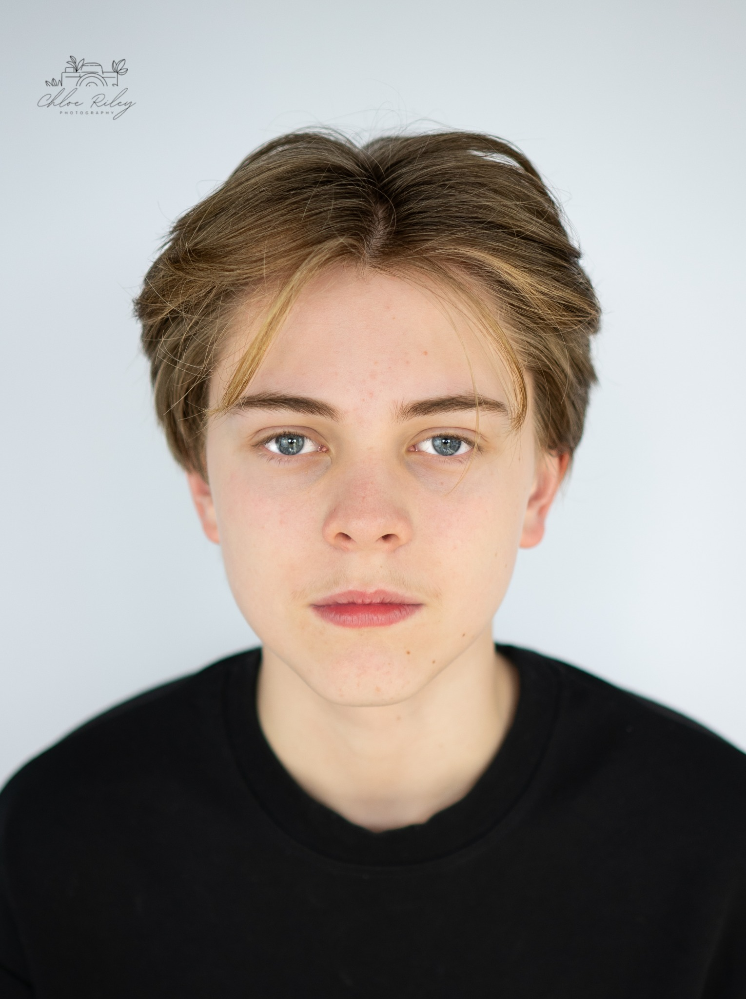

# Lyndon Drozd

Age: 14  
Languages: English, Welsh  
Location: Carmarthen  
Height: 5ft7  
Contact: [sophdrozd@hotmail.co.uk](mailto:sophdrozd@hotmail.co.uk) / 07786001633

## Profile

Passionate young actor with experience in feature films, short films, and stage productions. Bilingual in English and Welsh, with a beginner foundation in Meisner and Stanislavski techniques. Enthusiastic performer with additional interests in singing, modeling, and gaming.

## Training

Mark Jermin Small Group Acting Training – Ongoing  
Focus: Meisner Technique, Stanislavski Method Acting

Stagecoach Theatre Training – Ongoing

## Film Experience

* The Medieval Quest (Short) – Charlie  
  Peacock Media Studios | May 2025
* The Devoted (Short) – James  
  Bristol Uni Student Film | April 2025
* Blackout (Short) – Theo  
  Terra Libra Productions | March 2025
* Dorians (Short) – Tom  
  Robeeno Productions | Aug 2024
* Peter Pan’s Neverland Nightmare – Carl  
  Jagged Edge Productions | May 2024
* The Dancing Queen – Ashley  
  Jagged Edge Productions | Jan 2024

## Theatre Experience

* Guys & Dolls – Ensemble  
  Theatre Sir Gar Lyric | Stagecoach Carmarthen | April 2025
* Beauty & The Beast – The Baker  
  Theatre Sir Gar Lyric | Stagecoach Carmarthen | July 2024

## Modelling Experience

* Welsh National Prom Show – Fashion Show  
  Emmjs Model Management | Dec 2024
* SSAP Autumn Ball – Fashion Show  
  The Catwalk Club | Oct 2024
* Commercial – Platnum Apparel   
  Model | June 2024
* Old Gather Thames Project – 18th Century Boy  
  Julia Fullerton-Batten | Jan 2024

## Music

* Beard on My Face – Non-Featured Singer  
  Boardman Records | Dec 2024