Eve Evans  Seeking acting representation | laureneveevans@gmail.com  Chester  07921555622
Throughout my life I have been described as creative and kind, two qualities that I bring into my work as an actor. After a long time as being favoured as the comedic character in school productions due to a dry and witty humour, two years I was given the part of Chadwick in ‘Punk Rock’ and gave me an opportunity to explore a grittier side of character development. It was also during this unit of training that I became well versed with the teaching methods of Meisner which I thoroughly enjoyed. I continued to explore this side of my acting repertoire once I was accepted into Rode Bruford College.  As a dedicated and hard-working actor with five years of intensive training at the Hammond school of performing arts, an additional two years at the Pauline Quirke Academy and Rose Bruford College, where I have gained experience with all sides of the performing and creative arts. Throughout my training I have honed my skills in; acting, writing, directing and creating my own original work. I am no stranger to the demands of long days on a set and thrive in a professional working environment.  My experience has equipped me with the versatility and adaptability necessary to bring characters to life authentically in order to engage an audience. I have a passion for storytelling and a strong work ethic that has driven me to continuously improve and grow as an actor.  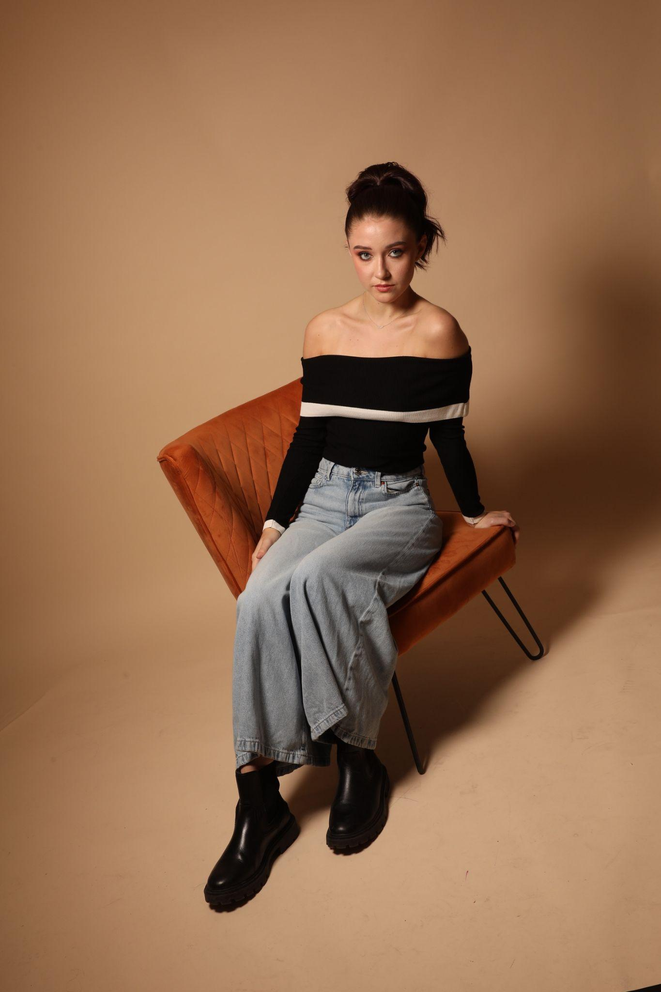  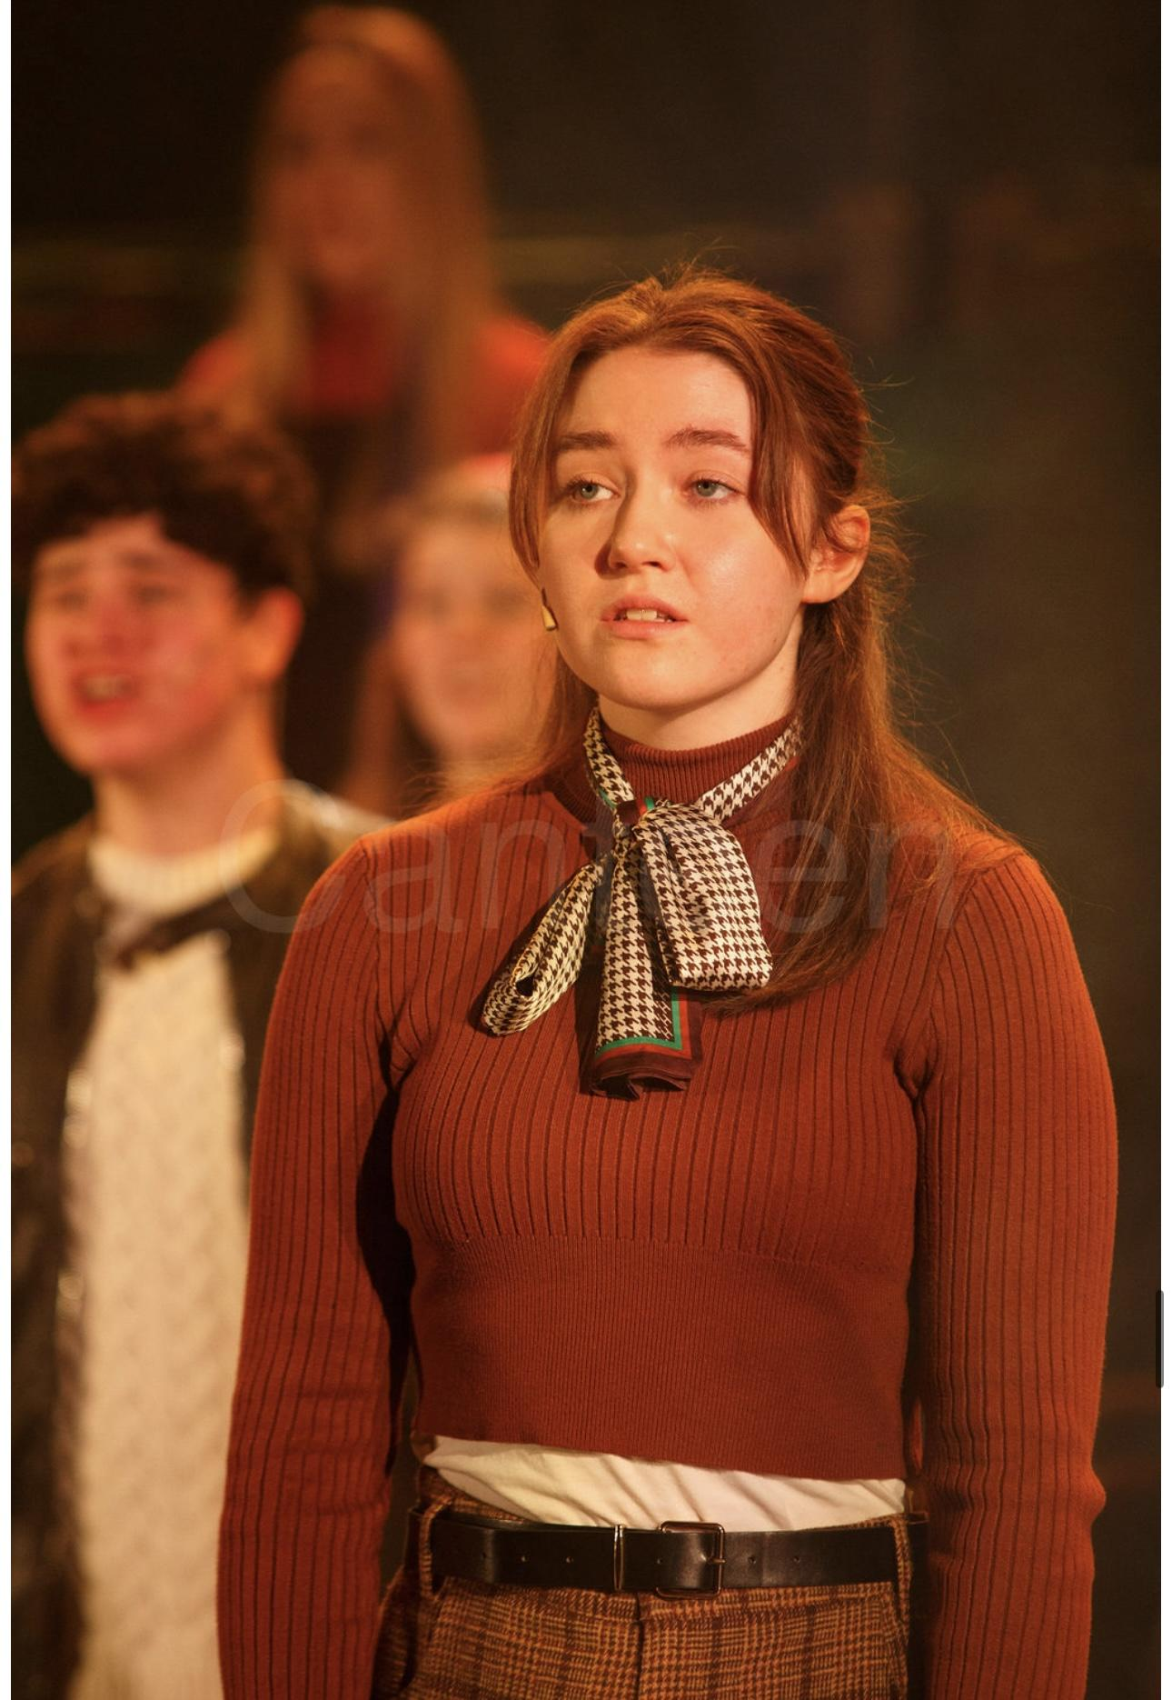 |   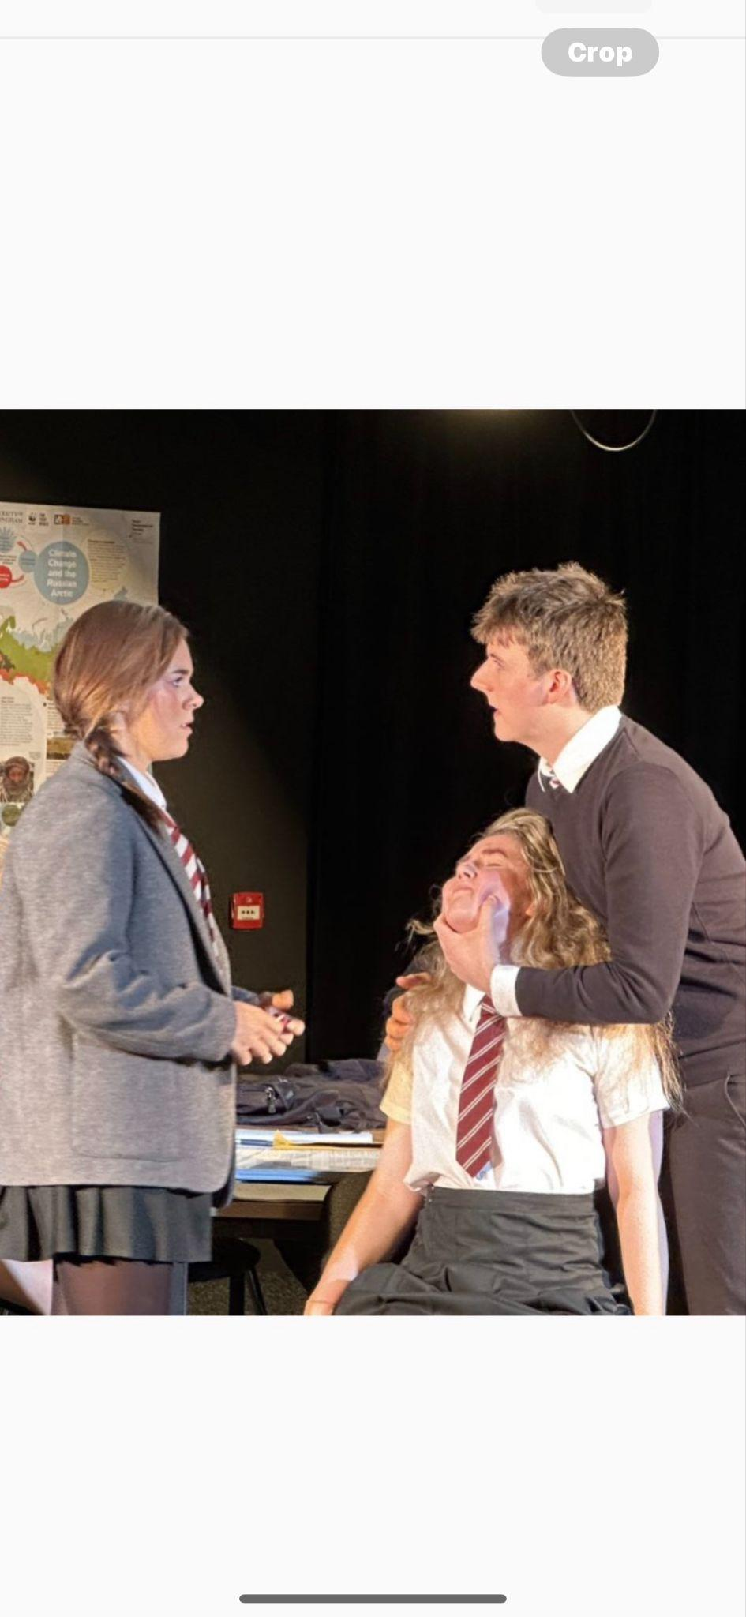  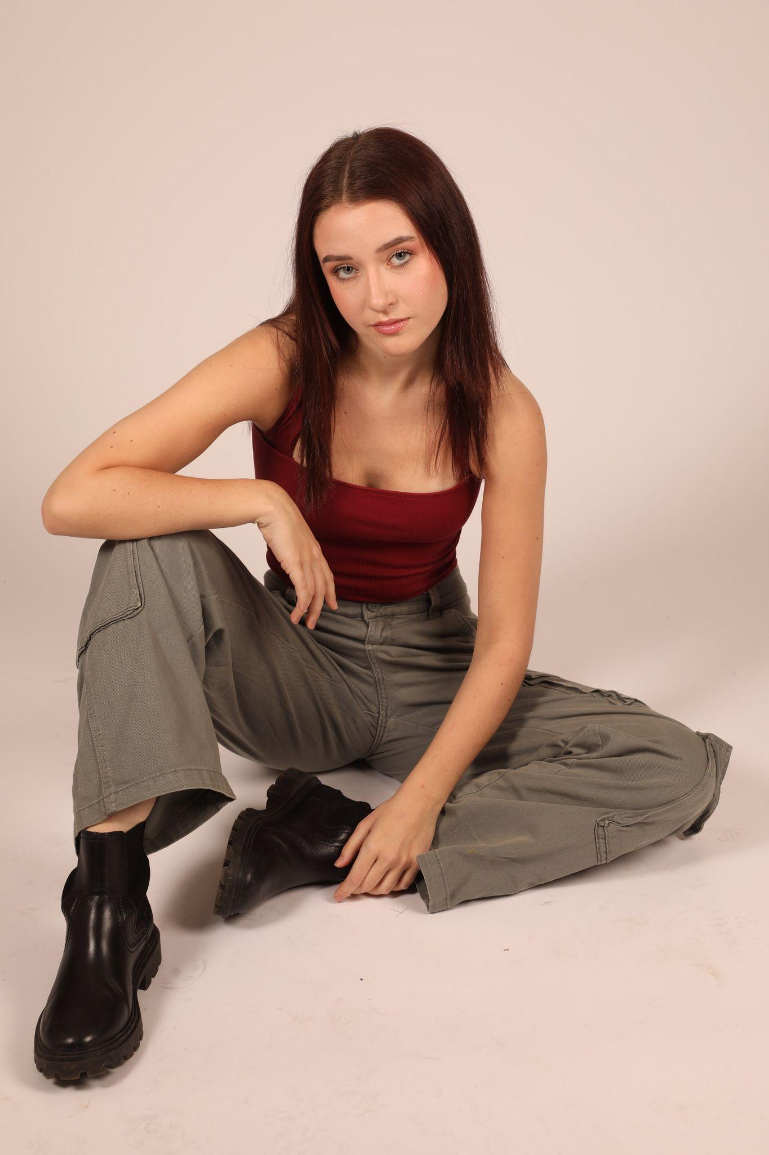
Photos: Headshot, Image from ‘punk rock’, Image from ‘Amelie’, Photos provided by UK models

