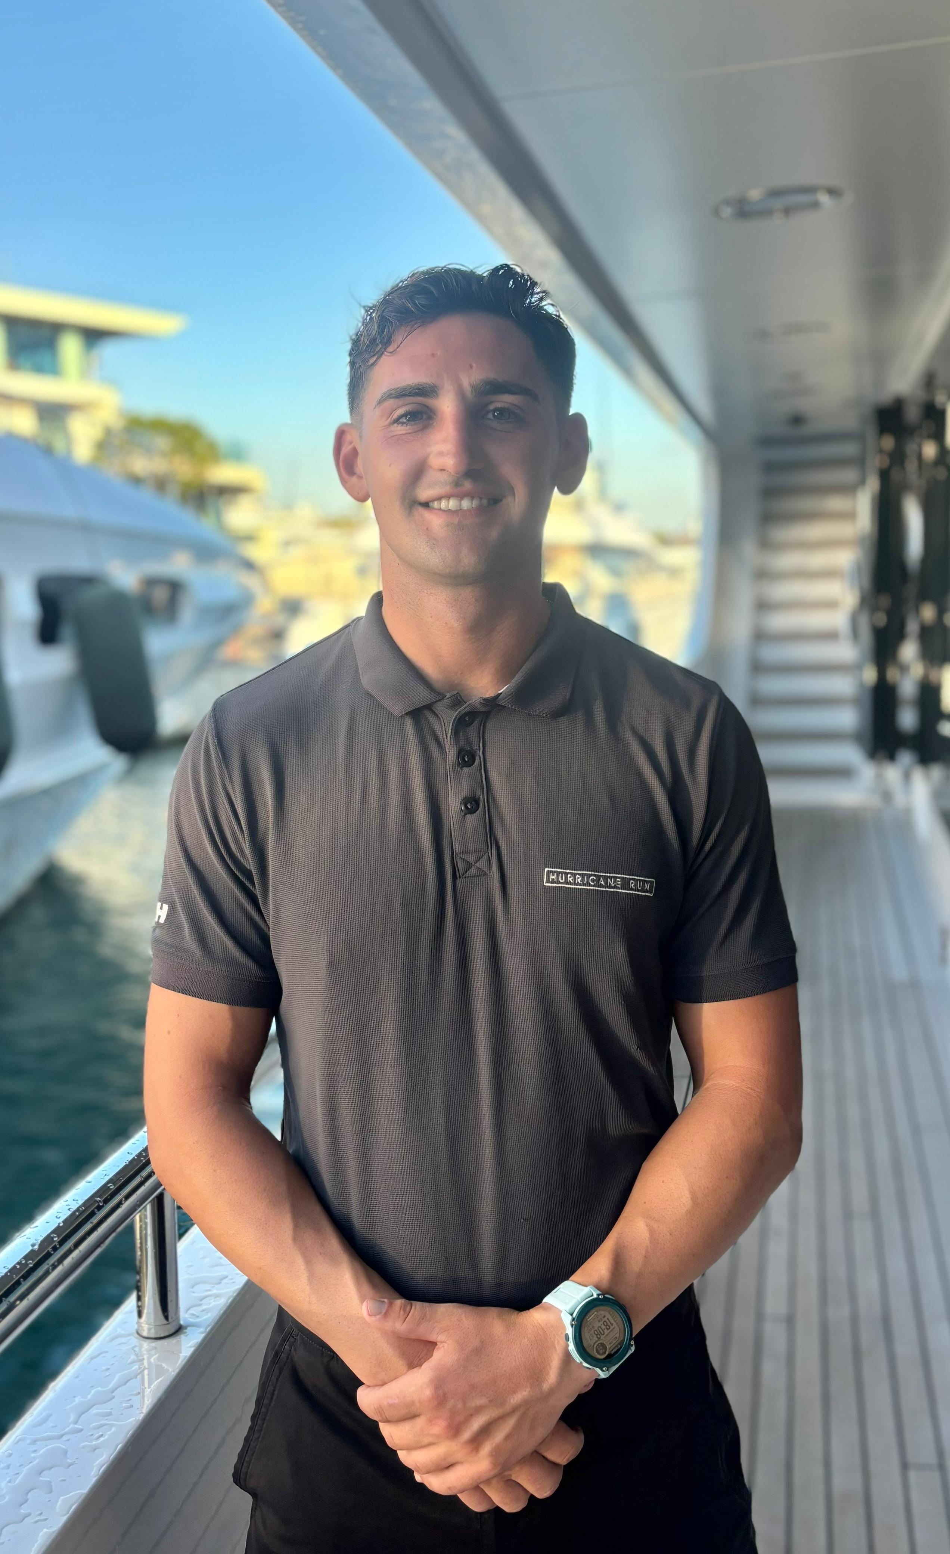Gianni Snyman

## Deckhand / Dive Instructor

#### **Date of Birth:** 26/09/2001

**Nationality:** Italian, South African

**Phone number:** +33 781483196

**E-mail:** snymangianni@gmail.com

**Location:** Monaco

**Visas:** B1B2, (EU Passport)

**Driving licence:** Yes

**Seamans Book:**  Cayman Islands

**Health:**  Fully Vaccinated

**Crew Pass:** Approved

## PROFILE

I completed a 21-month cadetship in 2021, which gave me solid experience across all departments on board and a good understanding of how things work at sea. After that, I followed my passion for the ocean and became a scuba diving instructor, which allowed me to work closely with people, build confidence, and stay active in the water. I then made the move into the yachting industry and have been working on a superyacht, continuing to learn and grow. I’m now looking for new opportunities where I can keep building on my skills, take on more responsibility, and grow within the industry.

## TRAINING AND CERTIFICATES

* IYT Master of Yachts Unlimited 200 tons
* Marine Communications Master VHF (SRC)
* Cyber Security Awareness
* Emergency First Response Instructor
* PWC Proficiency
* PADI Scuba Instructor
* Speciality Instructor (9 Specs)
* STCW Exp. 10.25(Renewal Booked 20/10)
* Designated Security Duties
* ENG1 Exp. 07.27

## SKILLS

* Chart work
* Sailing
* Engine & generator servicing
* Exterior & interior maintenance
* Sanding & painting
* Guest service & water sports
* Time management
* Emergency First Aid
* DJ & mixing music

## EXPERIENCE

**MARITIME EXPERIENCE:**

**Hurricane Run | 53m | Feadship | Temp. Deckhand: 15/05/2024 – 31/05/2024 |**

**Lead Deckhand: 04/11/2024 - Current | Mediterranean**

Having joined initially as a temp cover for two weeks, I was then invited back as permanent crew on Hurricane Run on a permanent contract and was promoted to lead deckhand within four months.

* General maintenance of the vessel
* Participated in emergency drills like: Fire on board, MOB and Abandon ship etc
* Involved with LSA and FFE inspections, which included inspecting condition and expiry dates
* Weekend and week day watches, which included rounds and filling in the official logbook
* Sanding rust and exposed areas that could lead to rusting for preparation to paint
* Mixing and painting of lockers and bilges
* Crane operations for launching and recovering of rescue tender as well as manoeuvring heavy equipment like capstans and doors
* Rescue tender operations which involved launching, driving and recovering
* Anchor watches
* Assisted with crane operations for launching and recovering tenders and jet skis
* Jet Ski operations for guests
* Deck Maintenance which included wash downs and polishing

**MA #111 | 18.9m | Lagoon 620 Catamaran | Cadet/Deckhand | 04/2021 – 02/2023 | Turkey**

* Participated in a comprehensive 2-year cadetship program in Izmir, Turkey, covering deck, interior, sailing, engineering, and service departments. Progressed to skippering and managing the vessels
* Trained on Lagoon 620 Catamarans, race boats, dive boats, tenders, water-ski boats, and water toys
* Conducted three crossings, responsible deckhand duties, chartwork, passage planning, navigational watch and trimming the sails
* Managed crew and administration during my final months and gained valuable leadership experience

**LAND BASED EXPERIENCE**

**Waterhoppers/In Depth | Scuba Instructor/Manager | 07/2024 – 11/2024 | Greece**

* Made weekly schedules and bookings
* Completed diving insurance documents and student record files
* Instructed variety of courses and managed equipment care
* Guided dives and snorkelling boat trips
* Performed guest pickups and transfers
* Performed safety and course briefings
* Skippered our 6m dive boat

**ProSport Divers | Scuba Instructor | 01/2024 – 03/2024 | South Africa**

* Facilitated comprehensive scuba diving courses
* Assessed competencies of students to determine success for open water dive certification
* Serviced Scuba regulators and BCDs

**Into The Blue | Divemaster | 03/2023 – 07/2023 | South Africa**

* Received extensive training and development through Dive Master Internship
* Dive leader for guests of varying abilities, guided and supervised divers, ensuring guest safety and enjoyment
* RIB Safety Boat operations including risk assessment of sites
* Gear maintenance

**Life Saving South Africa | Lifeguard | 11/2018 – 01/2021 | South Africa**

* Assessing conditions of currents and tides
* Assessing safety on the beach by guiding swimmers to safe areas
* Providing First Aid care
* Training new intakes according to base standards
* Filled in as crew Leader at times

## HOBBIES AND INTERESTS

I enjoy scuba diving and exploring marine life, as well as surfing and hiking in nature, which ignite my passion for the adventure and exploration. I’ve recently started mixing music at events and some bars which I enjoy a lot.

## REFERENCES

**Hurricane Run** | Confidential

**JP Nathrass** | **Captain** | MA Sail | +27824641508 | jpnathrass@outlook.com

**Dehann Grobler** | **Captain** | MA Sail | +27673505818 | [gdehann@gmail.com](mailto:gdehann@gmail.com)

**Ryan Eames** | **Manager of Waterhoppers** | +306981270341 | ryan@waterhoppers.com

**Lin Israel** | **Owner of Prosport** | +27834627453 | lin@prosportdiver.co.za

**Robyn Rossouw** | **Manager of Into The Blue** | +27661299281 | [robynrossouw007@gmail.com](mailto:robynrossouw007@gmail.com)

**Corne Calitz** | **Crew Leader for Life Saving** | +27730929494 | [jpnathrass@outlook.com](mailto:jpnathrass@outlook.com)