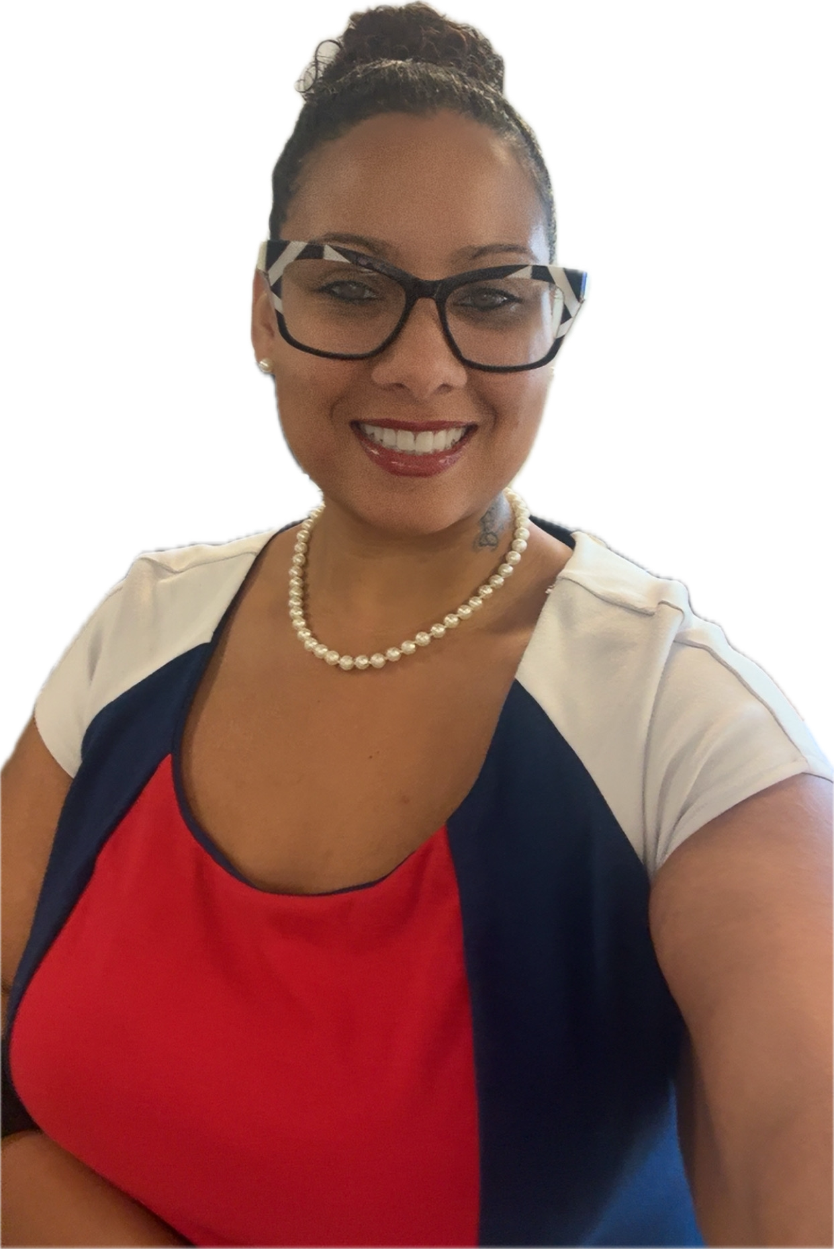 |  | - ADMINISTRATIVE coordinator

Mariah Davis

Objective
Dedicated and dependable professional with extensive experience in administrative, operational, and client-centric roles, actively seeking a remote position. I am skilled at coordinating administrative, business, and operational activities, including HR, payroll, accounts payable, and scheduling. With proven experience in managing team efforts and ensuring operational efficiency, I am proficient in performing administrative and clerical functions and am competent in fulfilling targets under minimum supervision. I am committed to maintaining strict confidentiality and adherence to regulations, including HIPAA.
Work Experience

- Contact  Mariah Davis  Champaign, IL  leona121020@gmail.com  +1 217 318 1649  - Education  - Skills  Hard Skills  * Administrative and Clerical Functions  * Payroll  * Scheduling  * Compliance Adherence (e.g., Medicare, Medicaid, HIPAA)  * Human Resources Management  * Microsoft Word  * Cash Handling / Cash register  * Typing  Soft Skills  * Supervision and Management  * Communication Skills  * Customer Service / Guest Relations  * Time Management  * Organizational Skills  * Problem-Solving Skills  * Interpersonal Skills (e.g., compassionate and sympathetic communication)  * Analytical Skills  * Confidentiality Maintenance |  | Experience  Concierge Services Supervisor  Clark-Lindsey Village-Urbana, IL | October 2022 to Present  * Supervised and managed front office operations and team members, ensuring efficient daily functions and adherence to company standards.  * Maintained fleet vehicles in optimal condition to ensure safe and legal operation.  * Coordinated resident transportation for appointments and outings, prioritizing timely and reliable service.  * Ensured clear and open communication with residents, staff, and external stakeholders  .  Celltrak/Office Coordinator  Carle Home Care-Champaign, IL | September 2021 to October 2022  * Accurately tracked and maintained clinician mileage records for reimbursement purposes, ensuring timely and accurate payroll processing.  * Maintained comprehensive monthly home care reports and updated client service records in compliance with CMS guidelines.  * Assisted in obtaining and processing necessary physician orders and documents according to CMS regulations.  * Monitored and coordinated treatment plans for patients.  Scheduling Coordinator  Help at Home LCC-Metroplis, IL | June 2018 to April 2019  * Oversaw client care, fostering positive relationships with referral sources, clients, and employees.  * Coordinated team efforts through effective supervision and open communication.  * Ensured adherence to employee schedules and electronic visit verification procedures, optimizing operational efficiency.  * Recruited and trained staff, contributing to the development and growth of the team.  Service Coordinator  Addus Home Health Care-Marion, IL | April 2017 to April 2018  * Coordinated administrative, business, and operational activities, including HR, payroll, accounts payable, and scheduling.  * Oversaw the new hire process, ensuring timely and accurate completion of all required documentation for new employees.  * Conducted thorough investigations and resolved escalated client complaints.  * Ensured strict adherence to Medicare, Medicaid, and HIPAA regulations and requirements.  Home Health Care Aide  Addus HealthCare, Inc.-Marion, IL | October 2015 to April 2017  * Provided compassionate and personalized care to elderly and disabled clients in their homes.  * Assisted clients with activities of daily living.  * Maintained strict confidentiality of client information and adhered to HIPAA regulations at all times.  You can use this as a template. I've restructured the content to be more impactful and highlighted your administrative and coordination skills.

