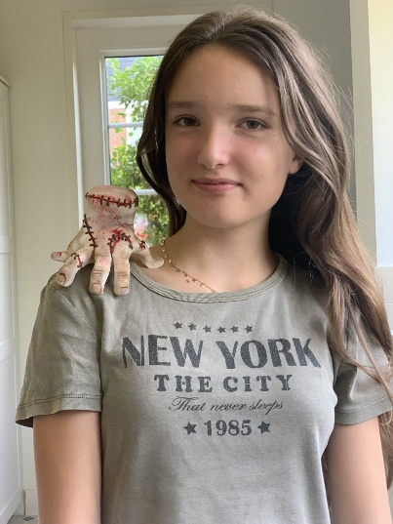
Fleur Kretschmer
Date of birth: 30/08/2012
Email: fleurkretschmer@gmail.com
Location: The Hague, The Netherlands

Summary
Energetic and versatile young performer with experience in musical theatre, acting, and on-camera work. Trained in advanced vocal performance (Zangstudio Den Haag & TOPklas 2) and musical theatre (NME Kids on Tour), with stage experience in ensemble and leading roles through the Anglo-American Theatre Group (AAGT) and DAPA Kids. Skilled in singing, acting, and dance, with experience in both background and solo video performances. Passionate about storytelling, stage presence, and eager to grow within film, TV, and stage.

Representation
Currently seeking representation.

Film / TV / Video Clips
Video Clip – Pyjama Party – Rogier de Avonturier – Role: Background – 2024
- Participated as part of the ensemble, on-camera timing, and group dynamics.
Video Clip – Dapa Kids – NME Kids on Tour – Role: Featured Solo / Ensemble – 2025
- Performed a short solo moment at the end of the video, showcasing vocal and acting skills, while supporting ensemble sections earlier in the clip.

Theatre
- Wednesday – The Addams Family the Musical – NME / DAPA Kids – 2024
  - Played lead role with full vocal, acting, and movement responsibilities; collaborated closely with cast members.
- Various Roles – Crazy Kids Night (CKN) – NME – 2023 & 2024
  - Adapted to multiple roles across two years, demonstrating flexibility and ensemble cooperation.
- Ensemble / Matilda Wormwood – Night on Broadway – AAGT – 2023
  - Participated in group singing, dance numbers, and stage choreography.
- Fizzy – Bugsy Malone – British School in the Netherlands – 2023
  - Lead character with responsibilities for acting, singing, and dancing; engaged with audience through dynamic stage presence.
- Various Roles – Rising Stars – NME – 2025
  - Developed performance skills in a professional musical theatre setting, including improvisation, character work, and ensemble singing.

Training
Zangstudio Den Haag – TOPklas 2 – Advanced Vocal Training – 2024–Present
- Year-round program in advanced vocal technique, performance, and stage presence.
- Personalized coaching on breath control, vocal range, tone, and emotional expression.
- Opportunities to perform in concerts and showcases.
- Focus on repertoire development, audition preparation, and performance interpretation.
- Training includes exercises for vocal stamina, projection, and stylistic versatility across genres.
NME / DAPA Kids – Musical Theatre & Acting – 2023–Present
- Year-round instruction in singing, dancing, and acting.
- Regular performance experience in ensemble and leading roles.
- Emphasis on improvisation, character building, and storytelling techniques.
- Additional focus on teamwork, stagecraft, and audience engagement.

Special Skills
Performance Skills: Musical Theatre, Singing, Dance (Jazz, Musical Theatre, Contemporary), Acting, Guitar
Languages: English (Fluent), Dutch (Native) , German (Conversational)
Athletic / Other Skills: Tennis, Hockey, Dance, Golf

