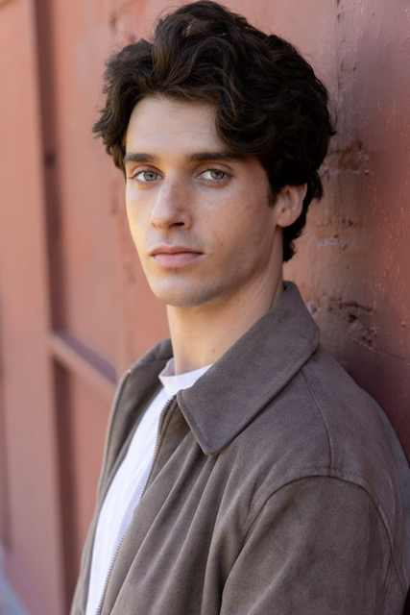
Alex Seidner
Actor

Email: setlifealex@gmail.com

Mobile: 770-235-2585
Atlanta, GA

Height:

Build:

Eyes:
Hair:

5’10”

Average/Toned
Blue
Dark Brown

Nationality:

Playing Age:

American
16‐30

Vocal Range:

Tenor

Education

2018 -‐ 2023 Georgia Gwinnett University Bachelor’s in Film Design & Production

Film

Production | Part | Company/Director | Year
The Dungeon | LEAD | Dir. Clayton Moores | 2025
Unspoken Words | LEAD | Dir. Kelsey Blevins | 2025
Life With Out You | LEAD | Summer Project | 2025
The Bride & The Goon | LEAD | Dir. Hugh Murchison | 2025
The Last Four | LEAD | Dir. Nyah Carlson | 2025
Heart Murmurs | SUPPORTING | Dir. Hannah Choe | 2025
Hungry Neck | SUPPORTING | Dir. Clayton Moores | 2025
Crybaby | SUPPORTING | Dir. Bixuan Zhang | 2024
Puppetfication | LEAD | Dir. Caleb Dean | 2024
Goodness Gracious | SUPPORTING | Sunshine Sunset Productions | 2024
Getaway | LEAD | Dir. Mia Hoffman | 2024
The Ravenger | LEAD | CMovie Studios | 2024
Do Not Go Gentle | LEAD | Little Dipper Productions | 2024
Pieces In Play | LEAD | Dir. Aaron Shurley | 2024
The Deer | LEAD | Dir. Colby Underwood | 2024
Dark Presser | SUPPORTING | Dir. Isabel Bobrick | 2024
Eli & Noah | SUPPORTING | Metissier Films | 2024
Unforgettable | LEAD | Dir. Griffin Milam | 2024
A Stellar Night | LEAD | Dir. Abigail Blommel | 2024
Fool’s Luck | LEAD | Dir. Colby Underwood | 2023
The Closing Shift | LEAD | PG RAIDED LLC | 2023
Heads, I Win | LEAD | Dir. Ethan Clark | 2023
Goodbye Michael | LEAD | Little Dipper Productions | 2023
Lagoon | LEAD | Off The Rails Productions | 2023
The Inquisition | LEAD | Dir. Stacy Beverly | 2023
Jesse’s Gift | SUPPORTING | Off The Rails Productions | 2022
television

Production | Part | Company/Director | Year
The Picture of Dorian Gray Pilot | LEAD | Belladonna Pictures | 2024
Storm of Suspicion | LEAD | Jupiter Entertainment | 2024

Commercial

Production | Part | Company/Director | Year
Hinge Spec Ad | SUPPORTING | Fox Hunter Productions | 2024
Celsius Spec Ad | LEAD | Martha Galaragga | 2024
Gas Prices | LEAD | Flying Flees Production/Devised | 2024

Industrials/ads/promos

Production | Part | Company/Director | Year
All Hands-on Deck Book Promo | LEAD | WAC Arts/Che Walker | 2025
IPORT/Sonance Ad | LEAD | Martha Galaragga | 2024
LIFE University Ad | SUPPORTING | Lavender Digital | 2024

Vertical Short Form

Production | Part | Company/Director | Year
But Daddy, I Love Him | SUPPORTING | WAC Arts/Che Walker | 2024
ELON | SUPPORTING | Dir. Amanda Fallon Smith | 2025
Other Skills & Interests

Accents:

Australian, Standard, American, Boston, British, New York, Scottish, Russian

Physical:

Golf, Boxing, Swimming, Running, Weightlifting

Experience in:

Improv, Modeling, Stand-Up, Directing, Writing, Stunts, Photo Doubling, & Standing-In

