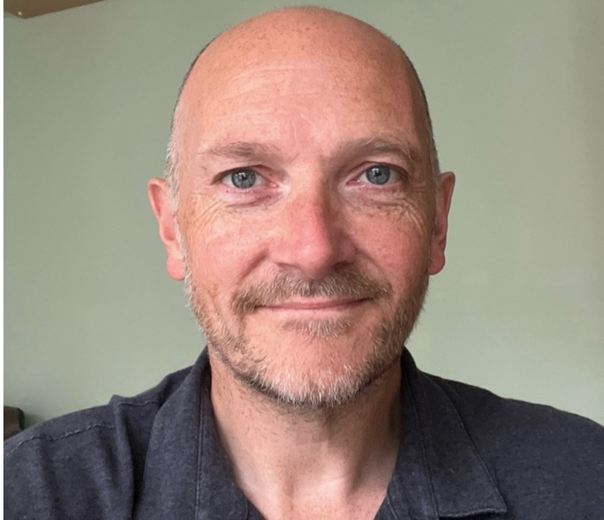**Trevor Atkinson**

**Bio**

Age 50, 6ft, Blue Eyes Medium build (12st 10lb / 81kg), size 11 feet

Bald/clean shaven head or Short brown/ greying

Clean shave or short brown/greying stubble

**Summary**

Experienced Supporting Artist/Double/Actor - actively training with The Actor’s lounge Cambridge (level 1 of 3) and online with Dave Lovatt (Monologues), Linda Taimre (Shakespeare) & Galadriel Stineman (Complete Acting) …flexible on availability, travel (I have a camper van for multi day projects) and can offer a selection of costumes.

DBS certificate available on request

**Experience**

**Film**

Peter Venkman -principle cast double for Bill Murray -Ghostbusters Frozen Empire

Heavy/Snooker Club player – ‘Wife & Dog’

**TV**

Miner - Mechanical(Silo S4)

Security walk on – Silent Witness

Office Manager-feature role - ‘Larkin’

19th century bystander & Mob member/ Boer War British soldier – ‘Gandhi Biopic’

Soldier – ‘Red Gun 2’

Tourist -Greater Anglia railways commercial

**Live event/productions**

Principle Cast ‘Dan’- What I did at school today -Comedy Amateur Dramatics Production.

Principle cast ‘Dave’-Dirty Dustin -Comedy Amateur Dramatics Production

Heavy/imposing MIB role to interact with attendees– music Album launch for band Hot Milk

**Current production in progress**

Murder mystery-delivering this Halloween