**OLUWANIFEMI ADEKOYA**

📍LOCATION: 125, BLU BRCKNELL, WOKINGHAM ROAD, BRACKNELL.

📞PHONE NUMBER: 07721560605

📧 EMAIL : [oluwanifemiadekoya076@gmail.com](mailto:oluwanifemiadekoya076@gmail.com)

📸INSTAGRAM: nimie_ade

**PERSONAL STATEMENT**

I am an inspiring model with a strong passion for fashion, creativity, and self-expression. I want to pursue modelling because it allows me to express my artistry while representing brands, helps build my confidence level and versatility. I am eager to grow in the fashion industry, bring my presence to every opportunity, and learn from professionals.

**WHY I WANT TO BE A MODEL**

* I want to gain experience, build a professional career in modelling, and challenge myself.
* The motivation to inspire others with individuality and confidence is what i aspire to do.
* I am passionate about bringing visions to life.
* I enjoy expressing myself through style, photography, and fashion.

**MY SKILLS AND QUALITIES**

* Adaptable to different poses, styles and concepts.
* Strong work ethic
* Ability to take direction well
* Confident in front of camera and on stage
* Dedicated to personal growth and liability.

**PROFESSIONAL PHOTOSHOOTS**

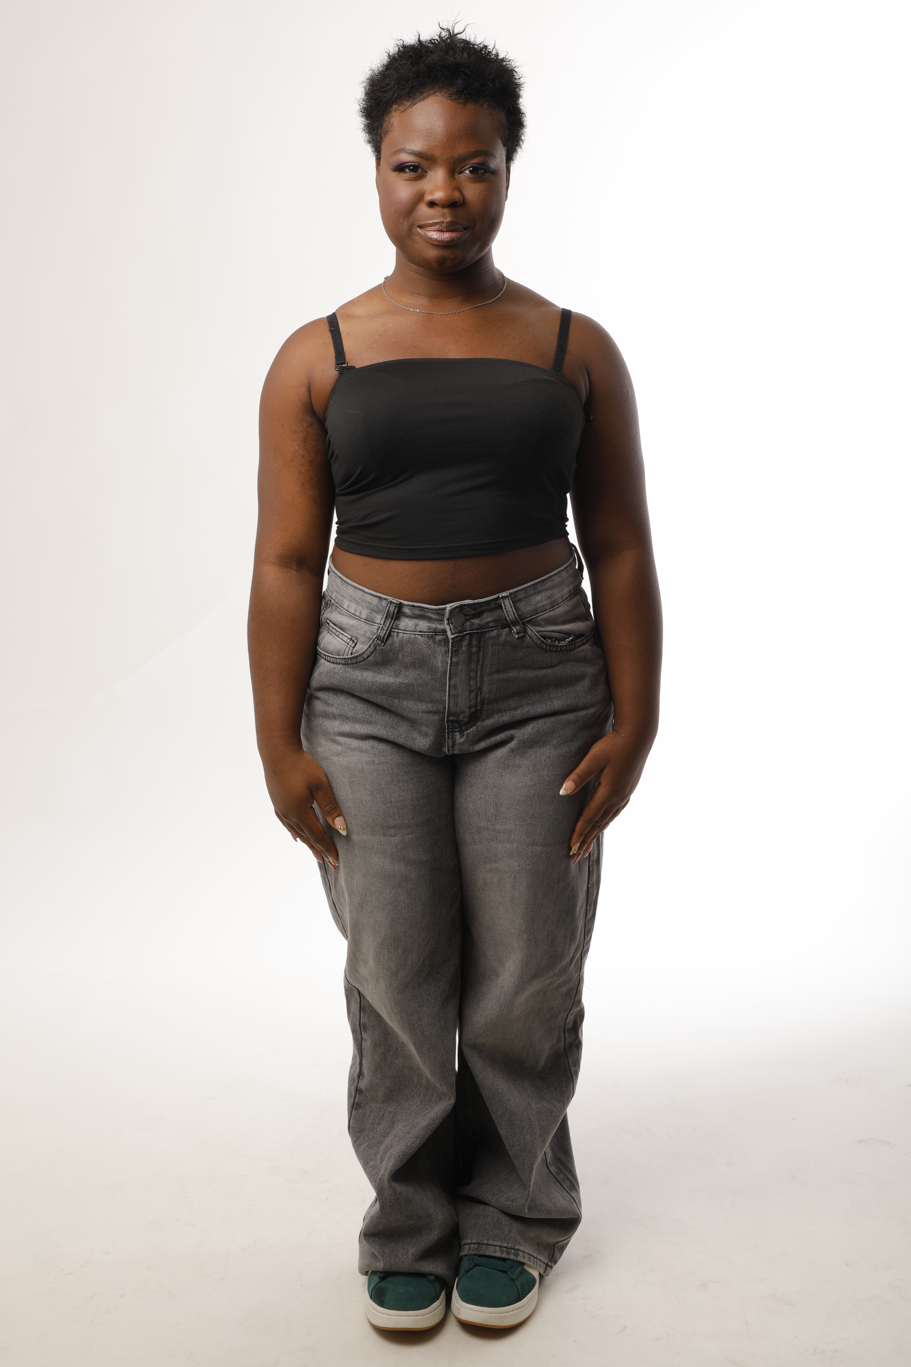

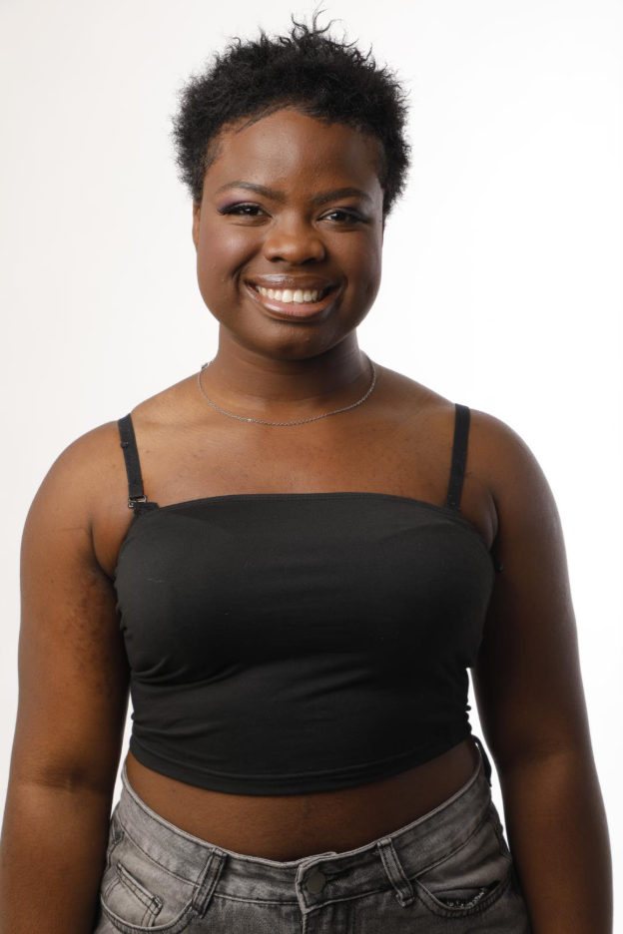 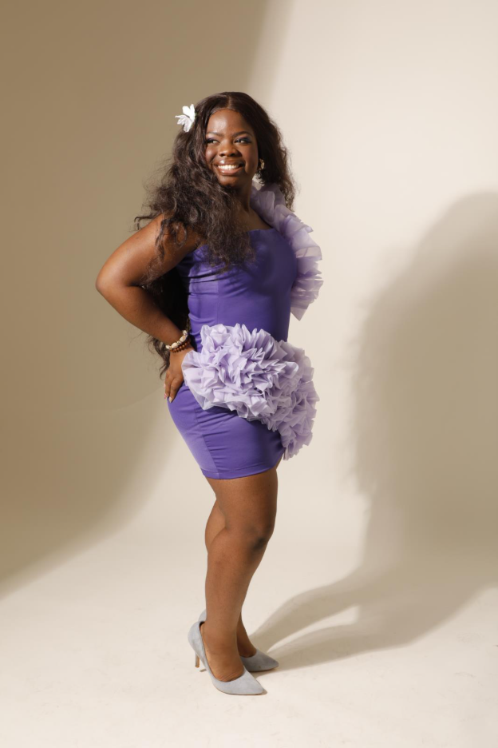

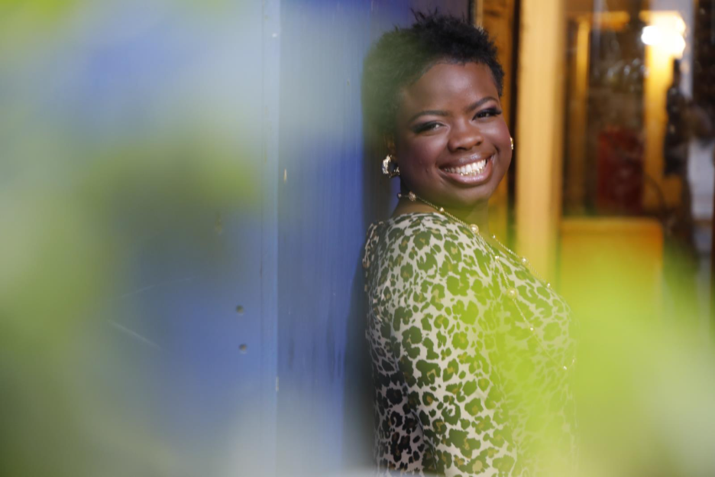

**PHYSICAL DETAILS**

* HEIGHT: 5’3
* BUST: 39
* WAIST:33.5
* HIPS:43
* DRESS SIZE: LARGE
* SHOE SIZE: 41
* HAIR: BLACK/ SHORT
* EYES: BROWN