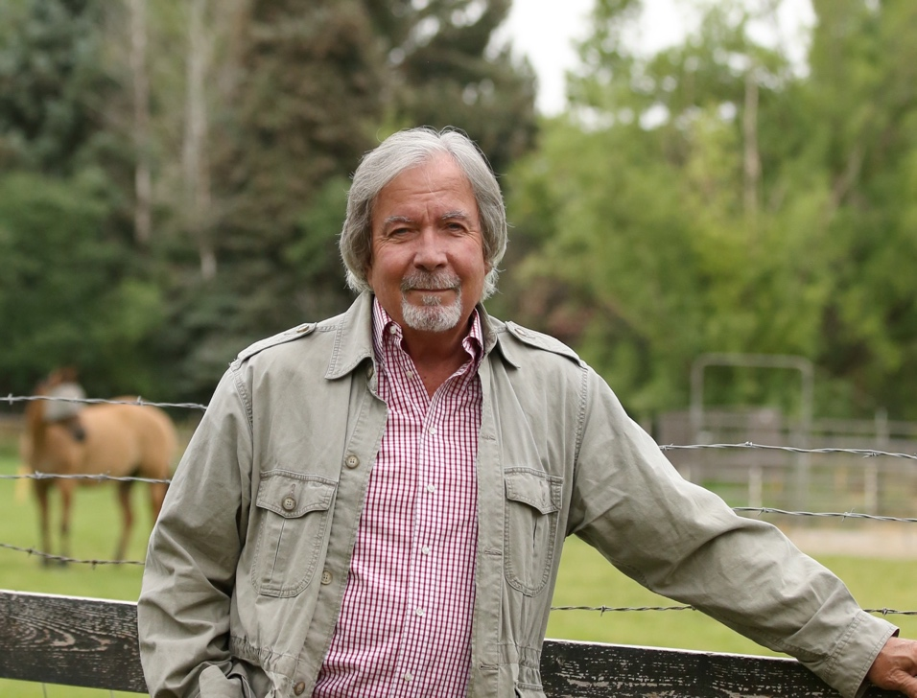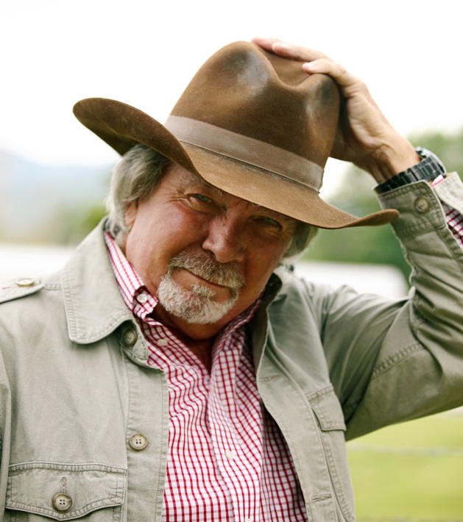**Norman Jarvis**

Contact Details: Physical Attributes:

[norm.jarvis@outlook.com](mailto:norm.jarvis@outlook.com) Height: 6’1”

801-599-7310 Weight: 215

898 Pumphouse Rd. Hair: Gray

Divide, MT 59727 Eyes: Blue

Age Range: 60-70

Summary:

Retired National Security executive and Intelligence Community operator. Skilled in improvisation, stage combat, horseman, military/law enforcement and counter terrorism technical advisor. Professionally trained and experienced critical undercover roleplaying and deception. Dedicated to creating, as directed, a quality connection between my characters and the target audience.

Film Credits

Montana Lucky Supporting Adam Smith/Sojourn Productions