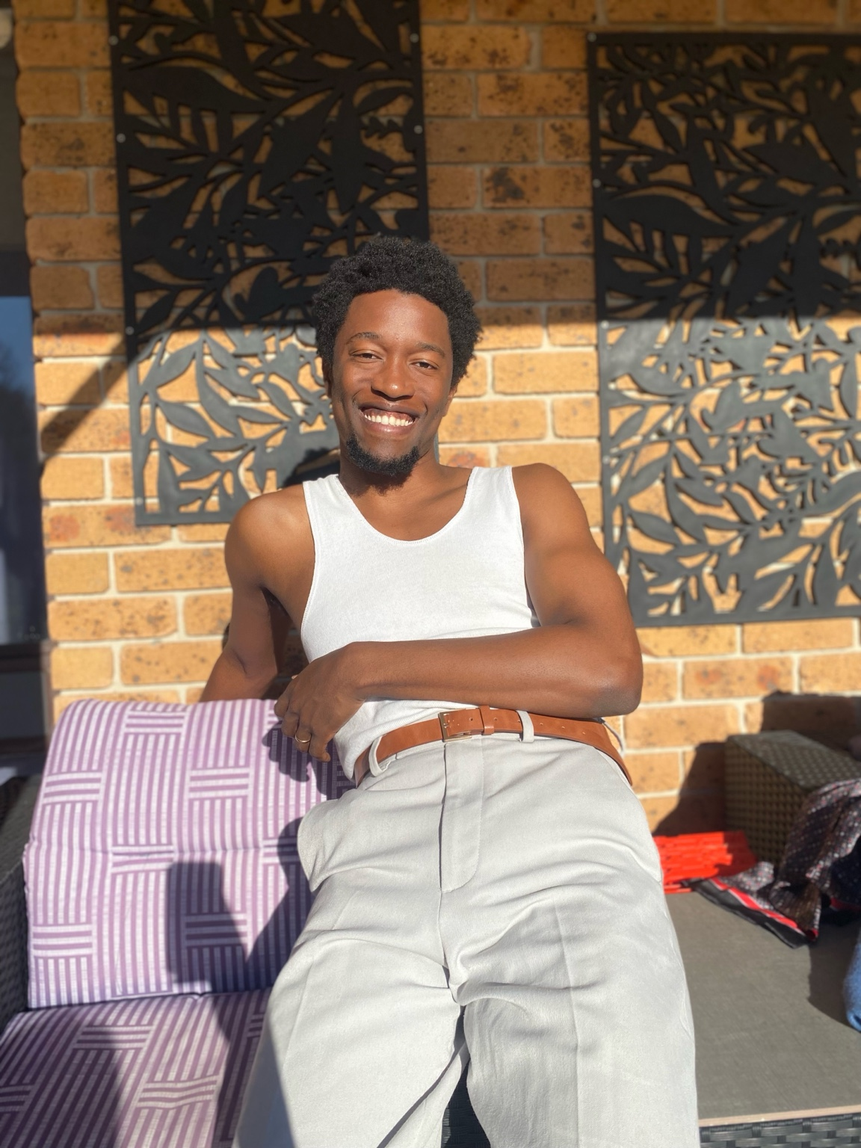

MALAN ZANA
📞 0477 175 711 | 📧 malanrzana@gmail.com | Represented by Agency 888
🎵 Artist name: ZHANESU | 📍 Based in Australia

PHYSICAL DETAILS
Height: 183 cm
Weight: 70 kg
Hair: Black
Eyes: Brown
Playing Age: 17–27
Voice: Singing (Tenor/Baritone — informal)

FILM & TV EXPERIENCE
NCIS: Sydney (TV Series) — Extra — 2025
2 Years Later (TV Series) — Extra (2 episodes) — 2025

TRAINING
• Self-taught via YouTube (ongoing)
• Influenced by Stella Adler technique

MUSIC
Performer & Songwriter under ZHANESU
• New Stage
• Destination
• Won’t Live a Lie
(Available on all music platforms)

SKILLS
• Singing
• Dance
• Drumming
• Dialects/Accents:
- American
- Irish
- Australian
- African
• Physicality, Character Work
• Improvisation

