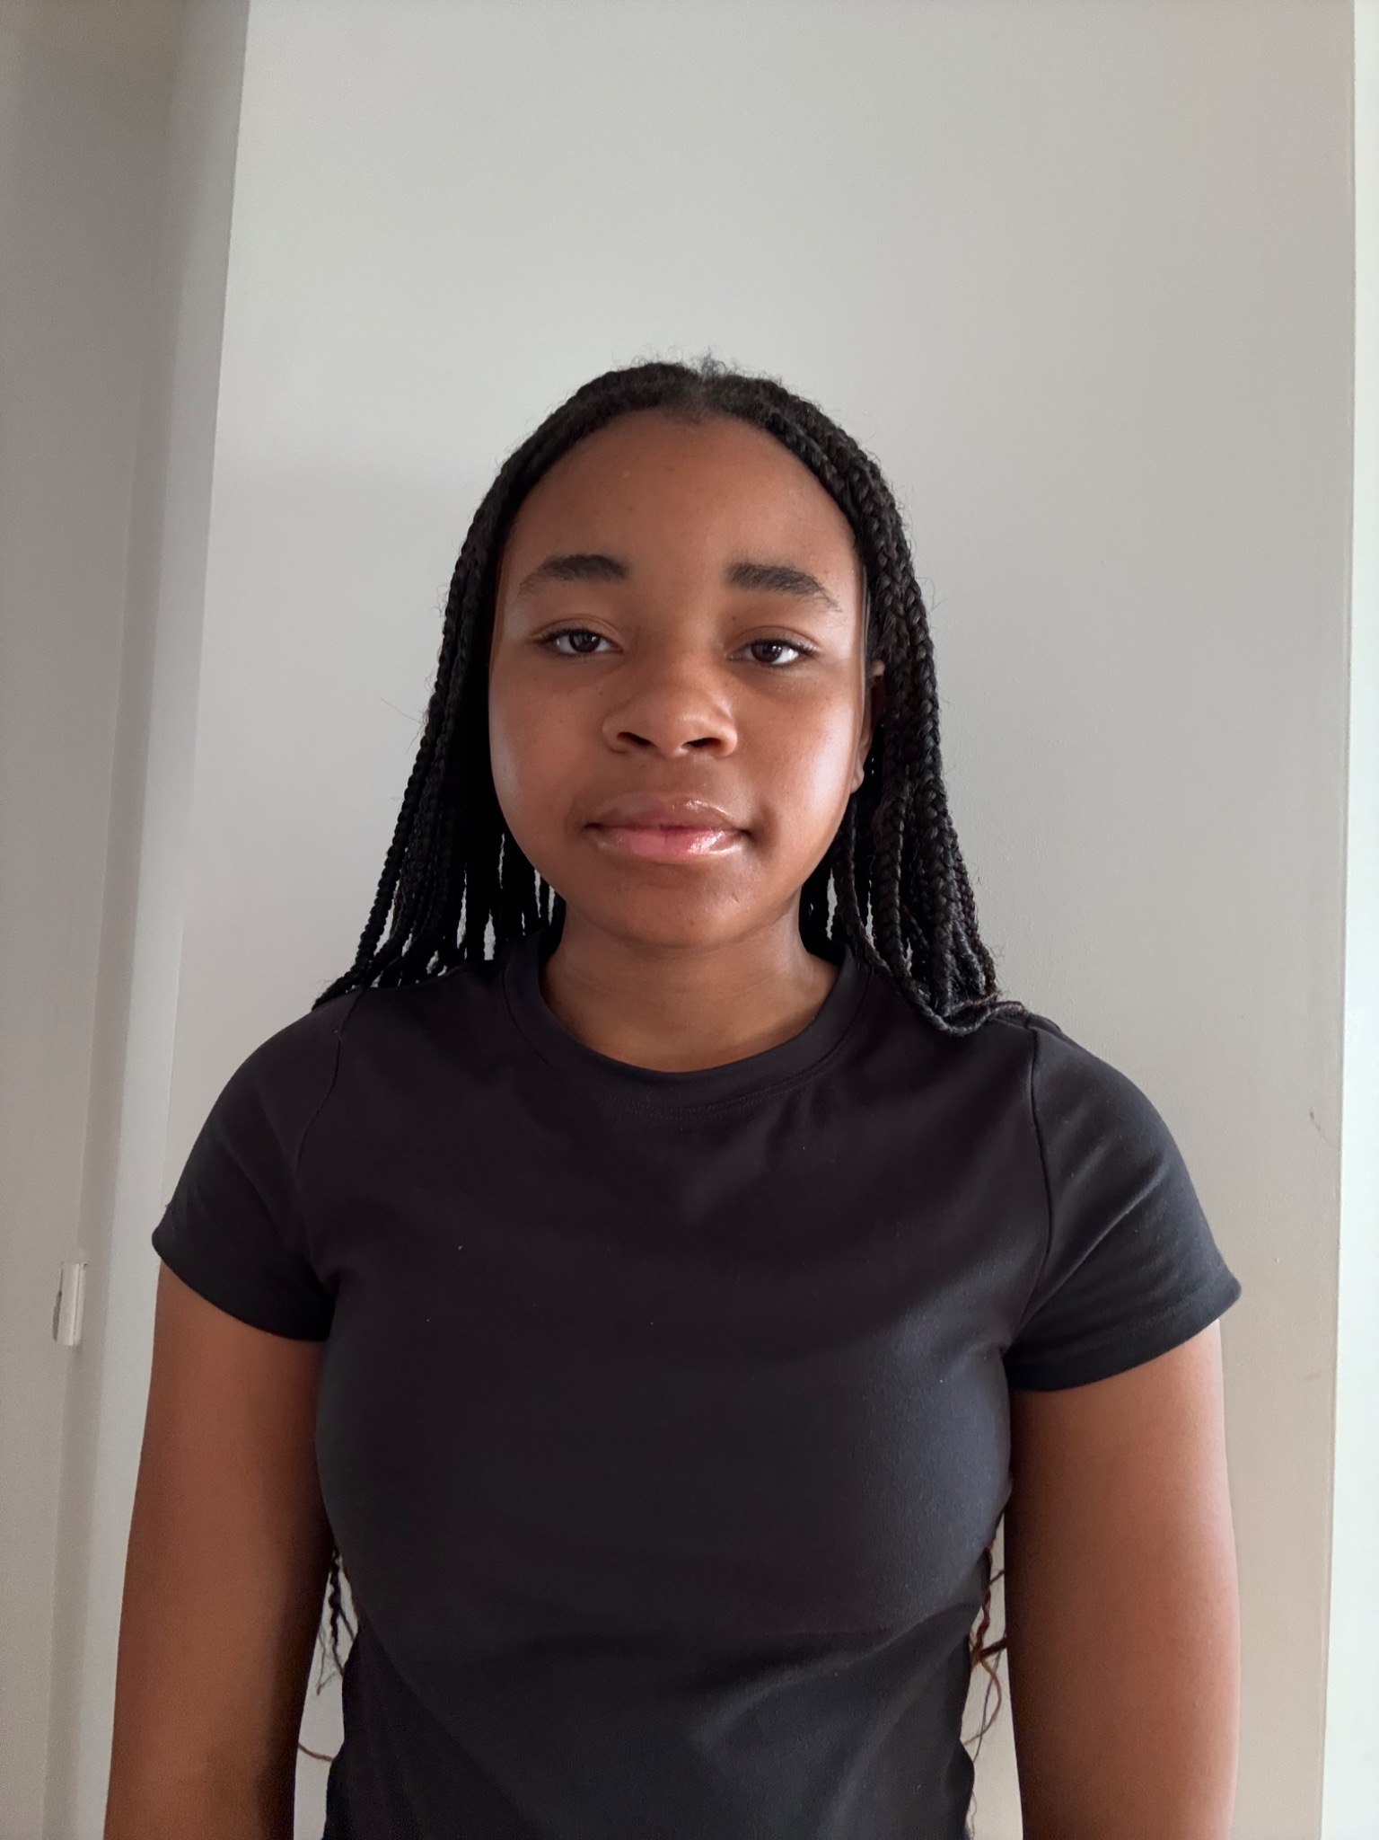

# KHLOE MUTAMANGIRA

Email: khloemutamangira315@gmail.com

Instagram: @khloe.faith_

TikTok: @followerofchristkhloe

## PHYSICAL INFORMATION

Height: 5’6”

Weight: 65 kg

Age: 14

Hair: Dark Brown

Eyes: Brown

Languages: Fluent English, Semi-Fluent Spanish

Accents: American (confident)

## EXPERIENCE

Backstage Crew – School Production  
- Assisted with stage transitions, props, and backstage organization for a school play.

Choir Member – School Choir  
- Participated in vocal performances and group singing.

## TRAINING & SKILLS

- Gymnastics (Former Gymnast): Strong movement, flexibility, and body control

- Horse Riding: Confident rider

- Soccer (Vice Captain): Leadership and team coordination

- Netball, Tennis, Cricket: Athletic, team sports experience

- Trumpet (Former Player): Basic brass instrument experience

- Singing: Trained in school choir

- Acting: Stage experience (backstage and performing), confident presence

## SPECIAL SKILLS

- American accent (strong)

- Singing

- Basic trumpet

- Stage crew experience

- Athletic versatility

- Leadership in sports teams

- Semi-fluent in Spanish