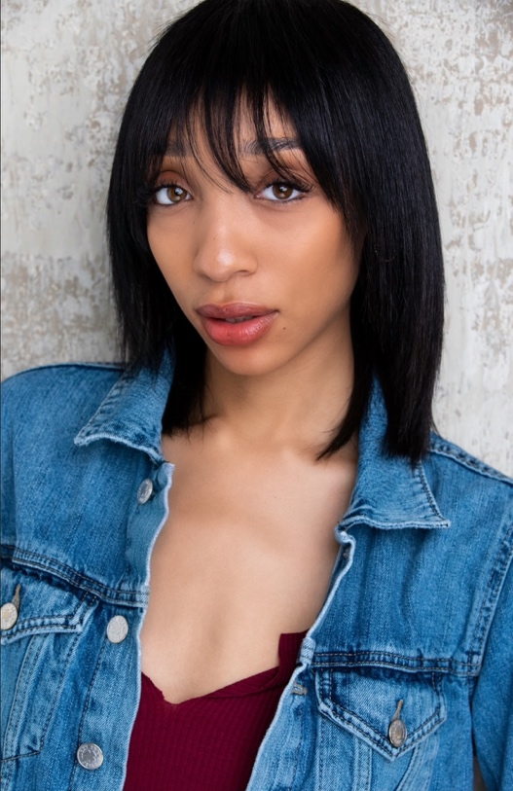
Jaida Standberry
Actress
Email: jaidasbookings@gmail.com

Mobile: 440-622-2836

Height: 5’8

Build: Slim

Eyes: Hazel
Hair: Dark brown
Nationality: Black

Education/Training

2012 -­‐ 2018 Theatre Cleveland School of the arts
2014 -­‐ 2015 Theatre Karamu House
2021 -­‐ 2021. Script Analysis Drama inc Atl
2022 -­‐ 2023 Film/tv Premier Actors

Theatre

Production | Part | Director | Network
A Christmas Carol | Fran | Scott Miller | Cleveland school of the arts
One Night | Nina/Jodi | Toni Garner | Cleveland school of the arts
Twilight: La riots | Ensemble | Scott Miller | Cleveland school of the arts

Film

57 Seconds | Ronnie/Waitress | Rusty Cundieff |  | Amazon Prime
5lbs of pressure | Keyshia | Phil Allocco |  | Amazon Prime
Call me now: Rise and Fall | Porsha | Tim Reid |  | Lifetime
The caregiver | Margo | Bobby/Renee Peoples |  | Tubi
You can never go home again | Samantha | Renee Peoples |  | Lifetime

Business of Christmas 2 | Trish/Bartender | Tim Reid |  | Bet +
Fixation 2 Uprising | Morgan | Bobby/Renee Peoples |  | Trafalgar Square

Other Skills & Interests

Extras:

Producing, Executive Producing, Boxing, Kickboxing, Directing, Improv, Contemporary dance, Guitar playing

