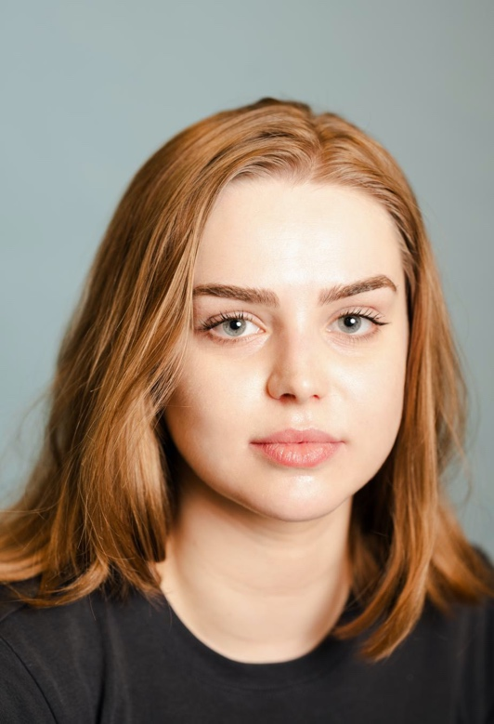
Freya Todd
07856079494
Freyatodd144@gmail.com
Spotlight: 4613-7838-0908
Playing Age: 16-26
Height: 5”5
Location: London

Skills: American-California, American-New York, American-Southern States, Bristol, Central Scottish, Cockney, Essex, Irish-Northern
AFTERPARTY | 2025 | Short Film | Daisy | Kingston University | Rosie Winnan
ONE FOR SORROW | 2025 | Short Film | Birdie | Magpie Productions | Ben Delaney
WHAT IS PERFECTION ANYWAY? | 2025 | Stage | Margaret | Wimbledon College of Arts | Freya Todd
MORNING CRUSH MUSIC - FIGHTING THE DOG | 2024 | Music Video | Katie | Amybeth LTD | Amybeth McNulty
WICKED | 2024 | Film | Shiz Student | Universal Pictures | Jon M. Chu
LUTHER: THE FALLEN SUN | 2023 | Film | Passerby | BBC Films | Jamie Payne
YOU | 2022 | Television | Student | Warner Bros. Television | John Scott
SILENT MIND | 2020 | Stage | Helen | Theatre For Life | Michelle Smith
BURYING YOUR BROTHER IN THE PAVEMENT | 2018 | Stage | Courtney | Theatre For Life | Michelle Smith

