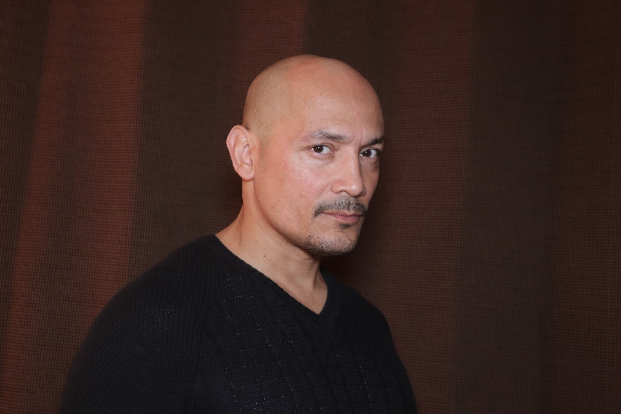



(917) 335-0503

rich42castro@gmail.com

# SKILLS

* Ground Pounder
* Boxing
* Firearms & Tactical Training
* Kick Boxing
* Acting
* Football
* Baseball
* Obstacle Athlete
* Weapons
* Fight Choreo
* Swimming
* Basic Parkour

[**Showreel**](https://vimeo.com/332030646/bddf01bafa)

**PROFESSIONAL EXPERIENCE**

**Stunts Actor**Power (TV Show)

* Stunt Coordinator: **Peter Bucossi**

**Stunt Driver**Vision Zero (TV Show)

* Director**: Carly Hugo**

**Stunt Actor**Not Saved by the Bell (Movie)

* Stunt Coordinator**: Chazz Menendez**

**TRAINING**

**UATW Stunts:** Chazz Menendez

**The Quiet Storm Seminars:** Jery Hewitt, Manny Siverio, Chris Barnes   
Jarred Burk, Anthony Vincent

RICH CASTRO   
**Stunt Performer (non-union)**

Height: 5’8”

Weight: 180lbs

**Contact**

**+91-8972648571 / 9064418957**

[**mukherjeeabhimanyu1992@gmail.com**](mailto:mukherjeeabhimanyu1992@gmail.com)

**3L Avani Orchid, Muchi Para, Tollygunge, Kolkata - 700041, West Bengal**

# Key Impact Areas

* Sales & Marketing
* Business Growth & Development
* Marketing Intelligence
* Strategic Partnership & Alliances
* Key Account Management
* Lead Generation
* Cross-Functional Coordination
* Client Relationship Management
* Competition Analysis

# Certifications

**Marketing Foundations certification   
(LinkedIn)**

**Persuasive Selling Certification   
(LinkedIn)**

**Soft Skills for Sales Professionals certification (LinkedIn)**

**Business development foundations   
(LinkedIn)**

# Languages

**English**

**हिंदी**

**বাংলা**