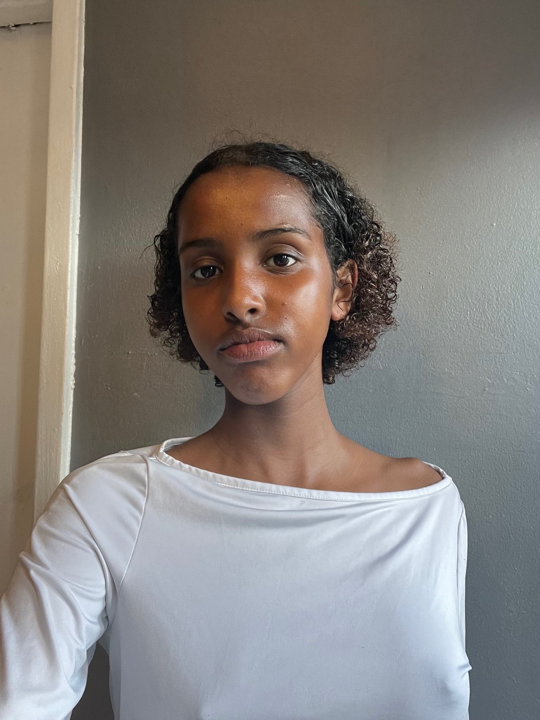

**Bushra Hassan**

London, UK | Height: 5’6 | Playing Age: 14–17  
Email: your.email@example.com

## Film & Television

Lead Role – Short Indie Film – Dir. Sawda Hassan (2024)  
Lead Role – Horror Short Film – Dir. Sawda Hassan (2024)  
Supporting Role – Short Indie Film – Dir. Sawda Hassan (2023)

## Theatre

Lady Macbeth – Macbeth – Albany Theatre (Lead)  
Wicked Witch of the West – The Wizard of Oz – School Production  
Mary – The Story of Jesus – School Production  
Wolf – Little Red Riding Hood – School Production

## Training & Workshops

Drama Work Experience – Lyceum Theatre, West End (*The Lion King* rehearsals)  
Work Experience – Albany Theatre (x2 placements)  
Accepted into multiple acting classes (2024–ongoing)

## Notable Auditions

The Princess Diaries  
Treasure Island  
Camp Rock 3  
Short Films

## Special Skills

Singing & Dancing  
Can cry on cue  
Accents: General American, Standard British, Posh British  
Method Acting (occasional)  
Improvisation  
Strong stage presence