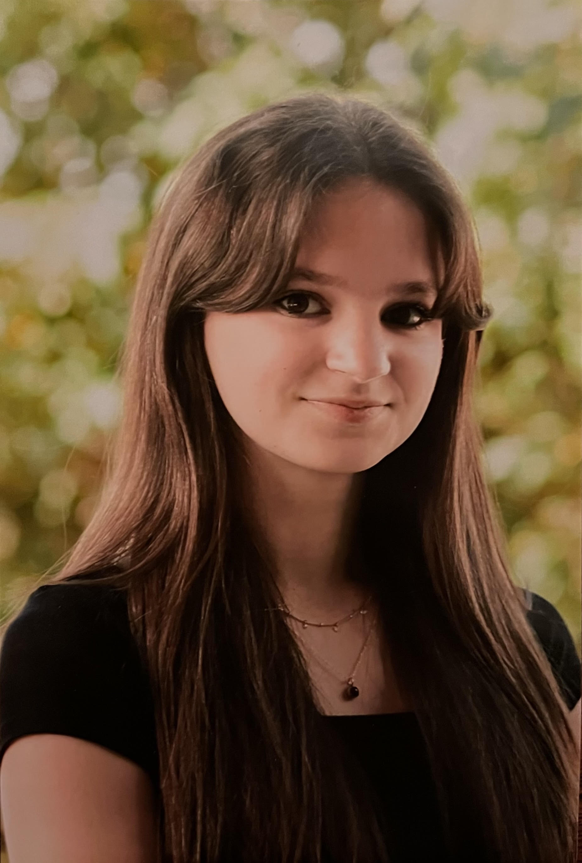Brie Lukasavige

Hair: Light brown Prounouns: She/Her

Eyes: Brown (719) 310-3692

Height: 5’4 [Brielukas@gmail.com](mailto:Brielukas@gmail.com)

## Education

Working on getting an Associates Degree in Theatre at Pikes Peak State College.

## Acting Experience

*Honk* Ensemble Jr.Woodlandplayers 2017

*Mary Poppins* Ensemble Jr.Woodlandplayers 2018

*Annie* Ensemble Jr.Woodlandplayers 2019

*Frozen Jr.* Cook/Oaken familyJr.Woodlandplayers 2021

*Oliver!* Ensemble Jr.Woodlandplayers 2022

*Treasure Island* Ensemble Panther Players 2022

*Anastasia* Ensemble Panther Players 2023

*The Little Mermaid* Maid/Ensemble Jr.Woodlandplayer 2023

*Big Fish* Ensemble Panther Players 2023

*The Hunchback of Notre Dame* Choir Panther Players 2024

*Willy Wonka* Alfie/Ensemble Jr.Woodlandplayers 2024

*The Lion the Witch and the Wardrobe* Aslan’s follower Panther Players 2024

Curtains Ensemble Panther Players. 2025

*Suessical Mrs. Mayor Jr.WoodlandPlayers 2025*

## Special Skills

* Singing - Soprano
* Accents - British and southern
* Figure Skating
* Dancing - All styles