TALENT PORTFOLIO: RUSSELL T. BLACKWELL

Email: russcheer@yahoo.com
Phone: (973) 771-4912
Instagram: @russcheer, @kindness_mobile_thrift_shoppe, @therusscheerfoundation
Website: www.therusscheerfoundation.org
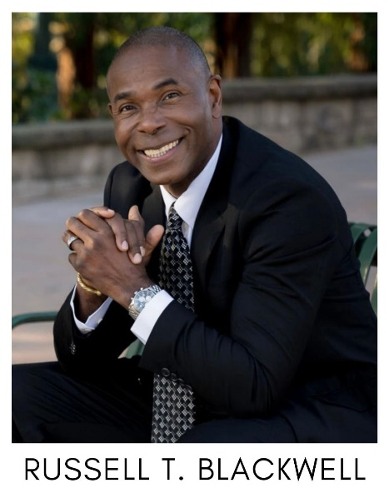

ABOUT ME
Russell Blackwell is a dynamic and versatile performer hailing from New Jersey, with an extensive background in professional cheerleading. Specializing in partner stunting, Russ has built a vibrant career as a performer, instructor, coach, judge, and motivational speaker in the cheer world.

His journey has taken him from the sidelines of the NFL and NBA to appearances in commercials, university films, and even the iconic Miss America Parade. Known for his high-energy performances and unwavering precision, Russ brings passion and charisma to every role, whether on stage, on screen, or in front of a live crowd.

Now based in California, Russ is the founder and chair of a nonprofit organization dedicated to spreading kindness and giving back to the community. His work continues to inspire both in and out of uniform, and he remains a respected figure across the entertainment, sports, and nonprofit worlds.

"Act as If - Carpe Diem."

PERFORMANCE RESUME
FILM & TELEVISION
“Superhero” – Lead – indie collegiate feature – Dir. Janine Vernola
“The Richard Bay Show” (WPIX) – Featured Guest - 1990
“The Rachel Ray Show” – Audience warm up – 1 episode - September 2010 “Today Show” – NBC – on cameral cheer performer (Olympics Edition) 2022 “Good Day Australia” – speaker – Instructor-Demonstration – 2004,05,06.07 “The Morning Show” (England) – Instructor- Demonstration – 2005,07,08 “Go Cheer” Regional Televised cheer competition – Broadcaster – analyst – 2001

THEATRE
Sampson and Delila - Opera – Supporting – Metropolitan Opera House Anti-Gravity -– performer – NYC/Utah Untitled Play – Stunt Choreographer – NYC Grease – Cheer Choreography – Memorial Auditorium - MSU
Crash Test Dummies – Ensemble – Off Broadway
DANCE / CHEER
Cheerleader – Montclair State University – 1986 Princeton University – Coach - 5 Years
Montclair State University – Coach 5 Years Universal Cheerleading Association – instruction/admin – US / Great Britain Performed in the Thanksgiving day parade in NYC. Performed in the Lord Mayor of Westminster day parade in England. New Jersey State Cheerleading Association - Director – Master of Ceremonies -3 years National All Star Cheerleading Champion – Open Division - 7 Years Terminators Semi Pro Football League – Cheer Coach and performer- 2 years National Football League – Eagles – Cheerleader stunt team – 2000 National Basketball Association – Fan Patrol – Lead Stunter and cheerleader – 5 years WNBA – Cheerleader- Liberty -1 year United States Air Force – civilian Instructor – Pacific Rim – 2 years Gymnastics Australia – Speaker – instructor- Judge – 6 Years Metro Stars MLS - Coach/Cheerleader- 2 Years Various National Organizations – Partner Stunt Champion – 7 years Tri-State Stunt Fest -Director – 5 years Circus Warehouse – Guest Instructor – 1 Season NBA All Star Game – Lead Stunter/Cheerleader – 4 years Miss America Organization – Escort- Performer – 2 years Major League Hockey – Exploratory team, cheerleader – 1 year Private contractor – instructor- safety – speaker – Judge -30 years
MODEL WORK
College Life Union Board – runway – Spring 1992
“Cheer” Magazine – Instructional/Editorial Spread – Fall 1997
“NCA” Uniforms – Editorial Spread/runway – May 2005 March of Dimes”– Print – Fall 1988
COMMERCIAL WORK
“Aquafina” – Spring 1992
“WalMart - Fall 1997
“ESPN” – Winter 1995

TRAINING
- Cheer Stunt Technique – Pat Wedge Georgetown Heat
- Instruction – National and Universal Cheerleaders Associations
- Elite Stunt basics – Gym Tyme Louisville Kentucky
- AACCA Safety Training – Memphis Tennessee/Sydney Australia
- Coaching Coaches – University of Notre Dame Athletics
- Cheer Stunts & Tumble – Various Gyms and programs across the US and internationally

SPECIAL SKILLS
- Partner Stunting
- Group Stunting
- Acro/ Circus experience
- Cheerleading Instructor
- Cheerleading Judge and speaker
- Stretching instructor
- Dialects: NYC, Australian

PHOTOS
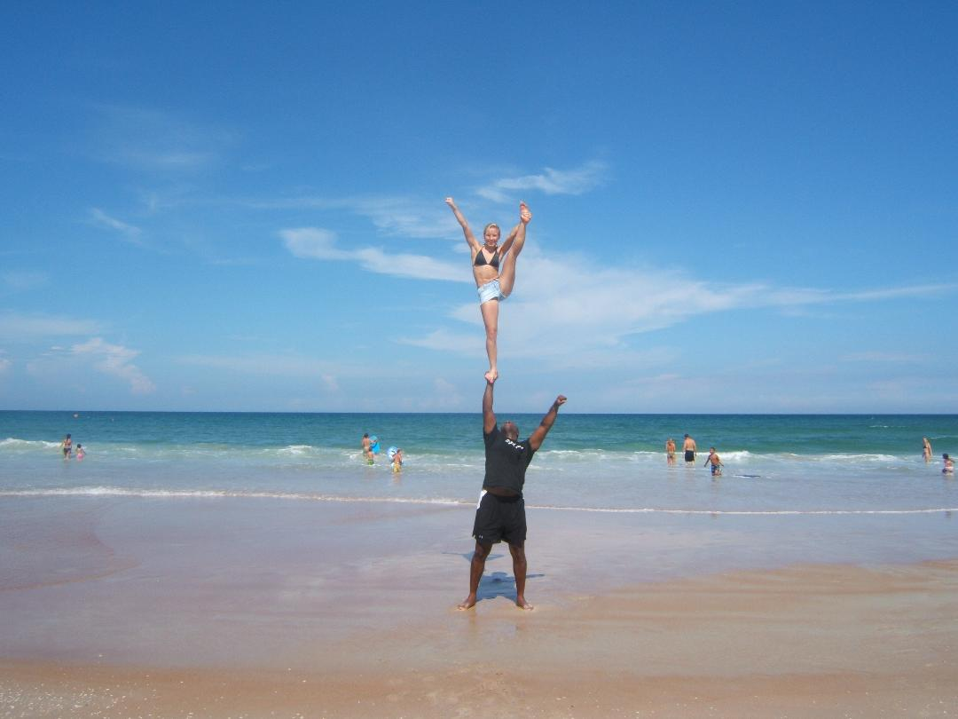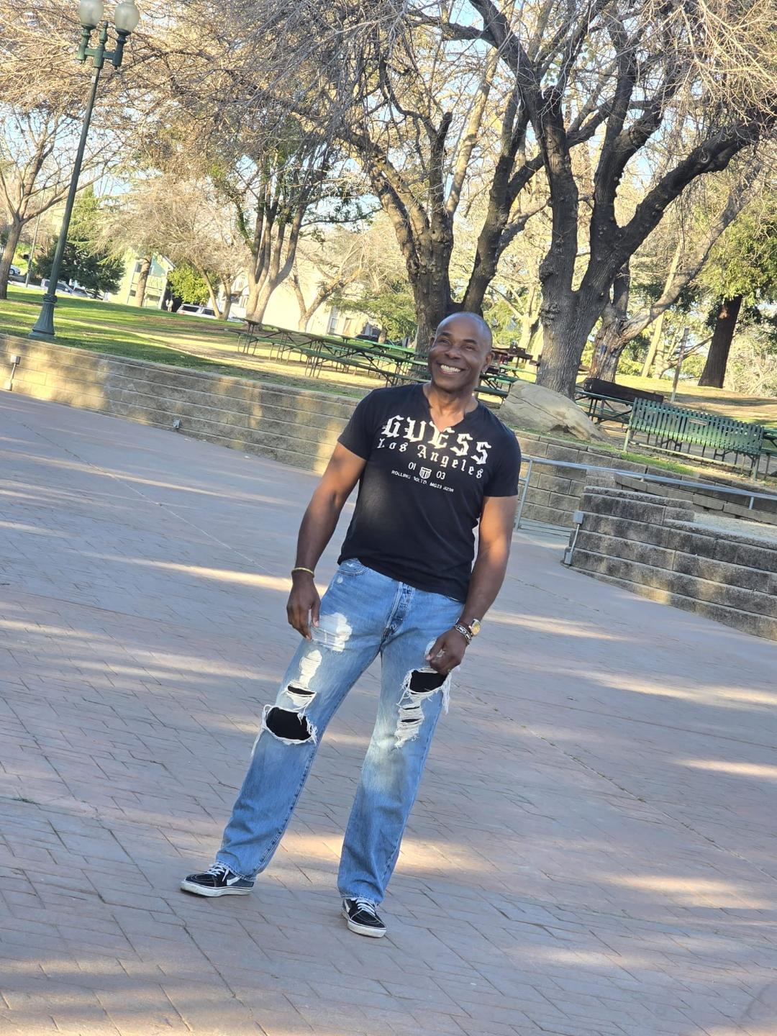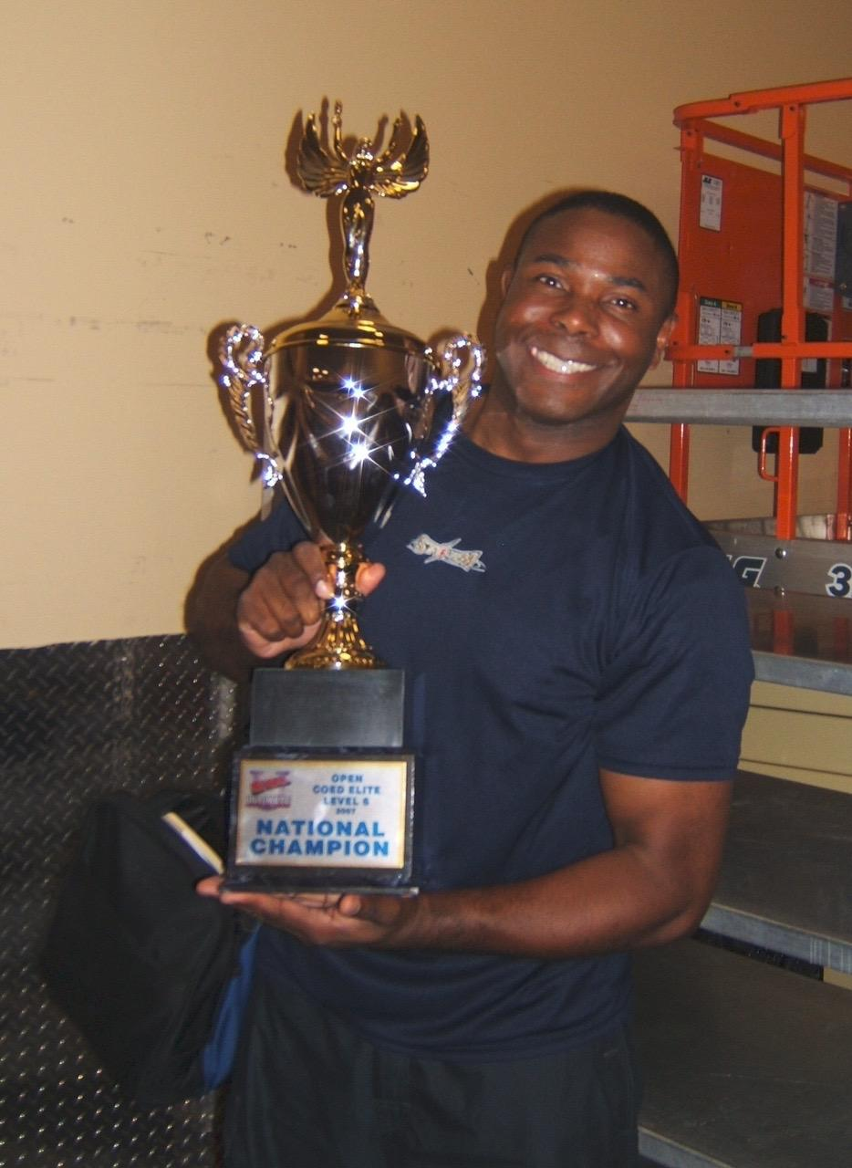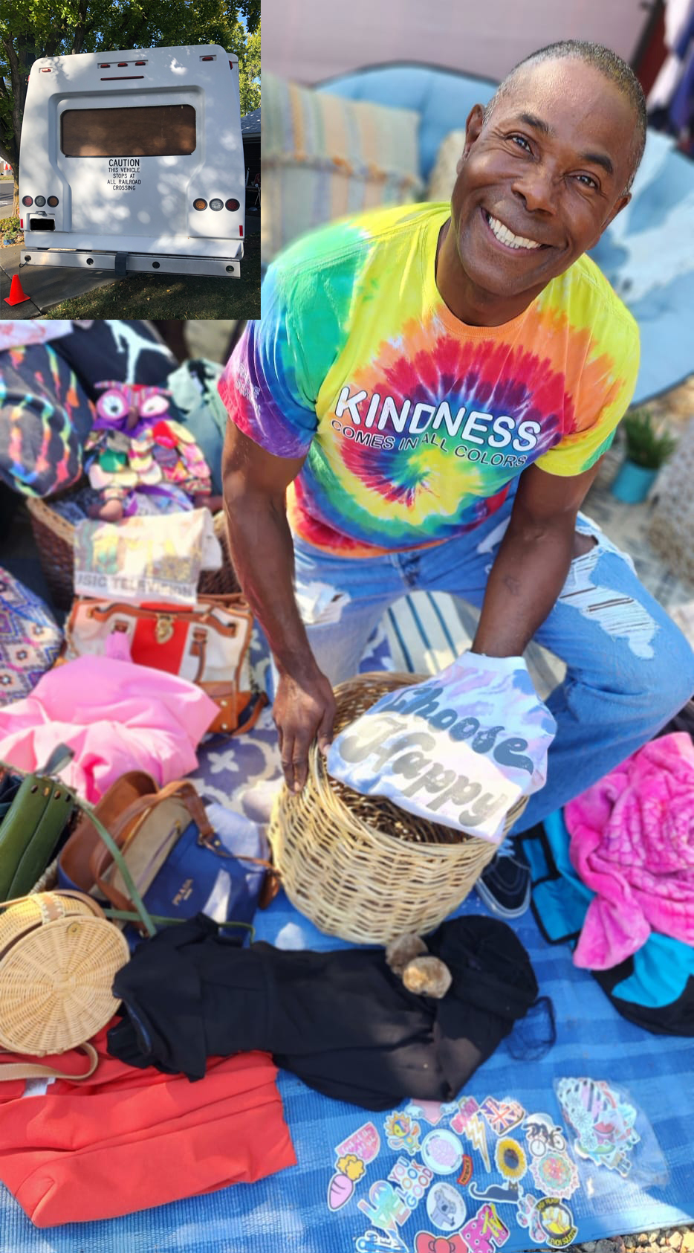
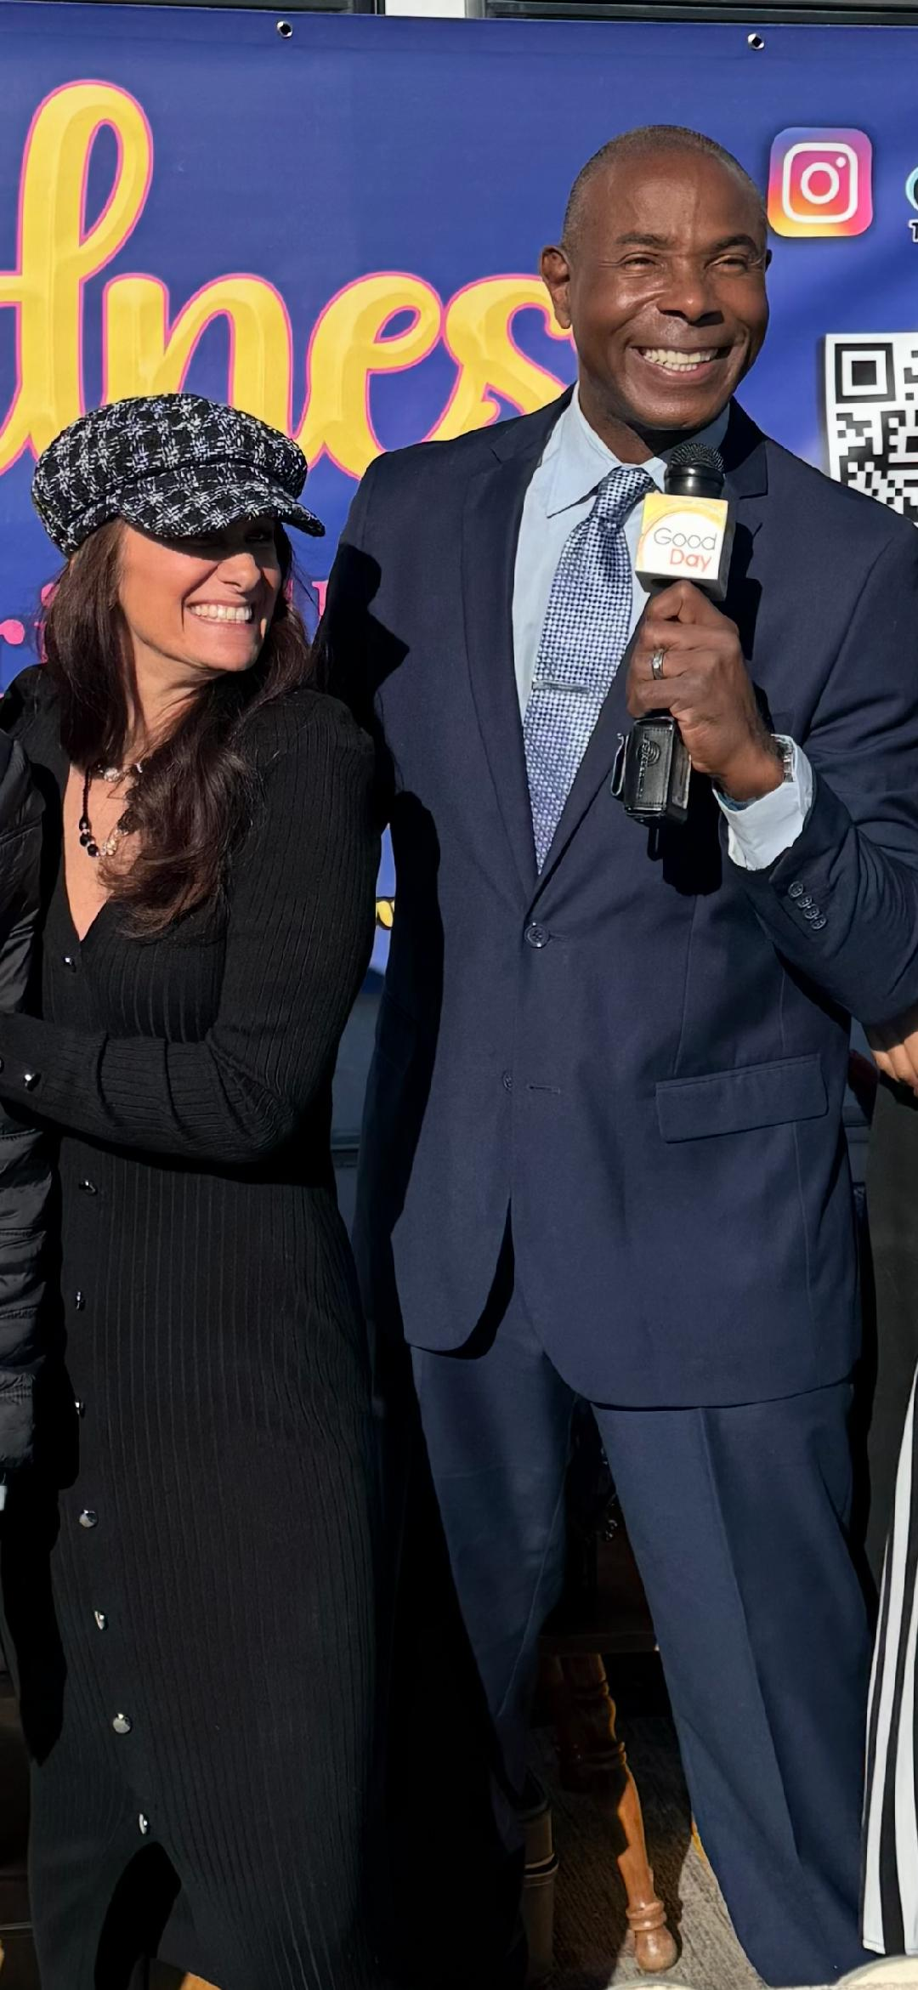

VIDEO REELS
TBA

PRESS & FEATURES
- “Universal Performance Association” – Hall Of Fame Recipient (Feb 2007)
- “Good day Sacramento” Interview – Sade Brown
- “ABC 10” - Interview -Alex Bell
- Hometown Hero - 2025

TESTIMONIALS

"Russell is the kind of person who walks into a room and instantly lifts the energy. As a cheerleader and performer, he’s unmatched in power, presence, and skill. As a coach and judge, he brings integrity and inspiration. And as a nonprofit leader, he puts heart into every move he makes."
— Kelly Ann Alexandre, Cheerleader Dancer & Longtime Friend"

"Russ doesn’t just take direction—he elevates it. Whether he’s learning choreography, adapting on set, or leading a community event, he listens with intention and executes with excellence. People naturally trust and follow his lead."
— David James Didee, Event Organizer & Community Partner

"I’ve judged alongside Russ and coached beside him—and in both settings, he’s a force of nature. His ability to motivate athletes while maintaining high standards is rare. He’s a master of his craft, and he gives back tenfold."
— Shiela Ford, Cheer Coach & Judge

"Russell is magnetic. He connects with people from all walks of life and makes them feel seen, heard, and celebrated. His nonprofit work is an extension of who he is—kind, uplifting, and full of purpose."
— Logan Shield “General Hospital Stunt man,” Public Figure & Philanthropist

"From stunting at the pro level to building a mobile boutique that spreads kindness, Russ does everything with heart. He’s a true ambassador of what cheerleading is all about—spirit, strength, and service."
— Joan Russell., Winery Owner & Event Host

