5’7” 165lbs **Anfernee (QeShaun) Bell** 720-919-6823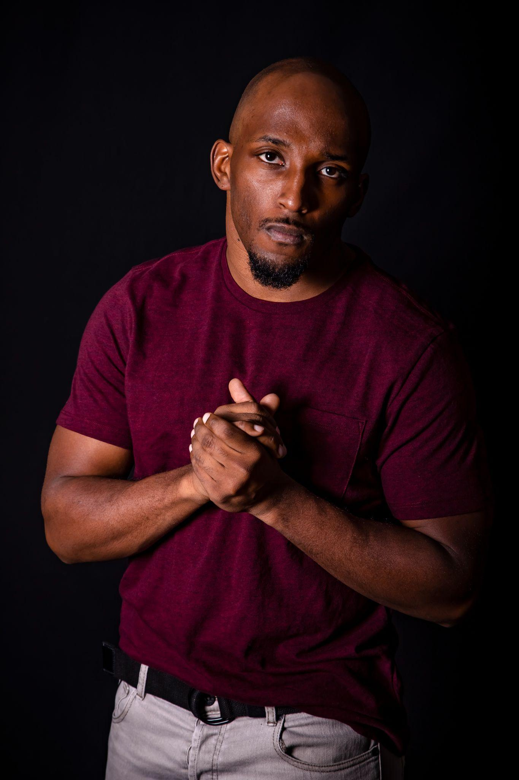

Denver, CO qeshaunbell@gmail.com

**Anfernee Q. Bell**

**(QeShaun)**

(720) 919-6823 - [qeshaunbell@gmail.com](mailto:qeshaunbell@gmail.com) - IG: TrueHBQ - Non Union

Height: 5’7” Weight: 160lbs Hair: Black/Bald Eye: Brown Shoe: 9.5

Neck: 15.5” Sleeve: 23” Pants: 32x32 Coat: Large Language: English

**Training**

Wrestling College/ Highschool (4 yr Competitive)

MMA Shin Gi Tai MMA Gym

Boxing A1 Boxing Gym

Tactical w/ Handgun & Tazer HSS (Security)

Truck Driving CRE England

Football/Track Highschool (2 yr Competitive)

**Skills**

**Fighting:** Boxing, Wrestling, Bladed Weapon, Blunt Weapon, MMA

**Falls:** Foot falls, stair falls, rolls

**High Falls:** Header (35 ft), Sit Fall (35 ft), Faceoff (25 ft), Backfall (25 ft)

**Wirework:** Ratchet, Jerk Vest, Rappelling, Hand Pulls, Flying Harness

**Fire Burn:** Back Burn

**Other:** Some gymnastics/ Acrobats, Some dance, some Parkour, Basketball, football, track, precision driving

**Certifications:** CDL, US Passport