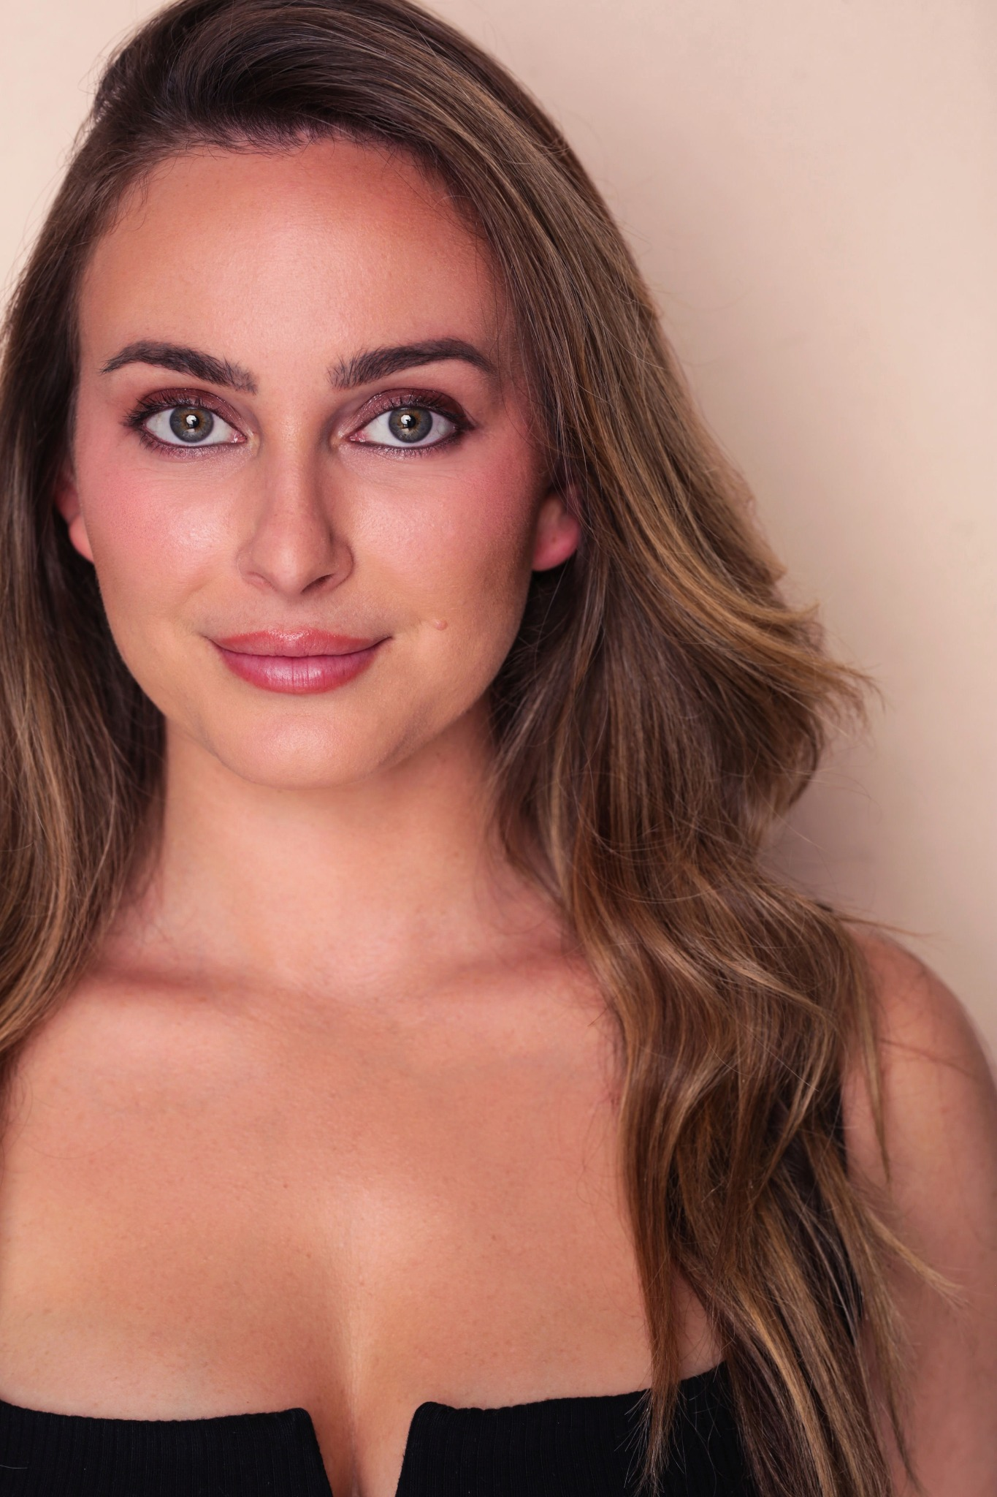

ALLY MELIDEO

Los Angeles, CA · ally@shopsurlacote.com · 310-698-2712

# FILM & TELEVISION

## Lookout at Woodrock Ridge

Role: Nikki

Feature (Post-Production)

## Brace for Danger

Role: First Class Passenger

Feature (Post-Production)

## Average Joan

Role: Average Joan – Networking Event Character

Pilot

## Risk

Role: Casting Assistant (character)

Short Film

# TRAINING

Anthony Meindl's Actor Workshop — Scene Study & On-Camera Technique (May–Dec 2024)

Sketch Comedy Writing — Jimmy Fowlie (Focus on comedic voice & sketch structure)

# PHYSICAL DETAILS

Height: 5'2"

Hair: Light brown

Eyes: Green

Union Status: Non-Union