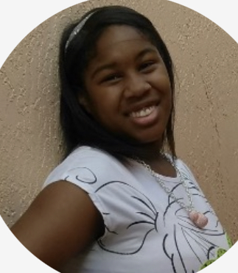

(754)-816-0022

Florida

parisvirtualhome@yahoo.comoo

LULsgejkeksA@163.com

**Paris Merdelus**

**Job intention：English**

· Improvisation (strong abilitycreating-in-moment performances)

· Accents: British, Russian

· Languages: English (fluent)

·

Although I have not yet had the chance to gain professional on-set experience, I have dedicated time to building a foundation in acting through training and coaching. Working with my acting coach, Karen, I developed skills in reading monologues, storyboards, scripts, and folktales, as well as practicing improvisation and accents. I am actively seeking legitimate opportunities to grow as an actor and bring my training, dedication, and passion to the screen.

**SKILLS & SPECIALTY**

No formal acting credits yet — actively training and seeking opportunities to gain on-set experience.

· **Elementary School Project — Performer**  
Acted in a commercial-style presentation focused on advertising Disney, developed as part of a class project. · **Private Coaching with Karen (Age 12)**  
Trained in reading and performing monologues, storyboards, scripts, and folktales to strengthen acting skills.

·

Driven performer with a love for acting across all genres — comedy, drama, action, and horror — ready to adapt and bring energy, heart, and range to the screen.

**SELF-EVALUATION**

**EXPERIENCE**

**OBJECTIVE**