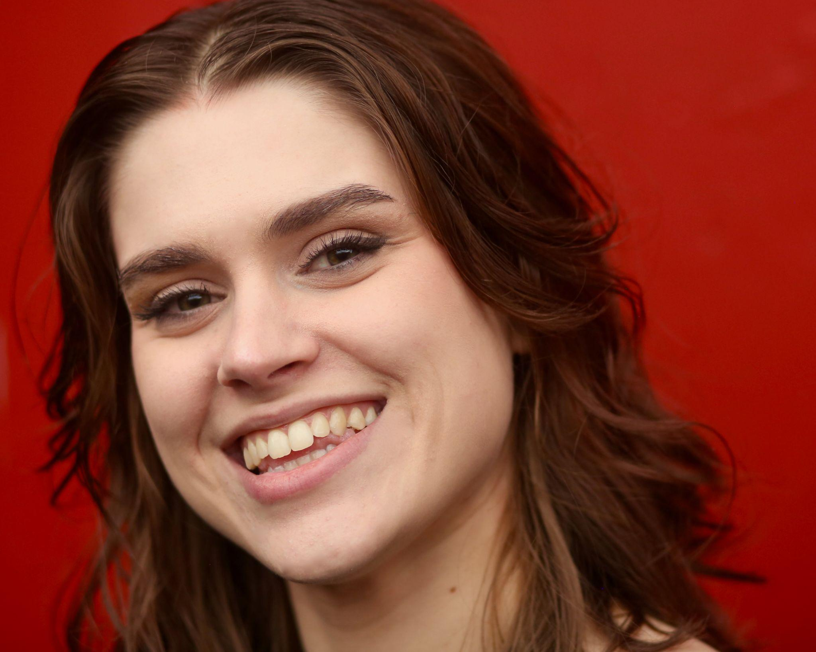

**Olivia Barbara Raso**

**Non-Union**

978-654-2708

[rasoolivia@gmail.com](mailto:rasoolivia@gmail.com)

Green eyes - Brunette

**ROLES**

***Stage***

| Phoebe  Little Stone  Ensemble/Helena  Ensemble/Hero u/s | *The Infinite Moment of Now*  *Eurydice*  *Dream, Love, Escape*  *Much Ado About Nothing* | Maddie Roth  David Kaye  Kate Kohler Amory, Rebecca Holderness  William Cunningham |
| --- | --- | --- |
| Pope Joan  Muffet DiNicola | *Top Girls*  *Uncommon Women and Others* | Julie Kiernan  Brianne Beatrice |

**TRAINING/EDUCATION**

* 6 week Meisner Intensive Course at Michael Chekhov Actors Studio in Boston with Scott Fielding
* Vocal Coaching with ProTalent - March thru August 2025
* 15 years experience singing in choir/ensemble settings
* BFA Performance degree from Salem State University - Class of May, 2020
* BFA Training
  + Acting- Alexander Platt, Celena Sky April, Peter Sampieri, Bill Cunningham, Esme Allen, Kate Amory, Brianne Beatrice, Bryn Boice, Julie Kiernan
  + Dialects - Celena Sky April, Peter Sampieri
  + Dance - Betsy Miller (ballet), Emily Beattie
  + Voice - Bryn Boice, Celena Sky April
  + Movement/Devising - Kate Amory, Rebecca Holderness
* Four week intensive theatre experience at ACT Andover. Over 42 hours of acting, dancing, and music training. Two stage fighting classes, and a week of training in stage combat.

**AWARDS/HONORS**

* Irene Ryan Finalist at the Kennedy Center American College Theatre Festival Region 1 - 2018
* Irene Ryan Acting Nominee for *Middletown* by Will Eno - 2018
* Irene Ryan Acting Nominee for *Almost, Maine* by John Cariani - 2017

**SPECIAL SKILLS**

* **Singing** (Alto/Mezzo:C#3-A5); **Dialects** (Irish, Cockney, Received Pronunciation, French, Italian, American Southern, Yiddish); **Beginners Gymnastics Abilities** (cartwheel, round-off, backbend, split), **Stage Combat** (hand to hand, sword)

***Olivia Barbara Raso***