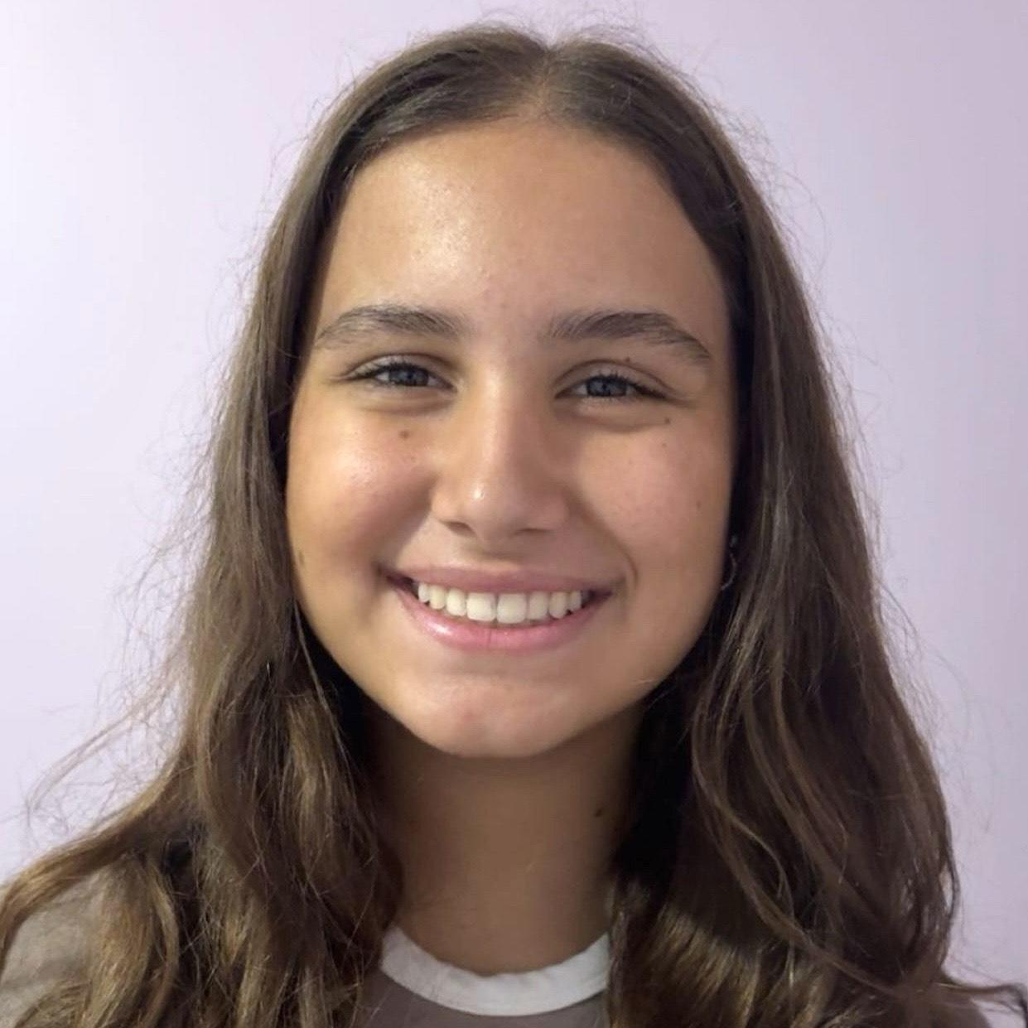 Acting Résumé
Name: Maria Luisa Leal
Location: Kearny, NJ
Phone Number: 973-289-8155 | Email: maluleal840@gmail.com | IG: @malu__leal
Height: 5’4” Hair: Dirty Blonde Eyes: Brown Age: 16 (Teen Range)

Theater / Musical Theater
Production | Role | Company/Director
Annie | Annie | Colégio João de Barro
Matilda | Matilda | Colégio João de Barro
Alice in Wonderland | Alice | Colégio João de Barro
The Wizard of Oz | Dorothy | Ballet Heloisa Schanuel
Princess Showcase | Cinderella | Ballet Heloisa Schanuel
Toy Story | Jessie | Ballet Heloisa Schanuel
High School Musical | Gabriella | Ballet Heloisa Schanuel
The Phantom of the Opera | Christine | Ballet Cristine Pires
Mamma Mia! | Sophie | Ballet Cristine Pires

Training
- Ballet & Performance – Ballet Heloisa Schanuel
- Musical Theater – Ballet Cristine Pires
- Acting & Performance Workshops – Alma da Arte (Brasil)

Special Skills
- Dance: Ballet, Jazz, Musical Theater
- Languages: Fluent in Spanish, Portuguese (Brazil), Portuguese (Portugal), English, Italian; currently learning French
- Quick memorization, ensemble work, strong stage presence

Professional Biography
Maria Luisa Leal is a 16-year-old actress who lives to be on the screen and stage. She is open to new experiences and adventures, always eager to grow as a performer.
"Acting makes me feel alive in a way nothing else does. It's like the moment I step into someone else's life, I'm not just pretending, I'm understanding, feeling and becoming. And in that space, where I'm not myself but also more myself than ever, it's like my heart gets louder. My thoughts get clearer and I get to live a hundred lives and feel every version of being human." – Maria

