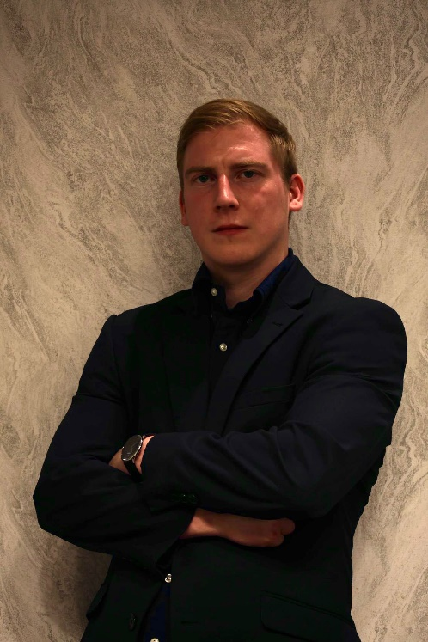

**Profile:**

* Number: 07527023382. Email: [alexcandlin3220@aol.com](mailto:alexcandlin3220@aol.com)
* Playing age: 22 – 28
* **Height: 5’9**
* **Appearance: White British male/ Blonde hair and blue eyes**
* **Location Lancaster**
* **Voice quality: Clear, bright,**
* **Body type: Athletic**

Theatre/ Stage roles

* **Supporting • Multi-characters – Shakespeare Ruined My Life – Oldham Theatre Workshop: 2008**
* **Lead • Hercules – Hercules: The Panto • Spellbound: 2021**
* **Supporting • Dickon – The Secret Garden • Lancaster Footlights: 2022**
* **Lead • Christopher – Star Crossed Summer • Independent theatre group: 2022**
* **Supporting • Jim – Railway Children • Warton Drama Group: 2023**
* **Supporting • Baldrick – Blackadder II • Lancaster Footlights: 2023**
* **Lead • Richard Hanney – The 39 Steps • Lancaster Footlights: 2023**
* **Supporting • Patrick – Ladies Day • Lancaster Footlights 2024**

**Short film roles**

* When the Tide Comes In - Otto: September 2022
* No Country for Old Men - Llewelyn Moss: February 2023
* Victim - Joe: May 2023
* Crystal Gazing - John: June 2023
* Lameuga 1982 - Doctor Marvin Brooks: July 2023
* Dusty Jeans - Joe: August 2023
* Behind You - David Moore/ The Night Murderer: October 2023 [Behind You (2024)](https://www.youtube.com/watch?v=2bjoEuxpcNY&list=PLioMHswKz1LV105zhUXtuJ_5mCYnmYVvz&index=9&t=1772s)
* The Pope and The Punch - The Pope 2023 [The Pope and The Punch | A Kung Fu Film](https://www.youtube.com/watch?v=DmW3WiQnhCc&list=PLioMHswKz1LV105zhUXtuJ_5mCYnmYVvz&index=4&t=675s)
* In The Bedroom - Jesse: December 2023
* Dopamine - Jamie 2024 [DOPAMINE | Short Film 2024](https://www.youtube.com/watch?v=9ZtcjoTkE44&list=PLioMHswKz1LV105zhUXtuJ_5mCYnmYVvz&index=7&t=4s)
* Psychosis - Richard Carter/ Jack Turner: March 2024 [Psychosis - A short film by Alexia Bazavan](https://www.youtube.com/watch?v=35Qlm8qfeVQ&list=PLioMHswKz1LV105zhUXtuJ_5mCYnmYVvz&index=2&t=4s)
* Thank You For Your Service - LCpl James Simpson 2024 [Thank You For Your Service (2024)](https://www.youtube.com/watch?v=NnsQpLCqIX0&list=PLioMHswKz1LV105zhUXtuJ_5mCYnmYVvz&index=1&t=13s)
* Rancid Beautiful Vile Creatures - The Beast: April 2024
* Wish Granted - Officer Davies 2024 [Wish Granted (2024)](https://www.youtube.com/watch?v=wecU4mDhTR4&list=PLioMHswKz1LV105zhUXtuJ_5mCYnmYVvz&index=3&t=655s)
* Behind The Smile - Father 2024
* Love Is A Mirage - Swann 2024 [LOVE IS THE MIRAGE](https://www.youtube.com/watch?v=oostfhUcRoU&list=PLioMHswKz1LV105zhUXtuJ_5mCYnmYVvz&index=8)
* Death Of One (short film) - Chris 2024
* Haunted – Detective Charles Prince 2025 [HAUNTED | Student film written by Lucas Hartley](https://www.youtube.com/watch?v=TDWj6b01uOo&list=PLioMHswKz1LV105zhUXtuJ_5mCYnmYVvz&index=10)
* Book of Little Slashers – The Fireman 2025 [Little Book of Slashers (Leon Furness) — LICA Festival 2025](https://lica-festival-2025.art/little-book-of-slashers-(leon-furness))
* Don’t Forget 4 – Sgt John McCarthy 2025

**Professional Roles**

* Geezers - Jax 2024 (fight scene performer)
* Fall To the Top - Lex 2024 (supporting role)
* House of the Unseen 2025 – William (main role)

**Skills:**

* Accents: Received Pronunciation, Mancunian, Irish, Yorkshire/ Lancashire, General and Southern American
* Ability to cry on command
* Able to perform emotional scenes
* Military experience
* Martial arts training and stage combat
* Improvisation
* Experience in performing long monologues
* Singing experience
* Mountain climbing
* Sky diving
* Rifle/ pistol handling and shooting
* Weightlifting
* Physical comedy

**Other**

* Full UK driver's licence
* DBL check

## Profile:

Alex Candlin is a bold, driven actor with a strong physical presence and a deep emotional range, shaped by over a decade of military service and sharpened through an ever-growing body of film and theatre work. With more than 25 short films, numerous stage productions, and three feature films under his belt—including projects featuring Paul Chuckle, Joe Egan, Shaun Ryder, and Laurence R. Harvey—Alex brings intensity, discipline, and authenticity to every performance. He’s trained in martial arts and stage combat, skilled in a range of regional and international accents, and is known for his ability to dive into emotionally charged scenes with immediacy and truth. He thrives on character transformation and isn’t afraid to go to dark or vulnerable places to uncover what makes a role come alive.

Adaptable and endlessly committed, Alex is always ready to go where the work takes him—be it a night shoot in the middle of nowhere or a last-minute call across the country. Long hours, late nights, and physically intense sets are all part of what fuels his passion for storytelling. With a reputation for professionalism, resilience, and on-set focus, he’s the kind of actor who shows up fully—no matter the role, the setting, or the challenge.