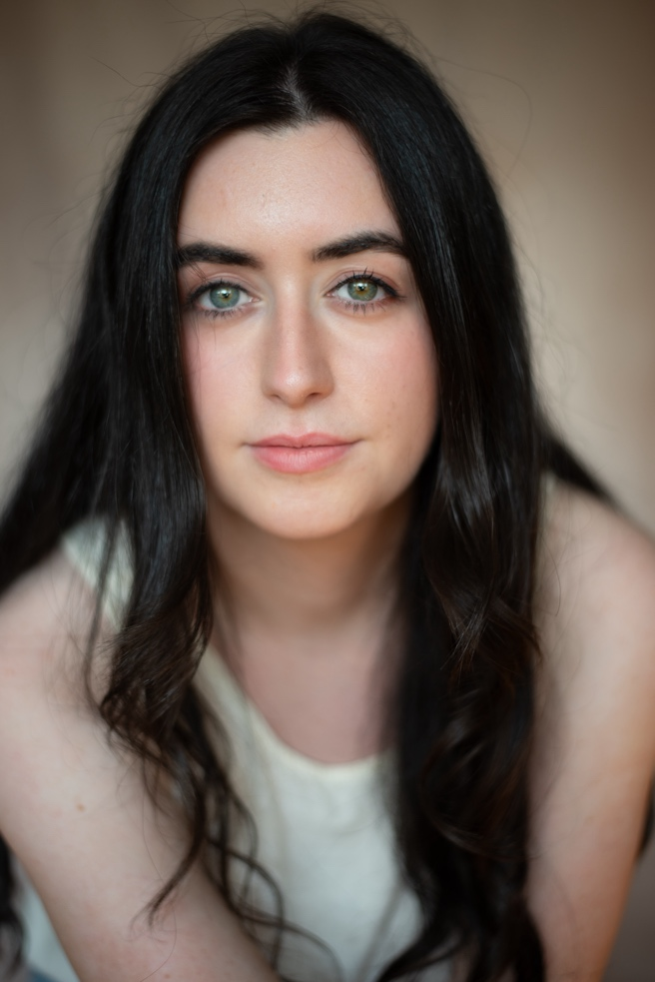
Acting CV
Lily Rose Conway
Contact Details
Email – lilyconway_234@yahoo.com
Mobile No. 07395572362

Height: 5’5”
Weight:9st
Ethnicity: White Irish
Build: Average/slim
Eye-colour: Blue-green
Hair Colour: Black
Voice Quality: Clear
Singing voice- Soprano
Hair length: Chest length
Role Playing Age:15-30

Accents and Dialects
British, Irish (Dublin, Sligo, Cork, Donegal, Antrim)
Southern American drawl, Liverpool, Australian, Russian, German, American, French, Italian

Training

GCSE Drama- St. Patrick’s Academy
A Level Performing Arts- St. Patrick’s Academy
Speech and Drama Training (Grades 1-8)

Lyric Theatre Acting Course- Kieran Lagan

RADA short course in acting

Workshop with Screen School NI & Sophie Pearson (Casting Director)

Acting for Screen course with Shelley Lowry

Music & Dance: Trumpet, chorus singing, solo singing, Irish dancing

Theatrical: Improvisation, miming, Brecht style, Meisner technique (realism), study of Stanislavski technique

Sports: Water surfing, skiing, mountain climbing, horse riding, swimming, golf, tennis, running, basketball, football

Acting Experience - Theatre
Role | Production | Company | Director | Year
Ensemble | American Idiot | Bardic Theatre | Bugsy McMahon | 2025
Kathy | The Last Quiz Night on Earth | Armagh Theatre Group | Adam Trotter | 2025
Ella | Christmas Lights | Armagh Theatre Group | Margery Quinn | 2024
Pip Bin | Bleak Expectations | Armagh Theatre Group | Adam Trotter | 2023
Secretary to the surgeon Lynn | Impact | Armagh Theatre Group- Market Place Theatre | Margery Quinn | 2023
Katherine | The Taming of the Shrew | St. Patrick’s Academy | M. Shields | 2020
Catherine | A Memory of Water | St. Patrick’s Academy | M. Shields | 2019
Mary | Juno and the Paycock | St. Patrick’s Academy | M. Shields | 2019
Mrs Cheveley | An Ideal Husband | St. Patrick’s Academy | M. Shields | 2019
Mags | Lovers | St. Patrick’s Academy | M. Shields | 2019
Beulah | The Happy Journey | Armagh Theatre Group | Felim Rafferty | 2018
Geraldine | Cheatin’ Hearts | Armagh Theatre Group | Malachi Kelly | 2018
Soldier’s Fiancee | But Chiefly Yourselves | Armagh Theatre Group | Margery Quinn | 2018
Natalya | The Proposal | St. Patrick’s Academy | R. Devlin | 2017
Jo | A Taste of Honey | St. Patrick’s Academy | R. Devlin | 2017
Aoife | Slices of Life | Armagh Theatre Group | Hilary Good | 2017
Emily Webb’s friend | Our Town | Armagh Theatre Group | Margery Quinn | 2016
Ensemble/Wife | Joseph and his Technicolour Dreamcoat | Priory Productions | Sean Donnelly | 2014
Lioness | The Lion King | Stage Stars | Lauren Hamill | 2013
Serena | Legally Blonde | Stage Stars | Lauren Hamill | 2013
Martha | A Night to Remember | St. Patrick’s Primary School | L. Bennett | 2012
Bobby | Our Ma | Patchwork Productions | Patch Connolly | 2011
Princess | Princess and the Frog | DFK Performing Arts School | Narelle Allen | 2010
Puppy Dog | Toy Story | The Grand Opera House | The Opera House | 2008

TV/Film Experience
Role | Production | Company | Producer | Year
Background Actor | Video Nasty | Deadpan Pictures | Julie Baines | April 2024
Background Actor | Love in Belfast | N/A | Gary Duffy | February 2025
Background Actor | You'll Never Believe who's Dead | Wildcard films | Oliver Butler, Trevor Birney, Patrick O'Niell | March 2025
Daughter | Cat-astrophe | Independent film | Self produced | April 2025

