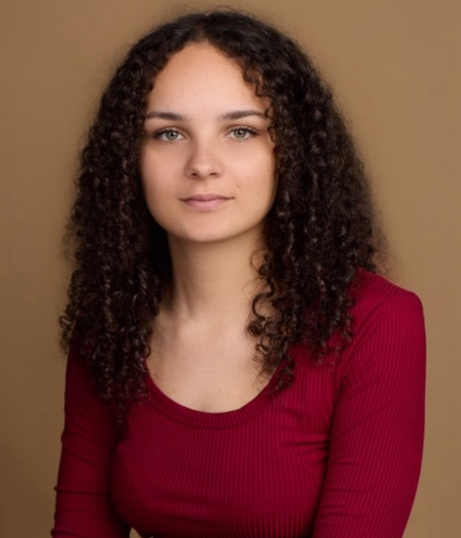
Faith Harper
156 Little Breach | Chichester, PO19 5UA | 07938903272 | faithharper2525@gmail.com | Spotlight: 8615-4534-0224

Personal Profile
Hi, I’m Faith Harper, a 23-year-old final-year student studying Musical Theatre and Acting for Film at the University of Chichester. This course has been extremely useful for learning acting for camera techniques and different aspects of the industry. My time on set as an extra and as a lead in an amateur feature film has given me great insight into the craft of screen acting, while my stage work has strengthened my presence and performance skills. I bring dedication, creativity, and a professional attitude to every project, and I am eager to collaborate with an agent to take the next step in my acting career.

Education
BA (Hons) Musical Theatre and Acting for Film
University of Chichester (2022–2025)
- Comprehensive training in acting for stage and screen, voice, movement, and production techniques.
- Gained knowledge of industry practices, including direction, video editing, stage management, and film production.

Pre-professional foundation year
Bird College (2021-2022)
- Intense training in the fundamentals of dance, acting and singing.

Extended Diploma in the Creative and Performing Arts Level 3
Midkent College (2019-2021)
- Training in drama and musical theatre.

Performance Experience
Screen:
Terror Toaster by Benjamin Lee
Sam
2024
Extra/Background Artist Roles:
A Very Short Film About Longing by Eimear McBride
Background Artist
2022
Layla Short Film by Celine Cotran
Femi’s Friend #4
2018
Stage:
Bird College PPFY Show
Bird College
Myself/Dancer/Singer/Actor
2022
Head Rot Holiday
Sharon/Angel
Sinden Theatre
2017
Macbeth
Lennox
Shakespeare Schools Festival
2016
King Lear
Oswald
Shakespeare Schools Festival
2015
Other:
University Class Productions
University of Chichester (2022–2025)
Featured in numerous stage and screen projects.
Fort Amherst Scare Tour
Scare Actor
2019

Skills
Basic - Stage and Screen Combat (University Module), RP Accent.
Intermediate – Singing (Mezzo-Soprano), Screen Acting Technique (University Modules), Jazz, Ballet, Tap.
Highly Skilled - Kent UK Accent (Native).

References
Available upon request.

