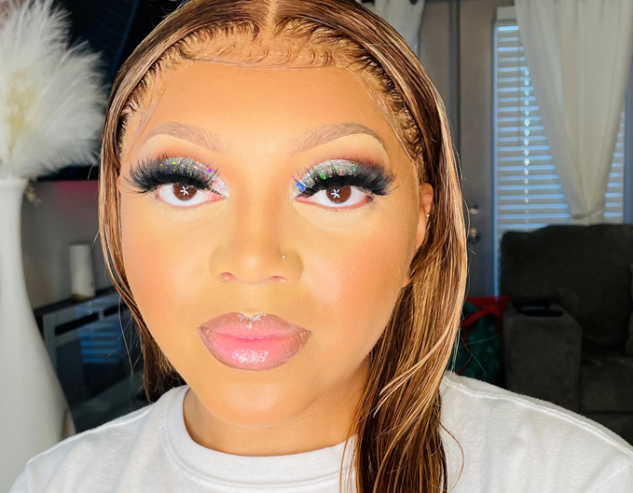

Jacqueline Treadway
Aspiring Actress

(336) 482-5946
Jacquelinesimone4l@gmail.com

Statistics:

Age:27 Height: 5’3
Hair: Sandy Brown Eyes: Brown
Weight: 130 Apparel: Medium

Dance Experience

World Dance class Cypress Lake Performing Arts HS 2014-2015

Theatre Experience

Improv class Cypress Lake Performing Arts HS 2014-2015
Intro to Theatre class Greensboro College 2015-2016

Film Experience

New Media Studies class Short Films Boy of Bliss “Elena” 2017-2018
Digital Videography class Short Films Student, multiple roles 2017-2018
Screenwriting class Short Films Screenwriter 2019

Photography Experience

Darkroom Photography class Greensboro College 2017-2018

Singing Experience

Music class Cypress Lake Performing Arts HS 2013-2014

Chorus class Southwest Edgecombe HS 2015

