Steven Wayne Young
Non-Union

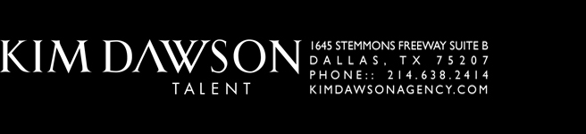
Eyes: Brown
Hair: Blonde

FILM
The Ghost of Spoon River Clem Barks Scott Meehan/director
7 Chefs for Vampires Keep Baron Von Turpin William Mason/director
First Date Old Man Aaron Garcia/director
Hot Box God Andrew Ramon/director
Airbnb Hammond Highsmith Samuel Curtis/director
A Wedge of Orange Waiter/lead Chris Baker/director/UK

TELEVISION
Active Shooter Man 1/Supporting De Man Hooks/director
Steamroller Comedy Ensemble KSTP TV, St Paul, MN
Prince Rome & Juliet WTVP/PBS

COMMERCIAL/INDUSTRIAL/VO
Corporate Invest Pitch/White Cap Principal Christa Trinler/Director
Heart Transplant Procedure Principal Consultanet/Cambridge, UK
Haylon Recovery System-Getz Principal Video Production Group
Toyota Volvo Principal Deverman Advertising
Jury Selection-Tazwell County, IL Principal Video Production Group

THEATRE
Caesar Julius Caesar Texas Shakespeare Festival
Lord Bloomfield Box Undermain Theatre, Dallas, TX
Reverend Chasuble Importance…Earnest Stage West Theatre, Fort Worth, TX
Romeo (Reverse age production) Romeo & Juliet Plague Mask Players, Dallas, TX
Cymbeline Cymbeline Nashville Shakespeare Festival
Bottom Midsummer Stamford Shake Fest, Stamford, UK
NOTE: I’ve been in productions of all but two plays of the Shakespearian canon.

TRAINING
UW-Milwaukee: Professional Theatre Training Program, (later the Delaware Program)

SKILLS
Trained in IPA. Dialects: Lived in the UK for a decade-master of UK dialects. French, Russian, Italian, German. USA: Northern, Midwest, & Southern. Standup comedian, published writer and produced playwright. Experienced in stage combat, weight training, and yoga.
rafael@kimdawsonagency.com p 214 . 638 . 2414

