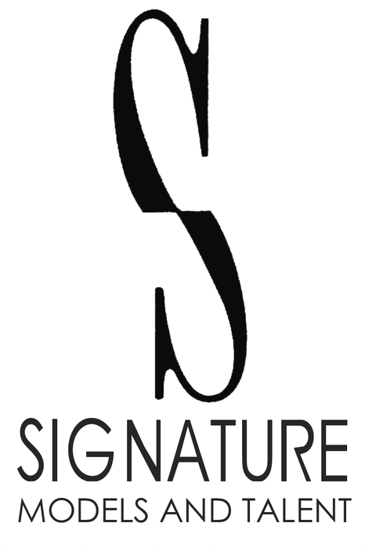
PMB #256 3370 N. Hayden Rd Ste. #123
Scottsdale, AZ 85251
Phone: 480-966-1102
Fax: 480-223-6444
mailbox@signaturemodelsandtalent.com

Maggie Jane

Height: 5’5 | Weight: 139 | Hair: Red | Eyes: Blue

TELEVISION

Turning The Paige | Runway Model | Writer Boy Films
Crescent Gang | Lawyer’s Assistant | 360 Films
Adopted 2 | Criminal Patient | Footage Films
The Shifting Church Organ Operator Tony C. Silva

COMMERCIALS

Nike | Background | Happy Place Inc
Red Robin | Principal | Caroline Crafton
GMS Marketing | Principal | Golden Medina Services
“The Bus” Jerome Bettis Superbowl Commercial | Cheerleader | Pepsi
TRAINING

Acting | Mel Mack | Mel Mack
Acting | The NEXT Team | Next Star Productions
Acting | The NEXT Team | Next Star Productions
Acting and Modeling | Barbizon | Barbizon Modeling and Acting School

SPECIAL SKILLS

Hiking, Running, Pilates, Yoga, Cooking, Screaming, Podcaster, Runway, Cup Pong, Drawing, Roller Blading, Dancing, Painting, Clarinet, Moped, Bicycle, Baking

