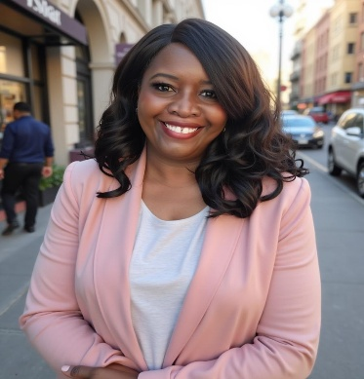
Sahirah Murdock

-
30
-
|

sahirahla@gmail.com Cell/text 323-301-5708

: Hosting | Radio and Television On- Air Talent | Audience Engagement

SUMMARY
Featured talent in national television segments (CBS, Bravo, TMZ), blending strong organizational leadership with media presence. Dynamic on air and in person host with a proven ability to engage audiences across National television and with live presentations and events.

MEDIA EXPERIENCE & APPEARANCES
- CBS National Promo – Featured talent; aired March–June 2025.
- Bravo TV National – Guest on Watch What Happens Live; aired June 8, 2025
- TMZ Live National – Airing June 2025
- Tonos Radio Host - Carole Bayer Sager, David Foster, & Babyface Online Music Company
- On air DJ & News reporter WAMD Radio AM 970
- News Intern WJZ TV & NPR Baltimore, MD

PROFESSIONAL EXPERIENCE
DOLBY Coordinator / Employee Experience Lead
Burbank, CA
- Event Host and founder of Dolby Days, an employee quarterly event.

ORACLE Coordinator
Santa Monica, CA
- Training Host

EDUCATION & CERTIFICATIONS
- BA in English – Pennsylvania State University
- University of London English & Theater Study Abroad Certificate
- Public Relations Course – UCLA Extension

