Sadé Singleton
Contact details  Email  sadegabbla@gmail.com  Phone  (323)944-8126  Education  Bachelor of Arts (Theatre Arts) Cal. State University Long Beach (2015-2020)  Identity School of Acting (2021) | Bio  Eye Color: Dark Brown  Height: 4’11  Hair Color: black  Weight: 171 lbs  Nationality: Salvadoran and Belizean  Playing Age: 16-25 | 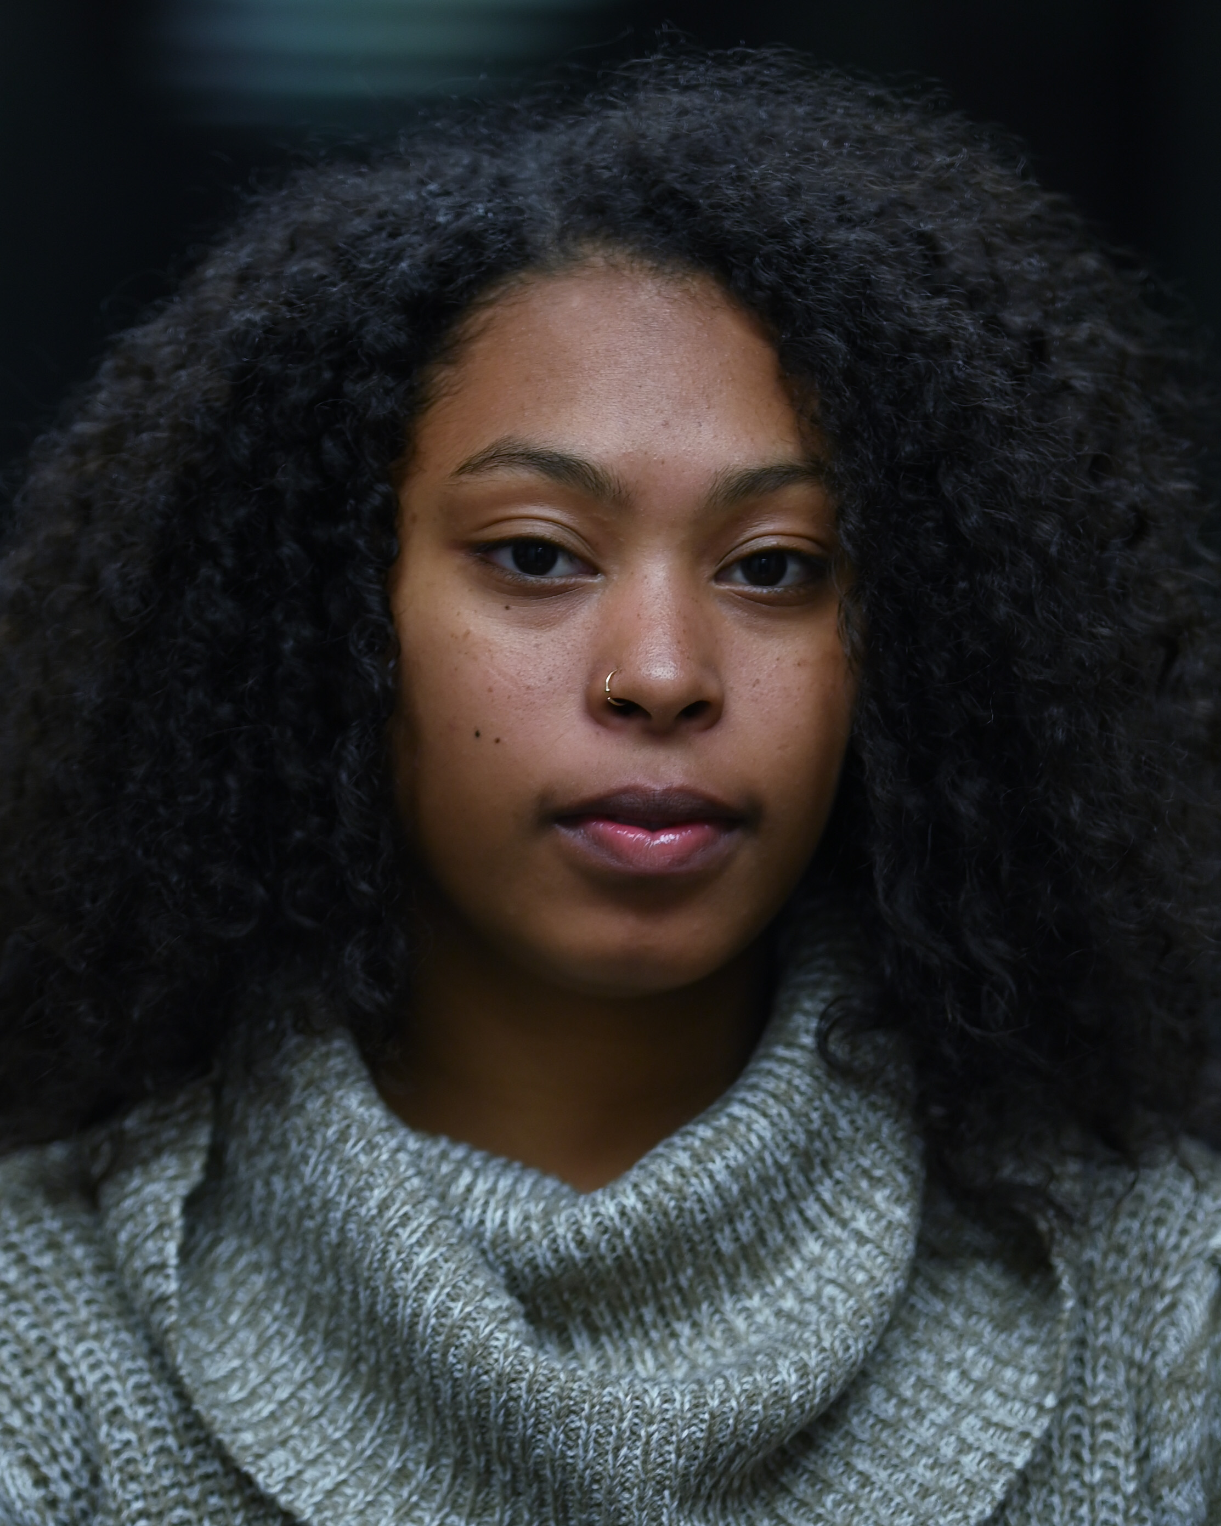
Roles/Work
12 Angry Jurors (2012) The Abridged Version of William Shakespeare ( Comedy) (2014)

Godspell (2013) The Stars of Track and Field, Student Short film/ music video (2019)

Fame (2014). A Live Mixtape, California State University Long Beach (2019)

Special Skills

Singer (Alto and Musical Theatre style, R&B and Pop)

Dancer ( Beginner Ballet, modern, tap and Hip-Hop)

Director

Sound and Lighting

Make-up

