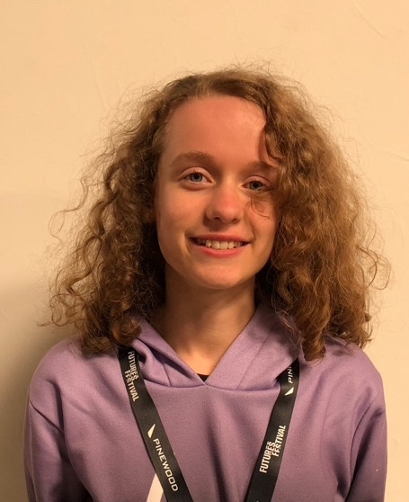
Bea de Haldevang
07738438341
beadehaldevang@gmail.com
Playing age: 15-18
Height: 5’5”
Location: Surrey/London

Higher education
2025-2028: Trinity Laban Conservatoire
of Music and Dance

Skills/qualifications
Music: piano & cello grade 6 standard, singing grade 7/8 standard, self-taught guitar & ukulele, songwriter
Accents: General American, posh British, Cockney, RP
Other: Spoken word poet, distinction in LAMDA grades 1-7, early dance training

Work experience
Year(s) | Company | More info
2014-2019 | Bullfrog Productions | Notable performances:  Melman in Madagascar Jr Flora in The Sleeping Beauty Jr
2021-2023 | Pauline Quirke Academy Tunbridge Wells | Notable projects and performances:  Directing a short film  Trinity grade 6 group performance  Khashoggi in We Will Rock You
October 2022 | PQA TWells | West End debut at the Shaftesbury Theatre playing two principal roles
July 2023 | Kent College Pembury | Played cello alongside professional musicians for KC’s lower school production
April 2024 | Guildhall School of Music and Drama | Music production short course at Guildhall learning synthesis, sampling and composition
2025 | N/A | Wrote a screenplay with an accompanying storyboard portraying 2 minutes of the film
2025 | N/A | Played a leading role in a student short film
2024 & 2025 | Kent College Pembury | Headlined at Kent College’s open mic nights singing original music

Socials:
TikTok: @beadehaldevang
Instagram: @beadehaldevang

