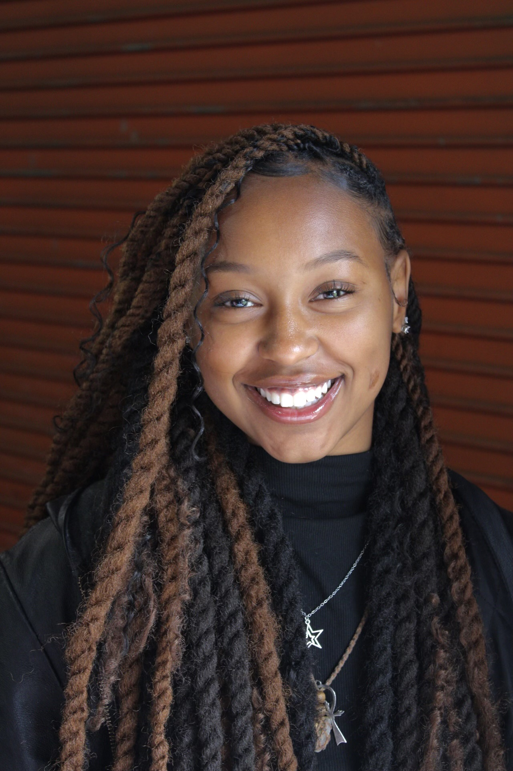 |  | Paige  Hodge  Accomplishments  3 years 1st Place Champion “Young Voices” Spoken Word Competition  Music Video  “Dry Bones”  “It’s a Pirate’s Life for Me”  Necat  Fab. Five Dancer  Dir: Rachel Sumner
Profile  Height: 5’4”  Eyes: Brown  Hair: Brown  Contact  PHONE:  615-689-1427  EMAIL:  21paige.hodge@gmail.com |  | Education/Training  Nashville School of the Arts  2020 – 2024 (Stage performance and Improv.)  Dir: Brook Ferguson  IT Cresswell School of the Art  2016 - 2020  Bria Evans and Shabaz Ujima  Malone Dance Academy  2014 – 2023  Dir: Cindy Lindsey, Ronnie Lindsey  Ballet, Jazz, Tumbling, Latin, Tap, Modern Jazz, Hip-Hop  Beginners Workshop  2018  Dir: Peter Sklar  New York  Special Skills  Drama, Dance, Jazz, Hip-Hop, Tap, Modern, Poetry  live Stage performances (Theater&Dance)  Broadway Dreams  Scholarship to summer training and Broadway performance  Summer 2023  Belmont University  Infinity Arts Camp  2019–2023  Dir: Kanetha Carr  Shades of Black Theater Festival  “Raising Queens”, “Brown Skin Girls”  Dir: Thea Jones  IT Creswell School of the Arts  “Colors of the Season”  Chor: Bria Evans  IT Creswell School of the Arts  “For Us by Us”  Chor: Bria Evans  IT Creswell School of the Arts  “I’m not OK”  Chor: Bria Evans  Malone Dance Studios  5 Year Showcase  Chor: Cindy Lindsey and Ronnie Lindsey  East Magnet High School  Majorette  Dir/Chor: Cindy Lindsey  Malone Dance Studio  Tennessee State University Parade

