**Brishelle Brooks**

New Orleans, LA | Set/Office PA

504-810-4822 | Brishelle.brooks@gmail.com

**Relevant Work Experience**

Black Bayou Cultural Heritage Doc. Production Assistant 2025

Good Night Mr. Nice Guy Production Assistant 2025

**Other Experience**

NOVAC Production Assistant Intensive Training 2025

Acadian Fashion Week Backstage Assistant 2025

Nola Spotlight Creative Director & Coordinator 2025

Brand Ambassador Large Scale and Fast Pace Events 2022- 2025

**Training**

NOVAC Production Assistant Intensive Training

* Completed a hands-on 8 hour training in entry-level film and TV production. Covered set etiquette, lingo, and paperwork; practiced daily on-set tasks including equipment setup, background coordination, and production support.

**Education / Certification**

Stevenson’s Academy of Hair and Design

Cosmetology License

2020-2022

Dillard University

Visual Arts Con. Creative Writing

2017-2019

Academy of Our Lady

2014-2017

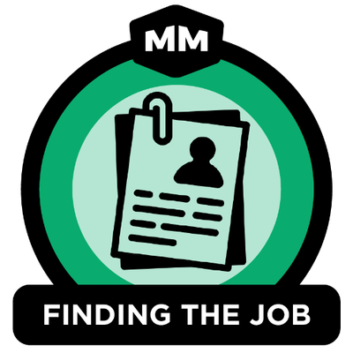

**Skills**

| La Driver’s License | Able to lift <40 lbs | Professionalism |
| --- | --- | --- |
| Time Management | Team Oriented | Organizational Skills |
| Multitasking | Reliable Transportation | Photography |