Sara L. Patterson
  - (224-578-3420)
https://www.linkedin.com/in/sara-patterson-07588a243/
CONTACT INFO  Eagle Mail : Slpatterson6012@eagle.fgcu.edu  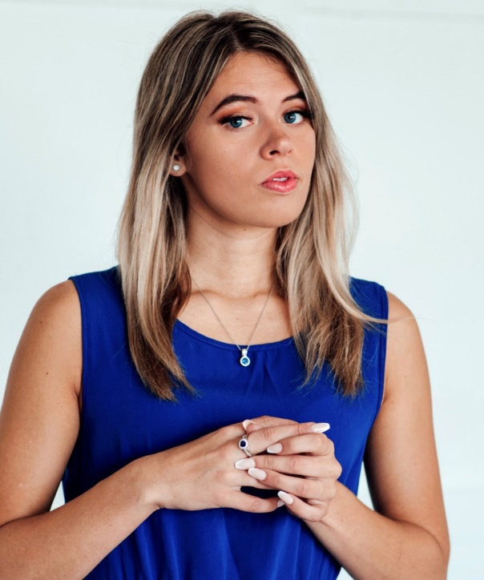 Gmail:  Spatterso57899@gmail.com  LEADERSHIP & COMMUNITY INVOLVEMENT:  Mentor – SWFL CEO Program, through FGCU Spring 2025 Semester at FGCU  - Provide guidance and feedback to high school entrepreneurs developing real business ideas through the SWFL CEO program.  - Share insights from college-level entrepreneurship coursework and personal business experience to support student growth.  - Assist with pitch preparation, business plan development, and confidence-building in a peer-mentor format and at a fundraising event.  Youth Leader – Ocean Church, Estero, FL  April 2025 – Present  - Serve as a mentor and spiritual guide for middle and high school students, leading discussions, prayer groups, and worship activities.  - Help facilitate youth events and foster a welcoming, Christ-centered environment for growth and connection.  - Support students in navigating personal challenges and developing their faith.  Music Volunteer – Shell Point Nursing Home, The Larsen Center, Sanibel, FL  2024 – Present  - Volunteered weekly on the hospice floor to sing and play guitar for residents, bringing comfort through music therapy.  - Created meaningful one-on-one connections with residents through compassionate conversation and active listening. |  | WORK/INTERNSHIP EXPERIENCE
 |  | Tga – swfl premier golf, tennis, and pickleball- HEAD COACH | 2023-2025
- Taught sports fundamentals to elementary and preschool students, fostering teamwork and fitness.
- Managed group activities, enhancing participation and skill development.
- Coordinated with schools and parents to ensure smooth operations.

 |  | Escondido Lounge- Downtown fort myers- cocktail waitress  - Assisted with the successful launch of a new bar venue, contributing to pre-opening setup, staff training sessions, and opening-day readiness.  - Established service protocols and workflows during the opening phase, ensuring smooth daily operations from day one.  - Managed high-volume drink orders while maintaining accuracy, timeliness, and professionalism during peak hours.  - Balanced multiple tables and bar customers, consistently meeting performance metrics for speed and service quality.  hooters, fort myers- waitress – 2021-2025 | 2024-2025
- Built meaningful relationships with company and guests, ensuring repeat business and a positive dining experience.
- Upsold menu items and delivered excellent service, consistently reaching sales targets.
- Featured in the Hooters 2023 Calendar, contributing to the brand’s marketing and promotional efforts with Breast Cancer Awareness.

RELATED SKILLS  - Social media: I have experience managing LinkedIn and other social media platforms for personal branding and networking.  - LinkedIn Certifications: I have completed various LinkedIn courses in business, marketing, and communication.  - Empathy & Emotional Intelligence: I am skilled at understanding and connecting with others emotionally, which helps me build strong relationships.  - Open-Minded & Opportunistic: I am always open to new ideas and eager to seize opportunities for growth.  - Kinesthetic Learner: I learn best through hands-on experience and practical application of knowledge.  - Teamwork: I work well in collaborative environments and enjoy contributing to team goals. |  | the cheesecake factory- server | 2023-2024
- Provided excellent service in a fast-paced environment, managing multiple tables per shift.
- Upsold menu items and contributed to meeting sales targets.
- Assisted with opening operations, ensuring a smooth launch of the new location.

 |  | Education
 |  | aa degree- florida southwestern state college | 2018-2021
- Relocated from Illinois to Florida to pursue higher education, adapting to a new academic environment.
- Maintained a strong academic standing with a solid GPA throughout my studies.
- Demonstrated commitment to personal and academic growth by excelling in coursework and participating in campus activities.

CERTIFICATIONS
- Previously CPR Certified in 2017-2018
- Design Foundations: Prototyping and Manufacturing
LinkedIn | Issued Dec 2024
Skills: Product Design
- Product Management: Building a Product Strategy
LinkedIn | Issued Dec 2024
Skills: Product Strategy
- Amplify Your Critical Thinking with Generative AI
LinkedIn | Issued Nov 2024
Skills: Critical Thinking, Artificial Intelligence for Business
- Developing Your Emotional Intelligence
LinkedIn | Issued Nov 2024
Skills: Emotional Intelligence
- Leading with Empathy
LinkedIn | Issued Nov 2024
Skills: Emotional Intelligence
- The State of Generative AI: Images, Prompting, and Language Models
LinkedIn | Issued Nov 2024
Skills: Conditional Image Generation, Prompt Engineering, AI Prompting, Generative AI
- A Design Thinking Approach to Putting the Customer First
LinkedIn | Issued Oct 2024
Skills: Customer Focused Design
- Design Thinking: Prototyping
LinkedIn | Issued Oct 2024
Skills: Design Thinking
- Introduction to Mill and Lathe Operation
LinkedIn | Issued Oct 2024
Skills: CNC Manufacturing
- Learning 3D Printing
LinkedIn | Issued Oct 2024
Skills: 3D Printing
- Take a More Creative Approach to Problem-Solving
LinkedIn | Issued Oct 2024
Skills: Creative Problem Solving
- Certified Nursing Assistant
Harper College | Issued Sep 2017 (Expired Aug 2018)

 |  | florida gulf coast university –  BACHELOR OF SCIENCE – Major in Entrepreneurship | 2021-2025
- Transferred from Florida Southwestern State College to pursue a bachelor’s degree, initially majoring in Health Sciences.
- Changed major to Entrepreneurship in 2023, focusing on business strategies, innovation, and leadership development.
- Actively engaged in coursework and extracurricular activities, building a strong foundation for a career in business with a past in medical sciences. Change of major during COVID-19.
- Recently graduated this Spring semester in 2025, with a degree of Bachelor of Science.

 |  | William harper rainy community college – internship | 2017-2018
- Enrolled as a high school senior to complete the Certified Nursing Assistant (CNA) program, gaining hands-on healthcare experience.
- Developed foundational skills in patient care, medical procedures, and healthcare ethics.
- Gained a strong understanding of healthcare environments, fostering a passion for the medical field.
- Successfully balanced high school coursework with college-level training, demonstrating time management and dedication.

