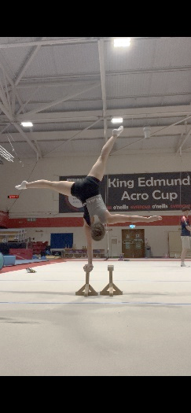
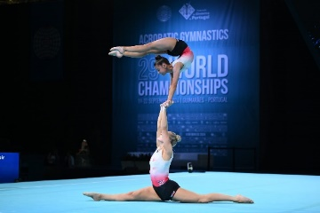
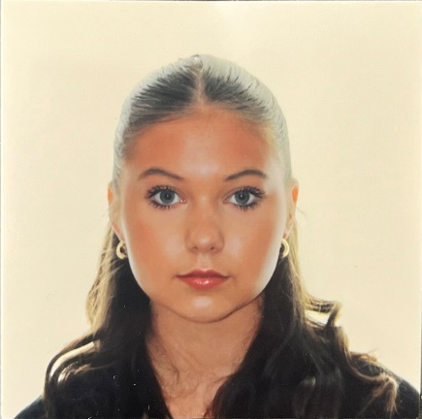
Natalia Gilbert
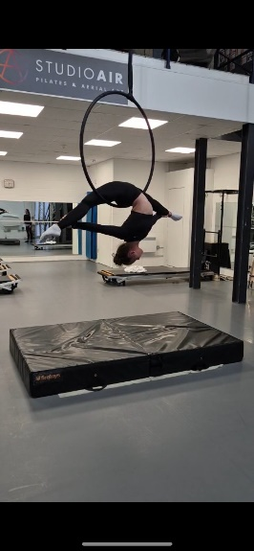
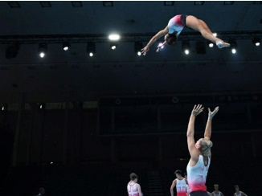
ngilbert007@icloud.com
+44 7445 572274
(UK and US Citizenship)

DOB: 22/02/2007 Height: 148cm Weight: 46kg

Gymnastics Career Summary:
Having started artistic gymnastics at recreational level from the age of 5 years, I quickly developed a passion for the sport and there was no stopping me! At the age of 10 I was invited to trial for Acrobatic gymnastics at Evoke Acrobatic Gymnastics Club in the UK and became the top of a Women’s Pair.
From the age of 14, I trained at King Edmunds Acrobatic Gymnastics Club in Yate, where I became the top of a Senior Women’s group. I then returned to being the top of a Women’s Pair, competing at Junior and Senior level, winning both World and European medals. I particularly love the performing aspect of this discipline, combining acrobatic skills alongside dance, where I get the opportunity to express my movement and emotions through the music and routine.
From finishing my competitive career, I have recently began taking aerial hoop classes which has allowed me to apply my flexibility and strength skills in a different way to which I am used to.
Achievements & Highlights in Acrobatic Gymnastics:
Sept 2024 – World Bronze medallist in the Balance Final in the Senior Women’s Pair category
July 2024 – Senior Women’s Pair British Champion
Oct 2023 – Junior Women’s Pair All-around European Champion
April 2023 – Junior Women’s Pair English Champion
May/June 2022 – Represented Great Britain in a Senior Women’s Group at two World Cups
Experiences:
Gym displays – performing up to 3 shows in one day at my gym club in the Summer and Christmas displays. Working alongside a large group of gymnasts, learning new choreography and acting out different character roles.
GBR Training Camps – opportunity to meet & train with other gymnasts & coaches, establishing good relationships and team work outside of our own club.
Regional TV News interviews – sharing my sporting achievements and experiences live in several TV interviews.

