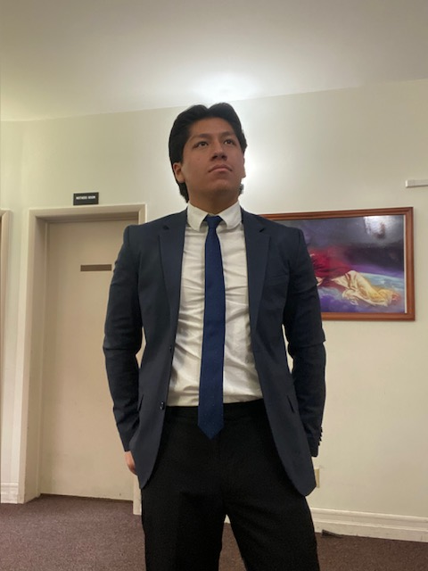 |  | Matthew Osorio
Contact  PHONE:  (714) 763-6305  EMAIL:  gallo2001mo@gmail.com  activities and interests  Running  Weight Lifting  Music performance  STEM Major |  | WORK EXPERIENCE  Mathnasium – 3398 S Bristol St Santa Ana CA 92704 United States  Math instructor/Tutor  [ February 2019 to August 2019]  - Aid students with understanding difficult math material.  - Grade work done during sessions.  - Assign individual workout plan for follow session.  - As a math tutor, I aided students with understanding difficult math material and helped assign individual workout plans for following sessions. I would also give feedback and help students improve in areas they struggled with.  Target - 2191 N Tustin St Orange, CA 92865 United States  Team Member (retail)  [December 2019 to December 2019]  - Aided guests that needed help with products in the toy and seasonal department.  - Provided assistance at the cash register when needed.  - Ensured assigned station was clean and presentable to guests.  - Collected items that were misplace and retuned to correct area.  Knotts Berry Farm – 8039 Beach Blvd Buena Park, CA 90620 United States  Team Member (Foods Department)/Host/Food Expeditor/Team Lead (Foods Department)  [June 2019 to March 2025]  - I worked as a host in a restaurant; being in charge of greeting and seating guests, as well as assisting servers with passing out food to guests. As a food expeditor, I would oversee the preparation/distribution of meals and assist guests with any concerns they might have.  - I have also worked as a manager; being in charge of supervising multiple shops in my area and being in the position of being in charge of other associates. Insuring that all associates were meeting company standards, were meeting their scheduled shifts, and providing assistance to shops that required special attention regarding customer satisfaction.  - Prior to both, I worked in a bakery for the majority of my time working at Knotts berry farm. I would help prepare pastries/make drinks for purchase, help guests with any questions they have, and make sure the shop was well prepared for guests to enter.  Kabo Kitchen - 1724 W 17th St Santa Ana, CA 92706 United States  Server/Food Expeditor/Cashier  [March 2025 to Present]  - I provide customer service as a cashier, expo food preparer and help manage orders for the drive through.  - I help ensure that the restaurant meets all cleanliness requirements and standards for the company.  - I aid in the preparation of the store opening and the process of the store closing.  - I assist guests with any concerns or issues they may have about their experience when dining at the restaurant.  EDUCATION AND CERTifications  Orange Lutheran High School – 2222 N Santiago Blvd, Orange, CA 92867  High School Diploma  Youth Employment Service (YES) of the Harbor Area, Inc. – Costa Mesa, CA 92627  Employment Skills Workshop – Certificate of Completion  Food Handler Certification  Food Handler Certified – Certificate of Certification  ServSafe Certification  Ability to Serve and Sell Alcoholic Beverages - Certificate of Certification  key skills and characteristics  - Bi-lingual in English and Spanish  - Hardworking, Organized, Responsible, Diligent  - Communication Skills  - Cash Handling Skills  - Leadership Skills  - Food and Drink Handling skills  - Team Player  - People’s Person

