About me:  I am a local Hawthorne resident that currently attends Somerville House and am looking for part time casual work. I am available on Tuesday and Friday evenings as well as Saturday and Sunday. I am 15 years old and in Grade 10.  experience:  - The Chemistry of Coffee Hawthorne - Waitress  - Student council representative at Norman Park State School 2021  - Captain of Norman Park Swim Club 2021  - Assistant helper at netball carnivals for juniors  - Started pet biscuits business supplying local family’s  Contact  PHONE:  0468 492 155  EMAIL:  Maceydwyer2010@hotmail.com  Hobbies  Swimming  Netball  AF |  | 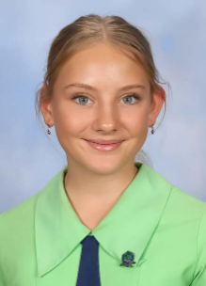  Macey Dwyer  High School Student  My Expertise:  - Leadership experience  - Experienced in volunteer roles; including fundraising  - Excellent customer service skills  - Self-confident and driven  - Tech savvy - using numerous apps and online platforms  Activties involed in:  - Somerville House Cantamus Choir  - Member of the Somerville House State Development Swim Squad  - Member of Royals netball club - Coorparoo  - Coordinated a foodbank drive every Christmas for the last three years  Why i am fit for the job--\  - Connect easily with people & have a friendly nature  - High energy & enjoy helping people  - Self-motivated & reliable  - Want to learn all aspects of customer service

