**KEIRA JARVIS**

Actor & Voice Artist  
07789 262199 | Keira.Jarvis@hotmail.co.uk | Sealand, Flintshire  
TikTok: @_wolfsbane

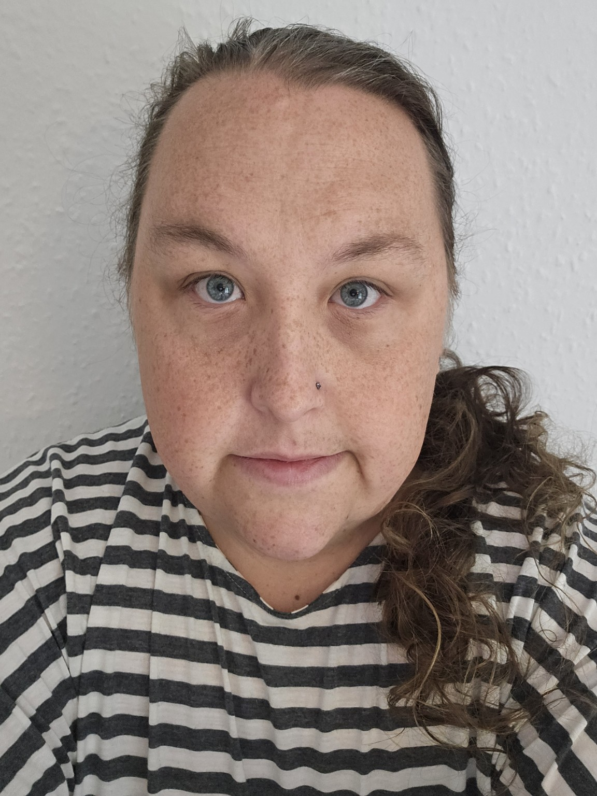

**PROFILE**  
Versatile actor and voice artist with stage, screen, and voice-over experience. Skilled in a wide range of regional and international accents, as well as celebrity impressions from Brian Blessed to Frank Spencer. As a transgender performer, Keira offers a unique vocal range not typically found in cisgender voices, enabling the creation of distinctive characters. Strong online presence with 24.6k TikTok followers and millions of YouTube views.

**TRAINING**

* Drama, GCSE (Grade A)
* Performing Arts, BTEC First Diploma, Barking College  
  • Contemporary Popular Music (Singing), 2 Years, Redbridge College

**CREDITS**

**Television**  
Maternity (ITV), Supporting role, 2023

The Weakest Link, 2012  
Dinobar Chocolate Commercial, Featured

**Stage**  
Sweeney Todd - Tobias Ragg (Assistant to Pirelli)  
Rockerfella - Brian (Lead)  
Jekyll and Hyde - Lighterboy / Ensemble  
Grease - Danny *(Singing, Dancing, Acting)*  
Oliver Twist - The Master

**Awards**

**BAFTA – Best Newcomer**

Barking Abbey Film and Television Awards

**VOICE & ACCENT SKILLS**

**Celebrity Impressions**  
Brian Blessed, Professor McGonagall (Dame Maggie Smith), Gandalf the Grey (Sir Ian McKellen), Frank Spencer, Michael Caine, and a wide range of public figures

**Regional UK Accents**  
Cockney, RP, Northern, Scouse, Geordie, West Country, Welsh, Scottish

**International Accents**  
American (General, Southern, New York), Australian, Irish, French, German, Italian, Russian

**Other Vocal Skills**  
Character voices including animated, comedic, dramatic, and age-range variations  
Exceptional vocal range including male, female, and androgynous tones

**OTHER SKILLS**  
• Improvisation  
• Character Acting  
• Comedy Timing  
• Singing (trained)  
• Strong Online Audience Engagement (TikTok, YouTube)