**KAITLYN GLICKMAN**

**610-554-1228.**

[**wdestini28@gmail.com**](mailto:wdestini28@gmail.com)

#### **About Me**

I have a passion for acting and performing. I can do both comedy and drama since I have a flair for both! I have done 2 local commercials, a short horror film, and have performed in multiple productions at my local theatres. I am witty, smart, and talented, and give 100% to every role I play, big or small!

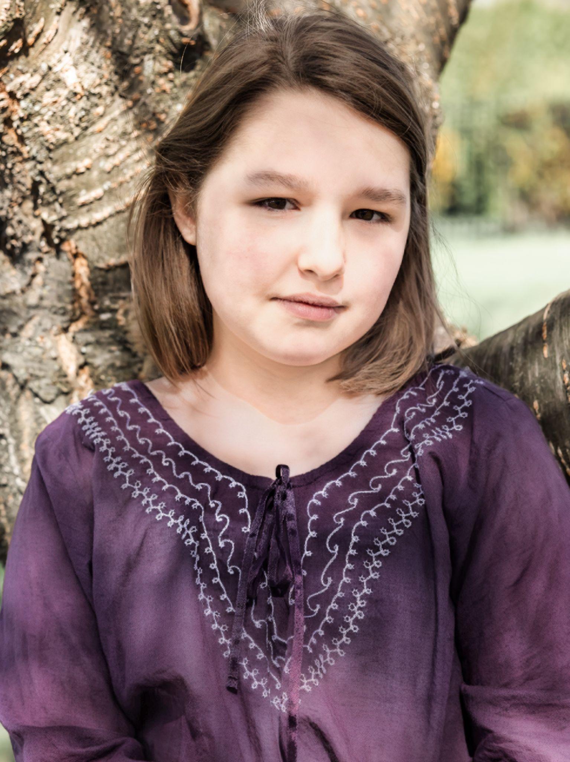

#### **Appearance**

* Age Range:9-13
* Birthdate:01/25/2013
* Ethnicities: White / European Descent
* Height: 4’11’’

Weight:145bs

* Build: Stocky
* Hair: Brown with blonde highlights
* Eyes: Brown

**Skills**

* Acting: Comedy, Dramatic
* Singing: Mezzo-Soprano
* Dancing: Musical Theatre
* Accents: Brooklyn, British, Southern
* Physical Comedy

**Credits**

**Theatre**

* **Legally Blonde Jr.** - Pfortzimer, Jump Roper, Ensemble. Star of the Day. August 2022.
* **Madagascar Jr.** - Maurice, Ensemble. Stagemakers JCC. November 2022.
* **A Wicked Christmas Carol** - Young Eurestia, Adele, Caroler. Fleetwood Community Theatre. December 2022. Community Theatre. December 2022
* **Goldilocks & the 3 Little Pigs** - Eva. (Original written by director Kirsten Almeida). Star of the Day. June 2023
* **Wizard of Oz Jr**. - Lullaby League Munchkin, Jitterbug, Ozian, Winkie. Star of the Day. August 2023.
* **A Christmas Carol** - Hat Toss Urchin. Civic Theatre Allentown. December 2023
* **Beauty & the Beast** - Ensemble. Civic Theatre Allentown. April 2024
* **Charlotte’s Web** - Avery Arable. Fleetwood Community Theatre. May 2024.
* **Twelfth Annual Tonys & Tapas** – CTS Performer. Civic Theatre Allentown. June 2024
* **Annie Jr** – Tessie. Star of the Day. August 2024
* **Alice in Wonderland Jr –** Small Alice. Fleetwood Community Theatre. November 2024
* **The Punch Line –** Melissa. LMMS Fall Comedy. November 2024
* **Honk –** Froglet, Goose, Bird, Girls Voice, LMMS Spring Musical, March, 2025
* **Mary Poppins Jr.** – Stepper/dance ensemble. Star of the Day. August 2025
* **Oliver –** Bet. Star of the Day All Age Production. September 2025

**Film/Commercials**

* A1 Towing Career Day Commercial: Molly - Dave the Dentist’s Daughter. Kefi Media. 2021

[A 1 Towin Career Day](https://www.youtube.com/watch?v=V_e8Q-kb5Og)

* A1 Towing Halloween Trick or Treat Commercial: Molly - Dave the Dentist’s Daughter. Kefi Media. 2021

[A1 TOWING "Halloween - Trick or treat" FHD30 H264](https://www.youtube.com/watch?v=MtfFDfbWkX8)

* **Over the River and Through the Woods –** Diana at 12**.** Short horror film produced by Graham Burrel. Post production.
* **Steve Brosky:** **Living in Allentown.** Kathleen Brosky. Oct14 Entertainment. Pre-production.

**Education:**

* PA Youth Theatre Workshop: 2021
* Star of the Day Camp: 2022, 2023, 2024, 2025
* Stagemakers Workshops: 2022, 2023
* Drama Club at Jewish Day School Lehigh Valley: 2022-2023
* Civic Theatre School, Allentown: Fall 2023 and Winter 2024 sessions.
* Theatre Specialty Course at Jewish Day School Lehigh Valley: 2023-2024
* Outschool Voice Lessons: Learn to Sing Like a Pro, Voice and Performance Technique for the Aspiring Singer II, Melanie Leibner Perkins, M.M. Musical Theatre. February 2024-Current