**Jeremy Mitchell**

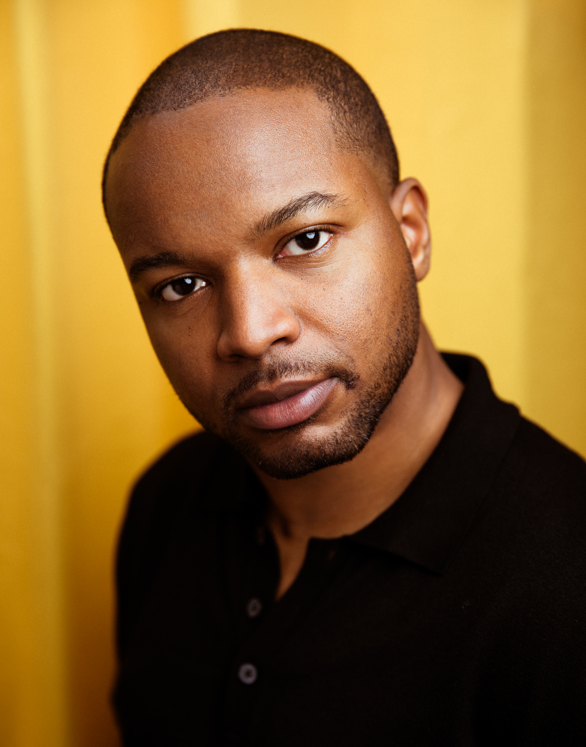



**Height** 5’10”  
**Eyes**Brown  
**Hair** Black

**Nationality**American  
**Natural accent** American

**Pronouns** he/him

Eligible to work in the UK and US

**Productions at Guildhall**

EV in *Morality Play* (dir. Helen Iley)

Claudio in *Much Ado About Nothing* (dir. Chelsea Walker)

Omari in *Pipeline* (dir. Breman Rajkumar)

Brookes/Bouncer in *Days of Significance* (dir. Monique Touko)

**Projects at Guildhall**

Dionysus in *The Bacchae* (dir. Patsy Rodenburg)

Chorus Leader/Member of the Chorus in *The Fire Raisers* (dir. Titas Halder)

Lekan in *Noughts + Crosses* (dir. Morgan Watkins)

Jeremy Mitchell in *Just another day at the office* (written/dir. Jeremy Mitchell)

B in *Crave* (dir. Topher Campbell)

Semyon/Yakov in *The Seagull* (dir. Lyndsey Turner)

Samad in *The Arrival* (dir. Ola Ince)

**Professional Experience**Voice of George Walker in *George Walker: Total Immersion* with BBC Symphony Orchestra at the Barbican Centre

**Other Experience**

2024 Penguin Random House Narrator Mentorship Program

BBA in Finance and Investments from Baruch College, NYC

**Skills**Basketball (intermediate)

Boxer (beginner)

Avid long-distance runner

**Contact**

Email: jaymitch.nyc@gmail.com

Phone: (917)-701-7099