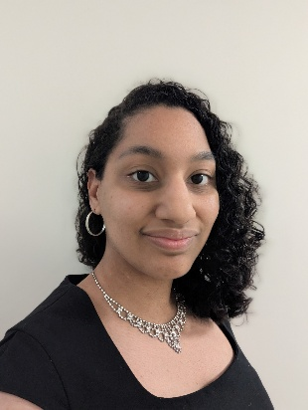

**Theater**

**Special Skills**

Non-Union

**Contact: (315) 612-8172**

**Email: jlsiders28@outlook.com**

**Website: https://jlsinsf13.wixsite.com/resume**

Squad Room Detective Adams Mynderse Academy Middle School

Cinderella Madame Mynderse Academy

The Drowsy Chaperone Ensemble Mynderse Academy

**Athletics:** Sprinting, Volleyball

**Performance:** Ballroom Dancing, Gamer (Console), Singing, Vocal Range (Mezzo-Soprano), Trumpet

**Accents:** American-Southern, American-Standard, British-BBC English

**Height:** 5’3”

**Weight:** 135lbs

**Eye Color:** Brown

**Hair Color:** Dark Brown

**Physical Attributes**

**Jada Siders**