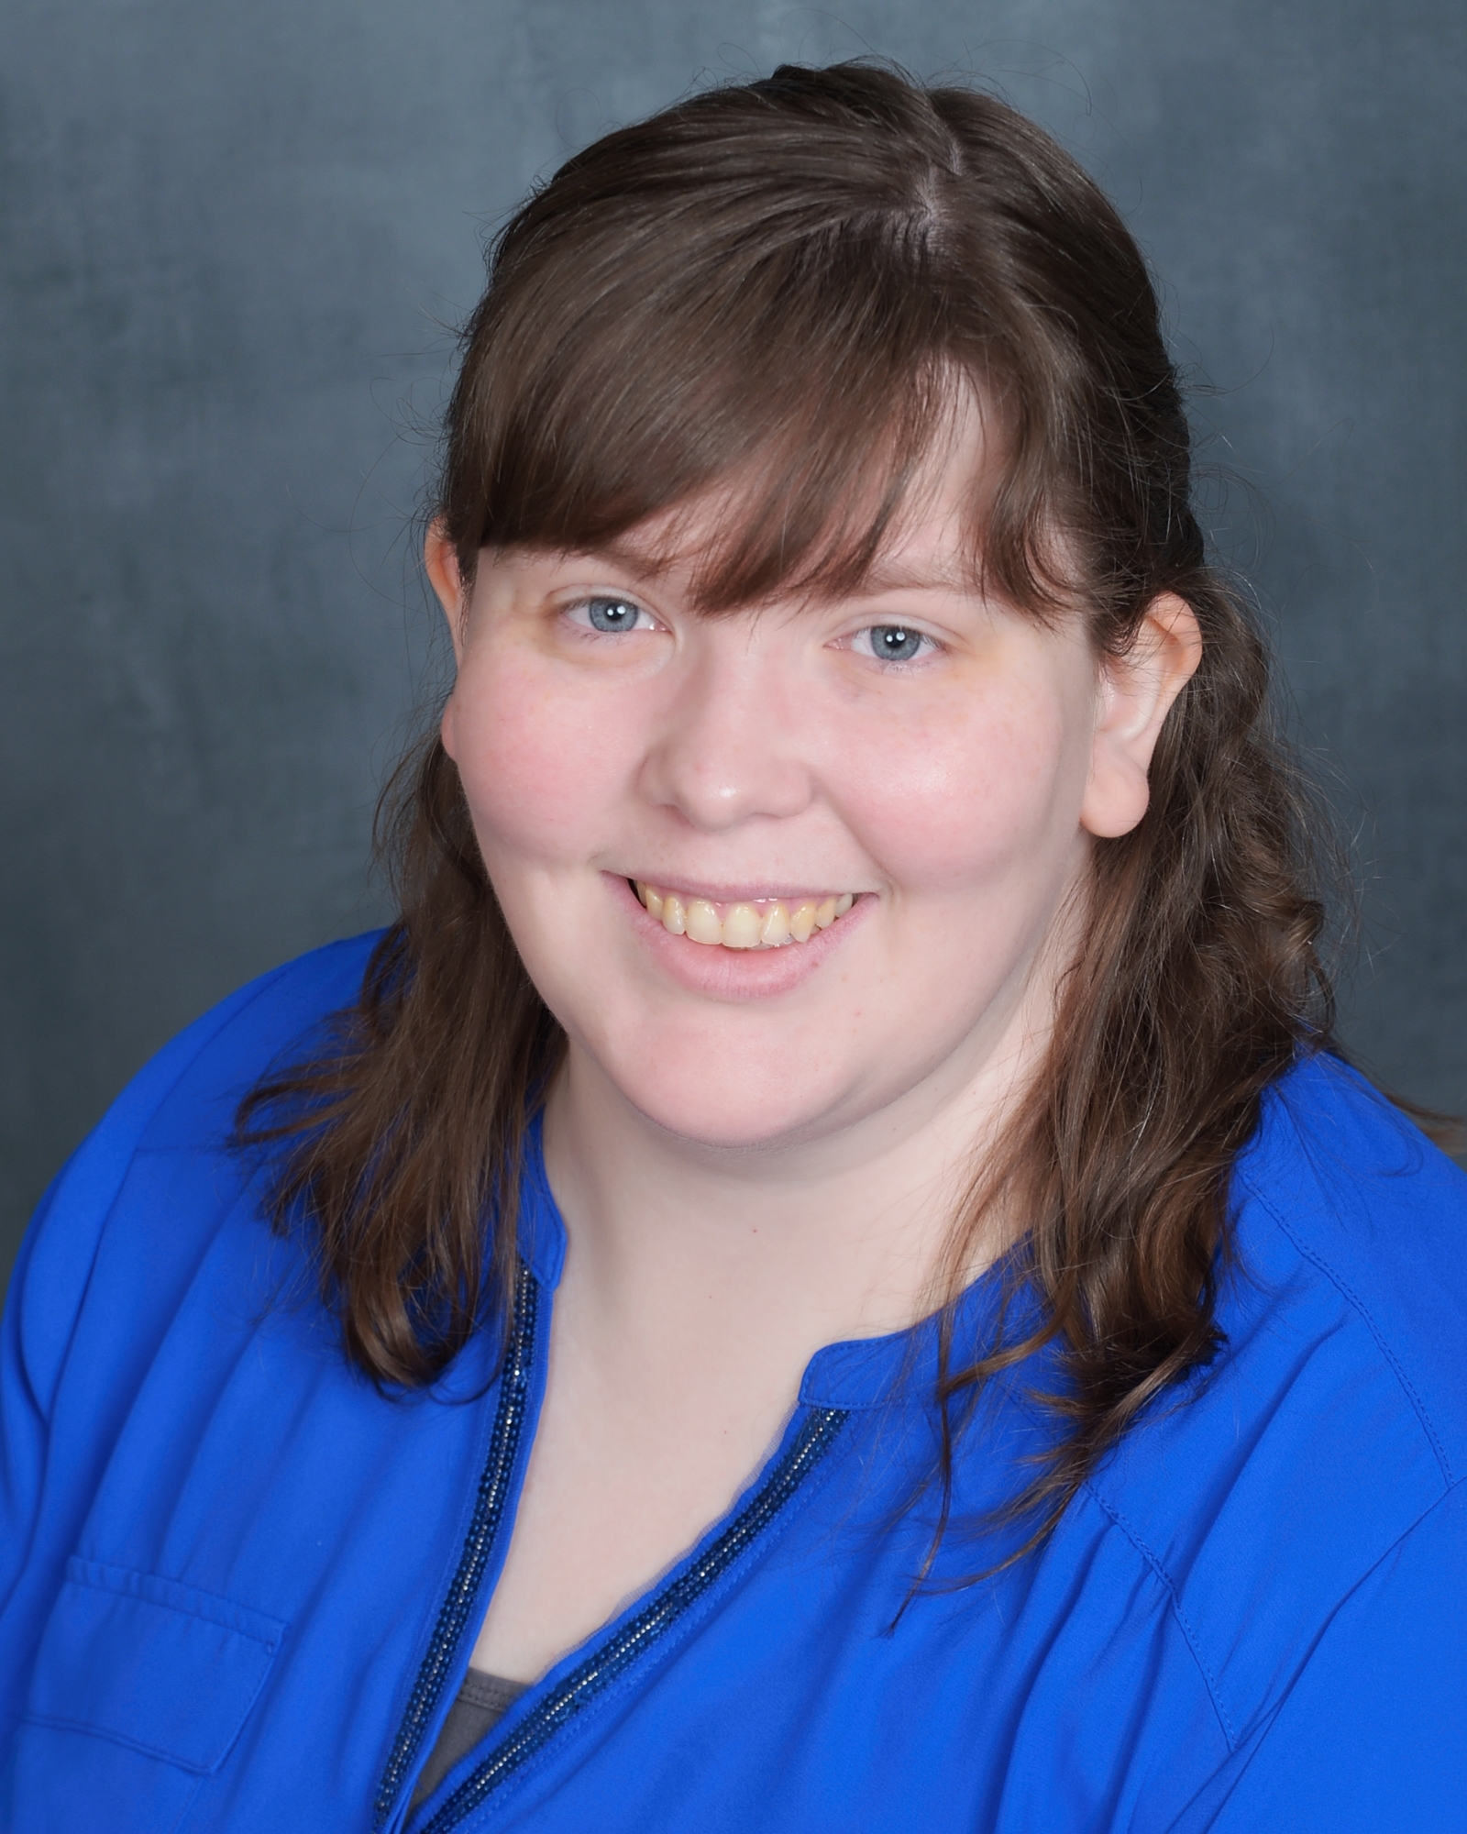

| **ERIN KRESS** |  |
| --- | --- |
| Erin has been professionally voice acting since July 2023 and is located near Pittsburgh, PA where she has access to both professional studios as well as a remote broadcast-quality studio. A clear collaborator who can easily jump from versatile character work to a conversational best friend in a commercial, Erin has a voice with universal appeal. | |



| **KEY SKILLS**   * Remote Capable * Quick Turnarounds with Clear Communication * Proficient in DAW & Hardware * Broadcast Quality Audio * Versatile Acting | **ROLES**   * Video Game - Guards vs. Goats - Kate * Video Game - Promise - Frieda * Audiobook - How He Helped Him - Ms. Partenson * Audiobook - How He Helped Him - Ms. Flower * Audio Series - A Journey into Blackrock - High Mage * Audio Drama - Spirit Bound - Kara Floris * Animated Series - The Hands of the Cursed - Myrah * Animated Series - The Hands of the Cursed - Yesenia * YouTube Channel Narrator - It’s Just Fantasy * Podcast Series - Legacy of Fate - Narrator * E-learning - Voice Actor at Stone River E-learning |
| --- | --- |
|
| **GEAR**   * XLR Microphones   + Shotgun Synco D2   + Large Condenser MXL 990 * Interface   + SSL 2 MK II * DAW   + Audacity   + Reaper |
| **EDUCATION**   * Voice Over School   + Joe Zieja Voice Acting Academy     - Completed July 2023 * Voice Over Classes   + Closing Credits     - *Creating Characters & Thinking Outside the Box*       * Completed 4 sessions in February 2025   + Closing Credits     - *Audio Engineering for Voice Actors*       * Completed 8 sessions May - June 2025   + Closing Credits     - *Voice Acting 201*       * Completed 8 sessions June - July 2025 * Voice Over Workshops   + Closing Credits     - On The Spot! Live Direction     - VO Workouts |
| **STUDIO**   * Internet Speed   + 937 Mbps Download   + 355 Mbps Upload * Booth   + 6’x10’ Custom Built   + 6 premium acoustic blankets * Soundfloor   + -60dB without further effects or editing * Professionally Tested   + -60db requirement for Demos   + Tested via Audio Engineering Class * Remote Capable   + Discord   + Zoom   + Source Connect |
|
| 🕔 Eastern US Timezone Greensburg,PA erinkressvo@gmail.com erin-kress-vo.com  Bossfightmedia Voice Actress | |