Dyvine Wallace
Personal Stats
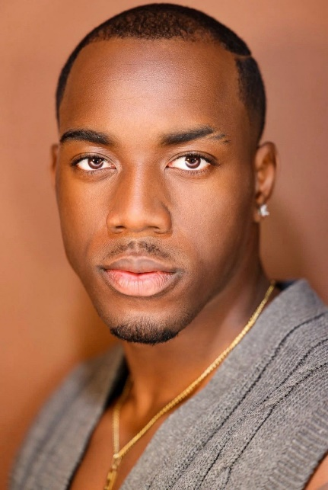
Height: 6’1 Chest: 43”
Weight: 200 lbs. Overarm (Shoulder): 50”
Hair Color: Black Wrist: 8”
Eye Color: Brown Waist: 32”
DOB: 04/21/1999 Neck:16.5”
Calf: 16” Arm Length: 37”
Hips: 38” Quad: 28”
Shoe Size: 12.5 Shirt Size: Large

Contact Information
Wallacedyvine@yahoo.com
(623)-221-7939
IG: d_wall21
Twitter: @TheGreatDyvine

Work Experience
High Fashion Runway Preview Models (Josh) - LA, CA
Acting Classes Ryan Glasgow - LA, CA
Commercial Demo Reel Preview Models (Josh) - LA, CA
Theatre David Weynan - Flagstaff, AZ
Sports/News Broadcasting Rory Faust - Flagstaff, AZ
Editorial/Digital shoots Preview Models (Josh) - LA, CA
Love & Hip Hop Miami Kathy McKee - Las Vegas, NV
Dog Food/Hiking Commercial Ava Porter/Andrea Fischetti - Sedona, AZ
Clothing/Drinking Brand Shoots Peoria, AZ
- Loud Culture (Clothes)
- One Harbor (Clothes)
- Yerbae (Drink)
- Crypto Chaserz (Clothes)
- Airfit (Clothes)
- Millenial Designs (Clothes)
- Gameday Social (Clothes)
- 24 Line
- Naughty Boy Golf
Pawn Stars Do America OS LA Productions - Mesa, AZ
Law Video (Background Role) Chris Wise (Vitra) - Mesa, AZ
Bachelorette Spoof Live Bearded Productions - Scottsdale, AZ
Uniform Guidelines Photoshoot True Food Kitchen Production - Phoenix, AZ
Native Pet (Hand Model) Brittany Tassone - LA, CA
MCA Digital Ad Mike Guillen - Phoenix, AZ
Tango Card Commercial Nolan Nissle - Phoenix, AZ
Bam Kazam Video Shoot Victor Fliorent - Scottsdale, AZ
Rabbit Wine Photo/Video Shoot Kelly LeSueur - Phoenix, AZ
Heirloom: Student Film (Lead) Rui Snow - San Francisco, CA
AZ Wedding Fashion Show (Runway) Kim - Phoenix, AZ
Teremana Commercial/Ad (Lead) James Lee – Phoenix, AZ
Black December (Theater: Lead) Shaneisha – Long Beach, CA
Boxed Inn: Film (Lead) Adam Taylor – Los Angeles, CA
La Crema Wine Shoot Kate & Krista – San Francisco, CA
Pickle Shot Shoot Jasmine & Marc – Hollywood, CA

Training
Voiceover Bubba Ganter Flagstaff, AZ
Runway Don Benjamin/Renee Bhagwandeen LA, CA
Acting classes John Casablanca’s, Online

Special Skills
Football 19 years Peoria, AZ
Track & Field 4 years Peoria, AZ
Swimming 19 years Peoria, AZ
Workout/Lifting 10 years Peoria, AZ
Standup Comedy 1 year Flagstaff, AZ
Acting 2 years Peoria, AZ
Modeling 3 years Peoria, AZ

