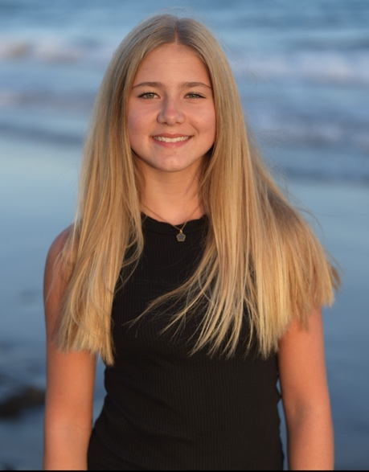 Alea Céline Belser

[alea.belser@brigsued.ch](mailto:alea.belser@brigsued.ch) **Phone Number: +41775120790**

**Theatre:**

• Tom und schini Rasselbanda, School Theatre

•Move,Dance Performance, Move Dance

•Kindergarden Theatre, Kindergarden

•Atelier Performance

**Education:**

•Kindergarden

•Primary school

•OS

**Special Skills:**

**•**Volleyball

• Beachvolleyball

•Dancing

•Horse Riding

•Snowboarding

•Skiing

•Hiking

**Links:**

**•**Instagram: ale.a011

•Tiktok: ale.a 011

**Personal Details:**

**•Age:** 14 years old •**Height**:5‘4 ft

•**Eyes:** Green • **Hair:** Blonde, Long •**Build:** Athletic

**Training:**

**•** Kindergarden Theatre

**•** Primary School Theatre

**•**  Move, Dance

**•** Atelier Performance

**Stage Experience:**

**•** Kindergarden Theatre 2016

**•**Primary School Theatre 2018

**•** Dance Performances 2015-2019

**•** Atelier Performance 2019

**•**Atelier Performance 2020

**Language Skills:**

**•** German , Native Language

**•** Swissgermam, Native Language

**•** English , Advanced

**•** French , Basic Knowledge

**Passport Status:**

**•** Swiss Pass