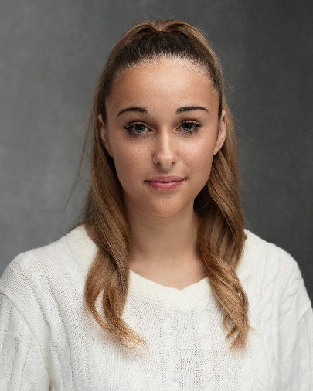**DARCEY SCULLY**

**Age:** 15 **Acting Age:** 12 - 19   
**Height:** 5”6   
**Hair Colour:** Dark Blonde   
**Eye Colour:** Blue   
**Nationality:** British   
**Location:** Bath, Somerset

**Willing to Travel:** London, Southeast, South, Southwest, Midlands

**Guardian:** Mandie Scully (Mother) [mandie.scully@hotmail.com](mailto:mandie.scully@hotmail.com) | 07717 298 594

**Contact Number:** 07518 077773 **Email:** darceyscully@icloud.com

**Education and Extra Curricular Activities**

**GCSEs (Predicted Grades)** Drama Grade 8 | Music Grade 9 | English Grade 7 | French Grade 9

StageCoach 6 years

**Performance Experience**

**Lead Role** – CATS the musical - School | 2025 | Played the role of Munkustrap

**Lead Role** – Legally Blonde the musical - School | 2024 | Played the role of Vivienne

**Lead Role** – Lion King the musical – StageCoach | 2023 | Played the role of Nala

**Lead Role** – Joseph the musical – School |2023| Played the role of Narrator

**Supporting Lead** – The Adams Family – StageCoach |2024 | Played the role of Alice

**Soloist** - Represented BANES at Southwest KS4 Concert | 2025 | - Defying Gravity with Bournemouth Symphony Orchestra

**Achievements**

Singing Grade 4 Classical and Jazz - Distinction

Singing Grade 6 Pop and Rock – Distinction

Group Musical Theatre Grade 5 – Distinction

Group Acting Grade 7 – Distinction

LAMDA Grade 3 – Distinction

**Special Skills**

* **Accents/Dialects:** UK Northern, American, French
* **Singing:** Mezzo Soprano
* **Dance:** Contemporary, Commercial
* **Sports & Physical Abilities:** Hockey, Netball, Swimming