Corhane Huff

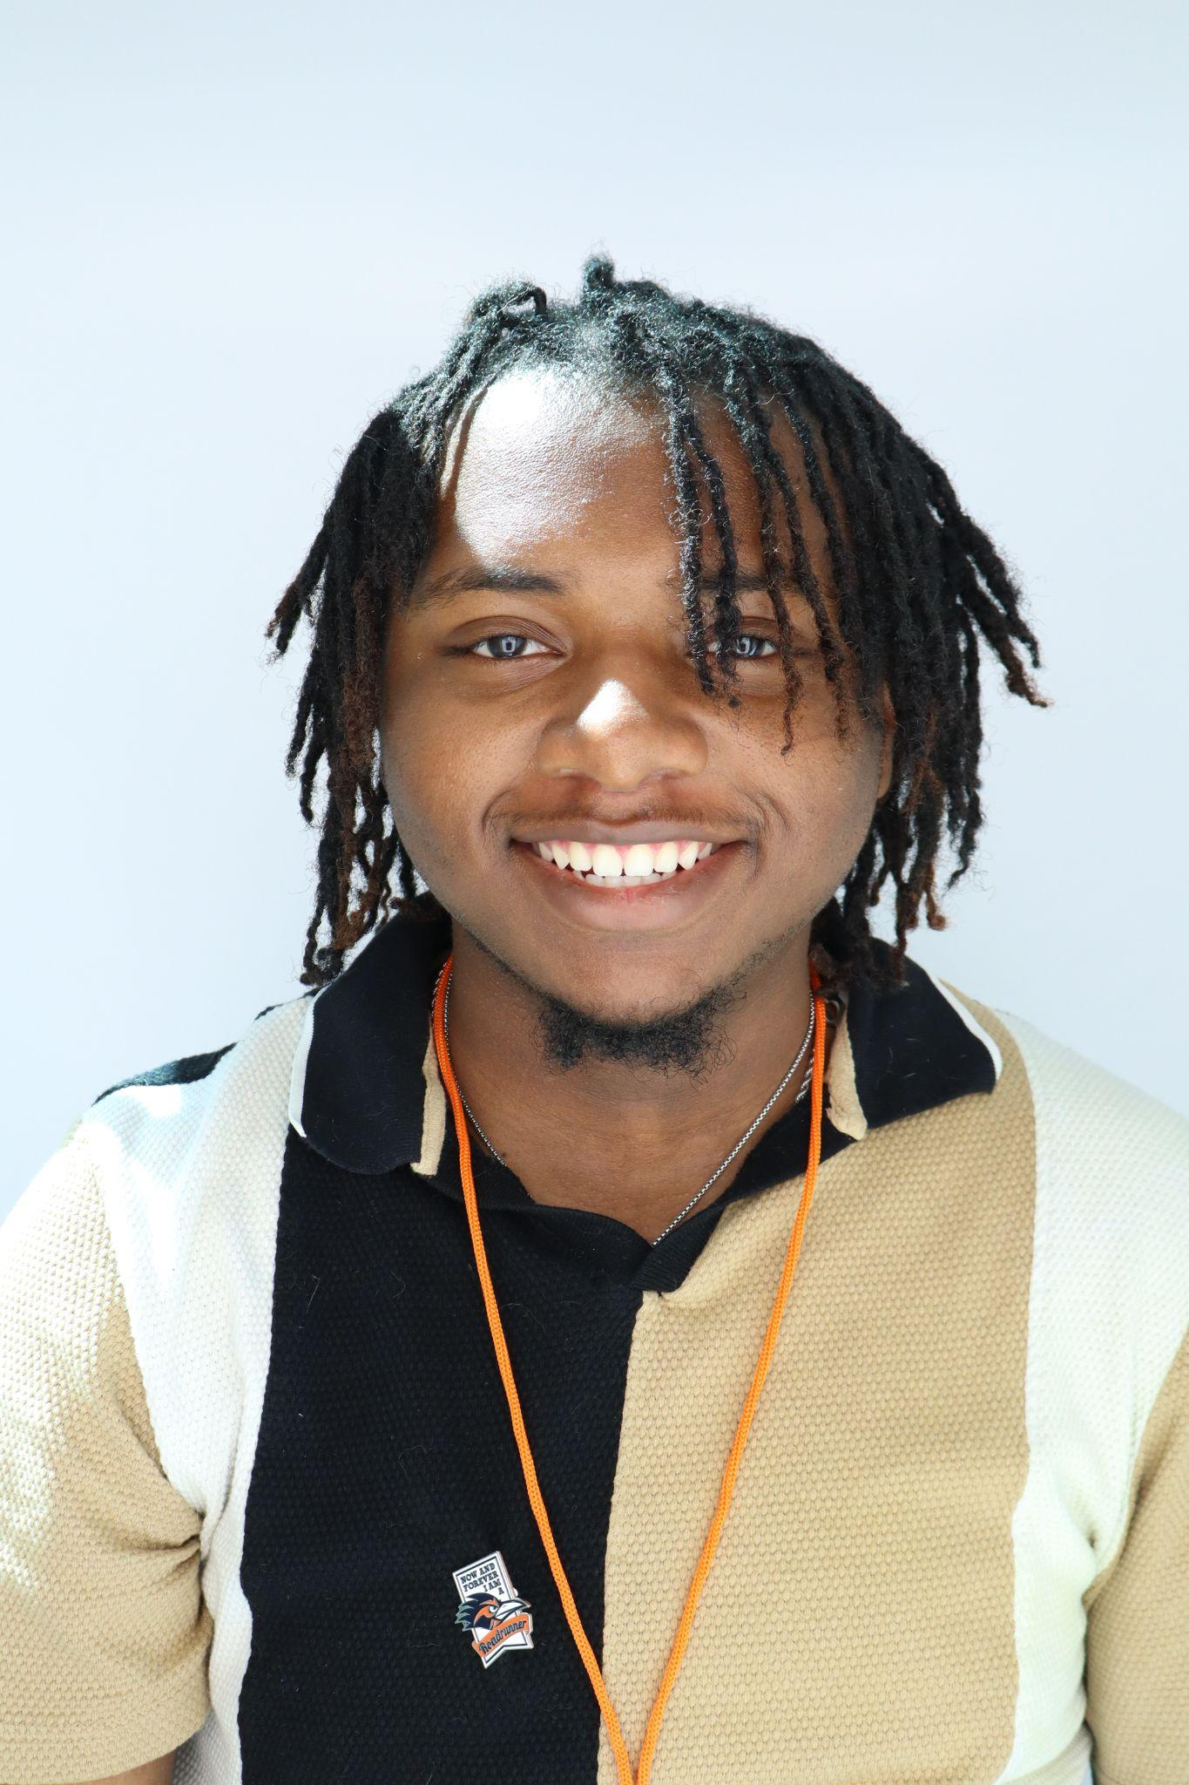

📍 San Antonio, Texas

📞 (956-543-0515)

📧 Corhane Huff

📸 Instagram: @chillw._cj

🎭 Age Range: 16–22 | Height: 5'11" | Ethnicity: African-American

🎬 Able to cry on command | Strong emotional expression

# Tv, Film,Commercial, Student Film

Aspiring actor seeking entry-level roles in film, television, or commercials to bring compelling characters to life through expressive performance and dedication to craft.

# Training

Self-Taught & Independent Study  
- Scene study, emotional realism, and monologue practice  
- TikTok content creation for camera awareness and timing  
- Character building through improvisation

# Skills

- Cry on command  
- High emotional range  
- Energetic, expressive, camera-ready presence  
- Comfortable with comedic and dramatic roles  
- Strong memorization and improvisation  
- Social media-savvy (Relatable content creator with growing audience)

# Education

Roosevelt Highschool , San Antonio, Texas  
Graduation Year: 2025

# Special Interests

singing, poetry, dancing, fashion, and TikTok video creation