**Brandie Chanelle Barima**

**Characteristics:**

**Hair**: black

**Eye colour:** black.

**Weight:** 65kg. **Personal details**:

**Height:** 171 cm

**Telephone**: 07898986878

**Email:** [b.barima1718@gmail.com](mailto:b.barima1718@gmail.com)

**DOB:** 18/07/2001

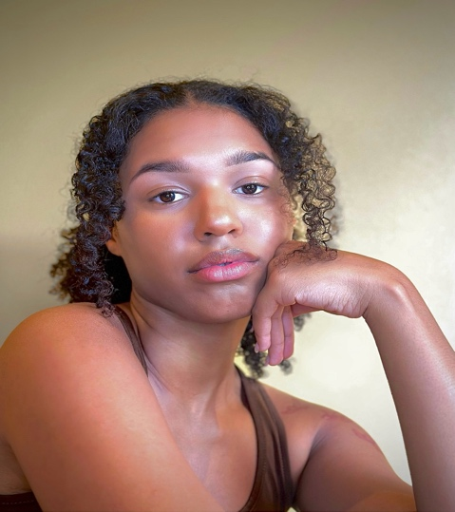 **Training:**

* Identity school of acting 2023 march- 2023 September
* Masterclasses- create destroy studio 2023- 2024

Films:

-Cuts- trailer reel -Lead role- Apollo: 2024. -WRENS-Lead-short 2024

-Tsunami shark- Feature film- Supporting Act- 2023

-Commercial- Exell Film- Actor/ modelling

-Nobody but nobody – Supporting Act- Short Film

-Get home safe- short film- Supporting act

-Deadman-Lead role- short film 2024