Grace Mills
18 Lord Reith Place HP9 2GE
Beaconsfield, Buckinghamshire
England, United Kingdom
+44 7713 836130
gracemillsy15@gmail.com

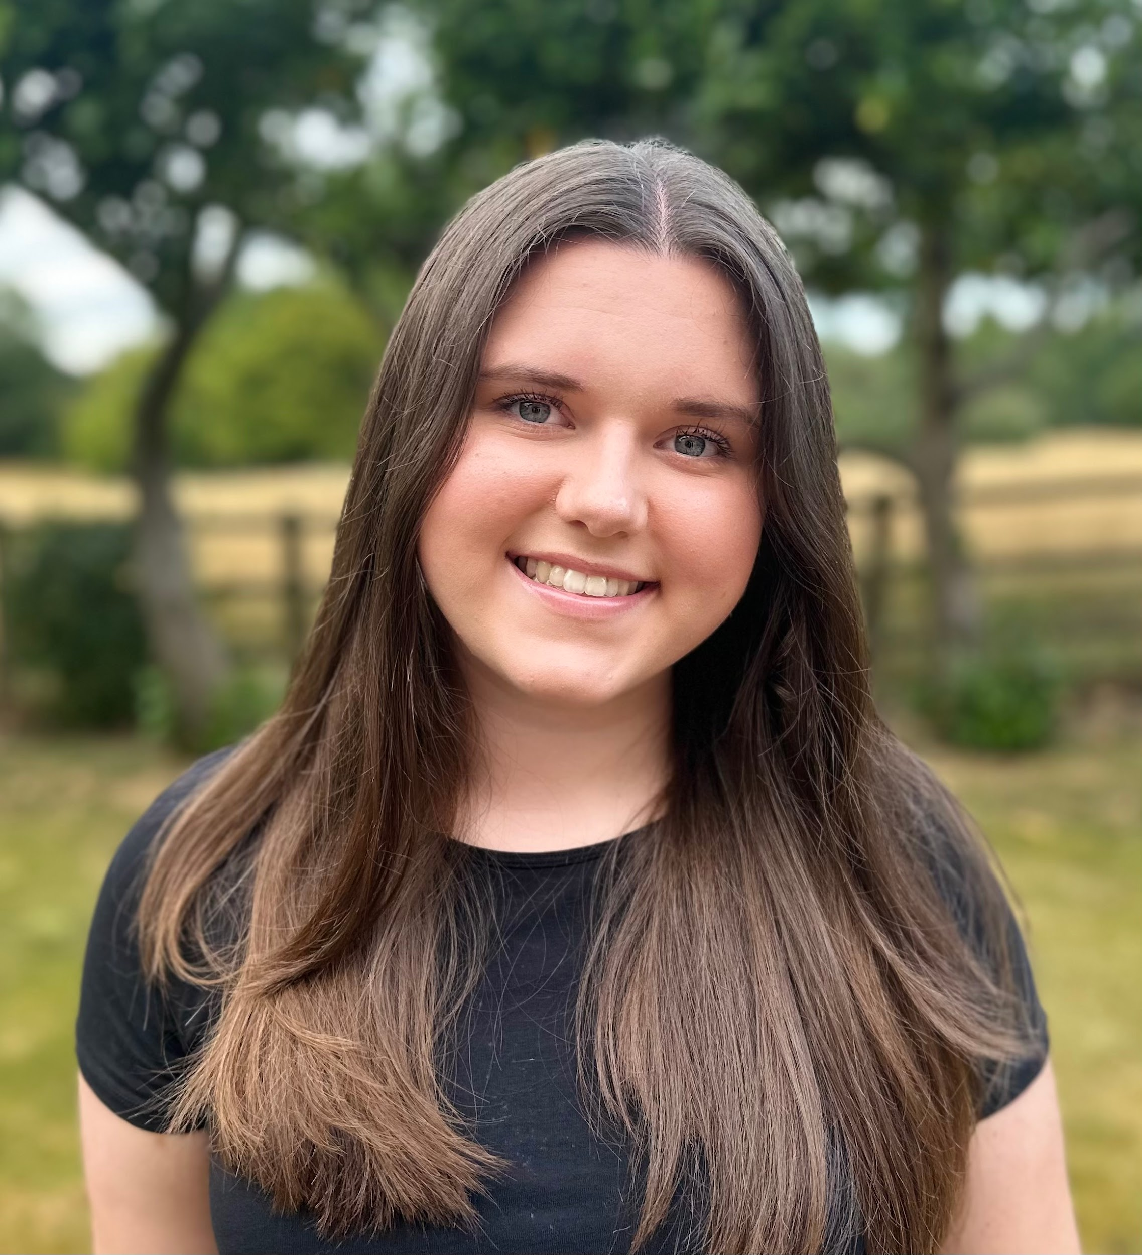

About me

I am a 15 year old aspirational actress, singer and dancer. I am in love with musical theatre as I love to perform but also go to the theatre to watch. I have had singing lessons growing up and have done singing exams for Grade 4 Pop and Grade 5 Musical Theatre, which I both got Distinctions in. I have done multiple classes in Musical Theatre and have been in multiple shows.

Skills
- Singing
- Acting
- Dancing

Experience
- Genie - Aladdin
- Grace Farrell - Annie
- Audrey 2 - Little Shop of Horrors
- Katherine Plumber - Newsies
- Ensemble - Six
- Elle Woods - Legally Blonde
- Princess Anna of Arendelle - Frozen Jr

Education

Year 11 - Royal Masonic School For Girls Rickmansworth GB

Awards

Grade 4 Pop Exam - Distinction
Grade 5 Musical Theatre Exam - Distinction

